Copy Paste Facebook Party –Wellness and Pampering
Use this as a basic outline for your party. You can mix and match images and posts from past parties too.
Template Tip: Do not copy and paste comments in red that you see at the top of each post. Just copy the text under each post title. Paste it into Facebook and then publish or schedule to your group. Be sure to personalize the post with specific info for your party and to meet your personality.
Be sure to change out the Weekly Special and go Live to launch and close your party. Engagement with your guests is key. Host coach and have your host post a couple of posts as well. Additional engagement posts can be found in the JEU >> Media Center.
Posts can be posted 3-4 over the course of three days or posted 3-5 minutes apart during a 45 minute party. You can kick off a party with a LIVE in Facebook and then end with a live as well.
Insert emojis to make the posts festive and fun. Posts can also be used as stand alone posts on your business page, Instagram and personal profile.
Banner option for top of group
Pre-Party Posts  Pre-Party Post 1 (Mark as Announcement):  Welcome to our Party!  Your host, XXXX, and I are looking forward to having a fun time together online as we share products that support your self-care and wellness in the new year!  Here’s how it works:  Check out the posts below to learn more about Jordan Essentials and join us here in this group on XXXX (date) at XXXX (time). You’ll receive chances to win fun prizes for commenting below to RSVP, for joining us on time, for participating in the event, and more!!  If you’d like to check out what Jordan Essentials has to offer, check out our online catalog at https://bit.ly/JEFall2021  You can place an order on XXXX’s party anytime before XXXX by going to: (insert party link).  As your JE consultant I’m available to answer any questions so reach out to me anytime in a personal message or call/text me at ______ (insert phone number)  Have someone who would like to join us? Share the link to this group and they can request to join!  I look forward to seeing everyone on ________ at _____!! Comment below if you will be joining us for a chance to win our prize drawing!! | Catalog Preview shows link when posted.
Pre Post  Feeding America – 1 Party Makes a Difference  Since the beginning of the pandemic, Jordan Essentials has been supporting Feeding America on behalf of our Consultants and our customers just like you.  We are humbled by the difference we can make together. | INSERT CURRENT WEEKLY TOTAL GRAPHIC HERE
Pre Post  Feeding America Kitchen Collection  For January, Jordan Essentials is donating 10 meals to Feeding America for each party closed.  Each of you are making a difference! If you would like to host your own party, let me know! Together, we can make even a bigger difference. | 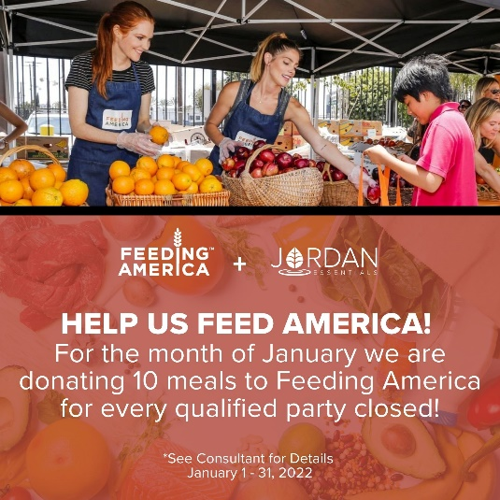
Pre Post  Say YES – To healthy products with healthy ingredients!  At Jordan Essentials our belief is that everyone deserves healthy skin—and joyful, healthy lives. When you say YES to Jordan Essentials products, you are saying YES to ingredients like magnesium, essential oils like lavender, purifiers like charcoal and rich moisturizers like shea butter.  Our products are made in fresh batches right in Nixa, MO. Delivered fresh from our manufacturing center to your doorstep! | 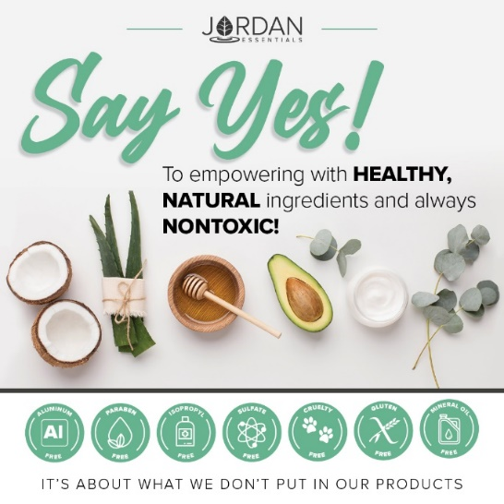
Pre-Party Post  And just as importantly, you will be saying NO to aluminum, parabens, mineral oil, SLS/SLES, gluten and phthalates that are found in many, if not most, bath, body and skincare products today.  If you want to read more, check out the Product Promise page on my website:  INSERT LINK HERE – Example:  https://XXXXXXX.jordanessentials.com/product-promise/ | 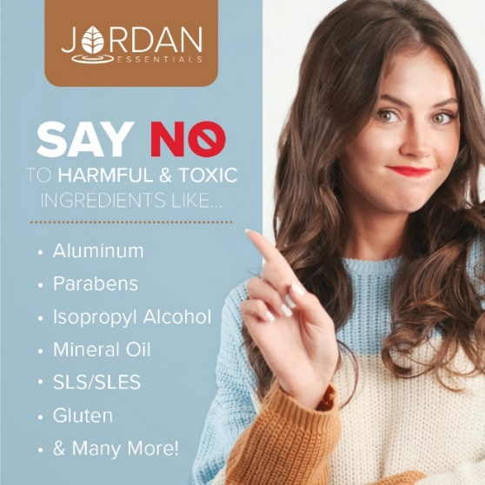
Pre-Party Post

Why is what’s in our products so important?

For two key reasons:

1. Our skin is our largest organ and what touches our skin affects all of our organs.

2. It takes just 26 seconds for what touches our skin to be starting to be absorbed into our bloodstream. The harmful effects of many chemicals used in skincare products are scary! And many include ingredients that prematurely age us or dry out our skin.

Jordan Essentials’ products use healthy, nontoxic ingredients combined to provide safe, healthy alternatives to their chemically-laden counterparts.

Pre-Party Post 4 (Day Before the Event):

Ready to Win?

If you are ready for some fun and some pampering tips, be sure to join our live event tomorrow at XXXX. We will be giving out virtual tickets for great prizes - the more tickets you earn, the more chances you have to win!

Not only do we provide natural and nontoxic solutions, but our products are also fun, pampering, and life-changing! Everyone needs and deserves pampering in their life. Right?

Who’s ready to win?
Pre-Party Post 5 (Morning of the Event):

Today’s the Day!!!

Join us TONIGHT at XXXX right here in this group for fun, connecting with friends, fabulous spa products, and some free giveaways!

Set an alarm on your phone, because everyone who responds during the live event gets extra chances to win!

Won’t be able to join the LIVE event or wondering how to order? Place your order anytime at ________ or contact me via messenger or phone to place your order or ask questions anytime!

30 Minutes Before:  Set A Reminder – We are Starting Soon!  The party starts in about 30 minutes! It is come-as-you-are so get comfy, grab a drink, get a pen and paper, and let’s get ready to party Facebook Style with Jordan Essentials! I am excited to share with Host’s friends who will be joining us tonight!  Comment below with an emoji or GIF that shows how excited you are for us to get started! | 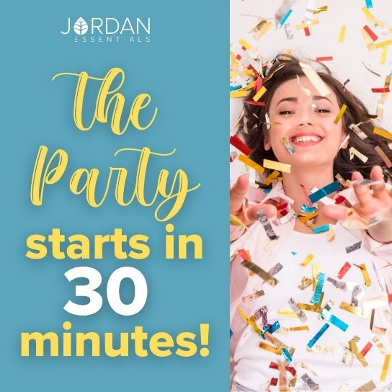
15 Minutes Before

Sharing Soap…and Sharing Hope!

I am so excited to be sharing Jordan Essentials with all of you! I am setting the mood for fun with our HOPE Candle.

Jordan Essentials candles are made with pure non-GMO soy wax. It melts clean and at a lower temperature than other traditional candles. The wick is made of pure cotton – no lead or metals!

The HOPE candle is the rich uplighting aroma of three essential oils – Lemon, Lavender and Rosemary.
5 Minutes Before

Time sure flies by!

We will be starting in just a few minutes. During our party tonight, which will last about 45 minutes, be sure to refresh your screen often so you don’t miss anything such as chances to win our product drawing!

Tonight you’ll earn a ticket into the product prize drawing for every Like/Love, comment or question on the posts in our event!

Hint – Go live to kick off your party!
Post 1: Welcome

Welcome everyone! Both XXXX and I are so happy you could join us. We both love Jordan Essentials and are excited to share our favorite products with you. For inviting each of you and hosting our event, XXXX is receiving amazing perks from Jordan Essentials. Now tonight, when your wish list is bigger than your wallet, let me know and we can work together to make those wishes reality with free credits when you host too!

As we chat, feel free to comment, like and LOVE the posts. The more you do, the more chances you have to earn tickets. I’ll respond as quickly as I can to questions and if you have questions after, feel free to reach out directly on Messenger. Remember, refresh often, sit back and have fun!

Double the Fun – Double the FREE  Now tonight, when your wish list is bigger than your wallet, let me know and we can work together to make those wishes reality with free credits when you host too!  January is really a special month. In addition to great benefits every month, January is our Double Host Rewards!  You can cross off twice as many items on your wishlist with double the FREE credits! Message me or comment if want to secure your January date! | 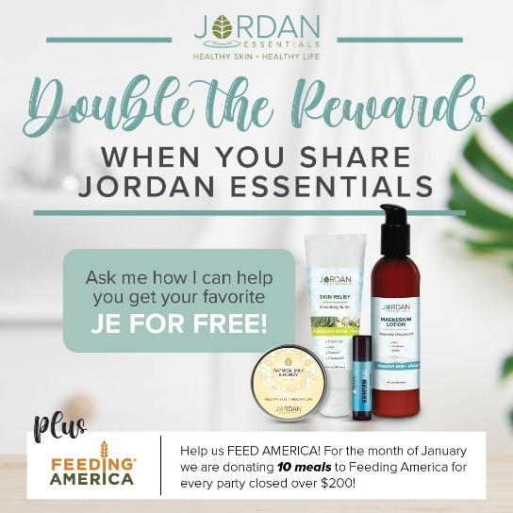
Example:  No party is complete without prizes! If you win, I want to be sure I can connect with you. So, for your first 5 points, message me "Hello" at http://m.me/marian.smithje and then comment DONE below.  This takes them right to messenger without being friends!  You can find your profile name in the address bar when you are on your Facebook page.  You can post this as a pre-post also. | Use this tip and link anytime you want to get guests engaged with contacting you directly.
Roll Call – Who’s Here With Us!

Let’s start with an easy question and see who is here. Comment below letting us know where you are viewing from and your favorite ……

Fill in here with favorite – for more interaction. Such as favorite winter sport, how they know the host, what they are most interested in learning more about, etc.

Comment with a gif for fun!

My Story POLL  That is so fun to see where everyone is watching from. I’m _________ and I am in ________.  Insert a sentence or two about your JE story. – | Insert a picture of YOU.
That’s my story, but I’d love to know more about YOUR story so I can best serve you tonight! Select any of these poll options that best describes you. | This can be used as a pre-party post too to start the engagement.
The JE Story  For those who have never heard of Jordan Essentials, it was started by Nancy Bogart in 2000. We are proud to be a woman-owned and “Made in America” company. All of our products are made with nontoxic ingredients and the healthiest ones available. We will feature a few of those products during this party.  Let me know where you are on your journey with healthy products and Jordan Essentials. | 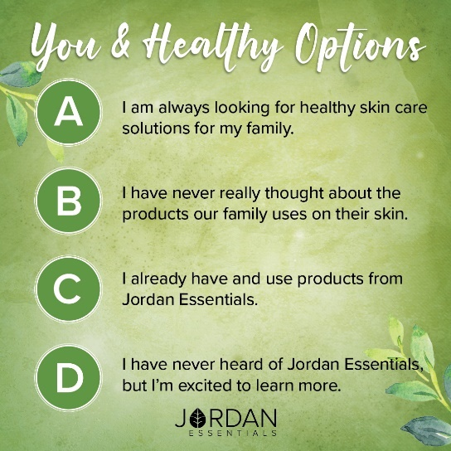
Ordering is Easy – This can be a Pre-Party As Well  There are two ways to order. Go to (enter party link) to shop OR contact me with your order or questions and I’ll place the order for you.  Remember, by commenting INTERESTED on any post, you’ll create a wish list for easy checkout at the end of our event! If you’ve read this post and are ready to get started, comment READY below!  You can also go to my website and start adding items to your cart! | 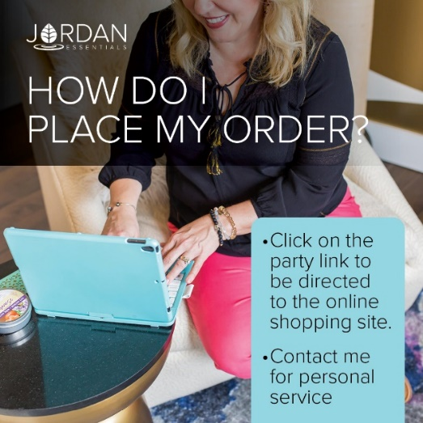
The Product that Started it All!  The Lotion Bar is a solid bar of lotion. It is made with beeswax to seal in the moisture and bonus – it doesn’t harbor bacteria – naturally!  Jordan Essentials is also fresh batch manufacturing. Meaning we are not mass-producing lotion bars that sit on a shelf for years or in a port waiting to be off-loaded from a ship!  They are hand-poured in our facility right here in Nixa, MO and then delivered right to you!  No cargo ships on the open seas for these! | 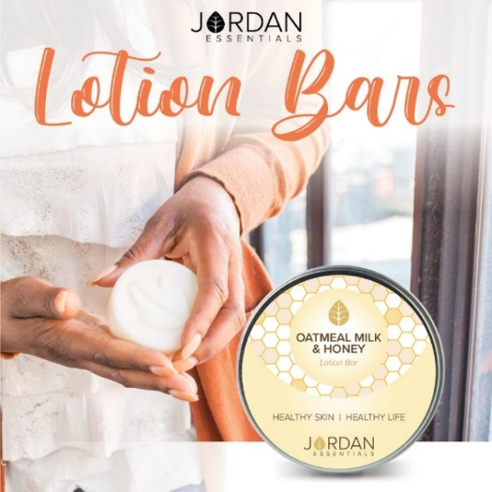
Aromas and Fragrances for Everyone!  Jordan Essentials offers Signature Fragrances plus Unscented in many of our products and collections.  Along with our most popular Oatmeal Milk & Honey, we offer have two that have been fan favorites since their release.  Promise is a light citrus flower of sweet clementine and freesia flowers. One of our most popular fragrances.  Hope is a fragrance made with essential oils of lemon, lavender and rosemary. It is fresh and rejuvenating!  Another favorite is Vanilla Pear is a rich, warm and crisp scent perfect for the winter months.  Which fragrances are your favorite? | 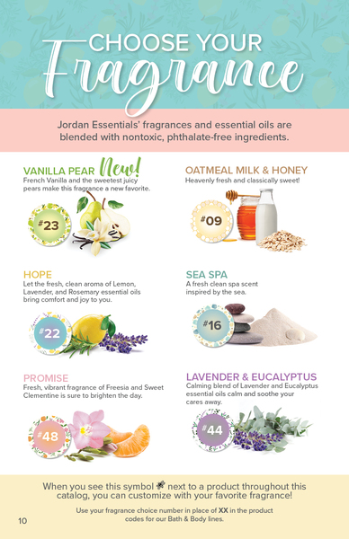
Bundle and Save!  Jordan Essentials has created a variety of bundles in your favorite fragrance to make shopping easy.  These bundles are priced for savings and support soothing, relaxing, and healthy at-home spa experiences!  Your Premier Collection, my favorite, includes five products – one of which is the lotion bar and two magnesium products and is available in your choice of our signature fragrances. Both our Everyday and Premier Collection qualify you for our January Customer Special too!  Let’s chat this collection! | 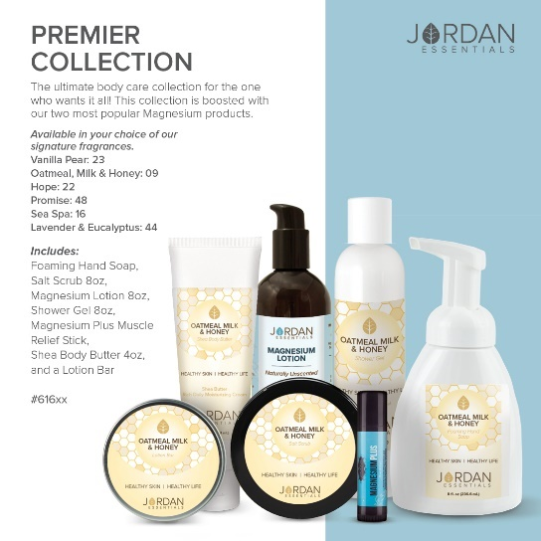
Hand Washing Blues!  Consistent hand washing and the dry, colder winter air is hard on our hands.  Jordan Essentials Foaming Hand Soap is a rich, moisturizing soap with healthy ingredients. Its soft, silky lather feels like a mini pampering session every time you wash your hands!  Free from DEA, SLS and parabens, JE Foaming Hand Soap is safe for the entire family. Choose your favorite scent - Mix and Match for every sink in the house! | 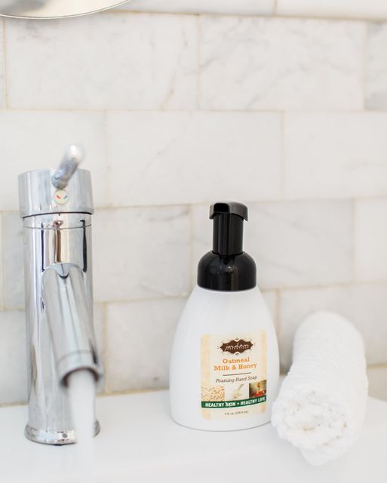
Slough Off Winter Skin with a Salt Scrub  Gently exfoliate away dry, winter skin cells to reveal vibrant, younger looking you!😎  🍃 Exfoliating is a healthy way to increase circulation and encourage regeneration of new skin cells. This can reduce skin discoloration, balance skin tone and improve skin texture - giving you an even, all-over glow!  Jordan Essentials salt scrub is made with healthy, non-toxic ingredients.🌿 It exfoliates and polishes our skin with custom blends of natural oils and salts.  For an at-home hand spa experience, place one pump of foaming hand soap and one scoop of salt scrub in your hands. Wash, rinse and feel amazing! | 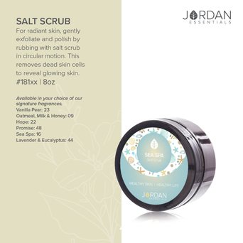
Not all Hand & Body Lotions are Created Equal!

Treat your skin with the nutrients it needs with Jordan Essentials' Hand & Body Lotion. This is also included in the Premier Collection.

Shea Butter, Green Tea, and Aloe give this lotion its soothing and moisturizing feel without being greasy or heavy.

No mineral oils, parabens or other “icky” ingredients to prematurely age your skin.

Layer on the fragrances to feel and smell wonderful all day long or apply before bed and wake up to softer skin!
A Healthy way to Cleanse!  There is nothing better than a warm shower & your favorite Jordan Essentials Shower Gel  The Jordan Essentials Shower Gel is a rich, concentrated recipe that is DEA free! It won’t clog your pores or dry out your skin!  Healthy ingredients cleanse and pamper your skin, leaving it feeling soft, silky and moisturized! | 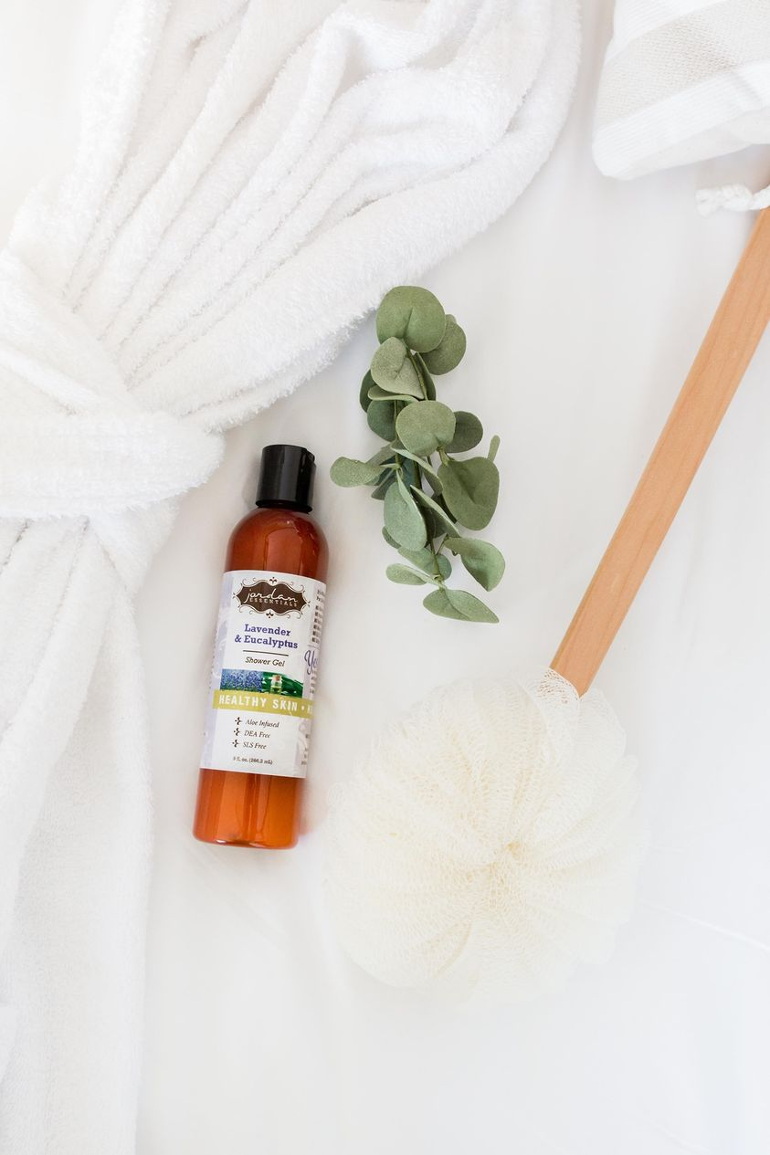
For Deep Moisturizing Every Day  Shea Butter! Shea butter is a fat extracted from the nut of the African shea tree. High in Vitamin A, benefits of shea butter to the skin include superior moisturizing capabilities, healing properties, and improving skin conditions.  It is ideal for the driest skin like heels (feet), knees and elbows.  Shea Body Butter is rich, creamy and feels oh so good! I love to put it on my feet before bed for softer feet each morning! | 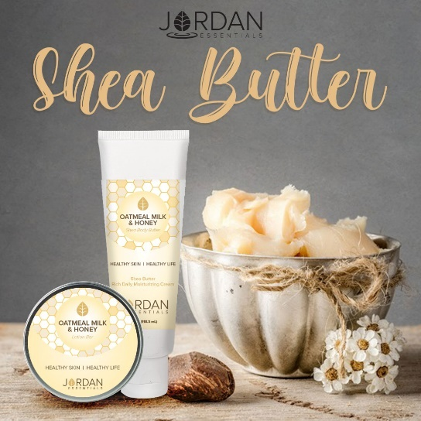
And…Magnesium!  Two additional products are included in the Premier Collection – a Magnesium Plus Blue Stick and a Magnesium Lotion. | 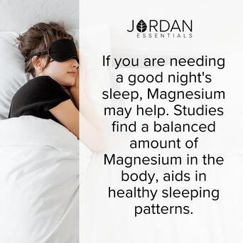
Why Magnesium?  Did you know 55% of Americans are deficient in magnesium?  Our topical magnesium lotion comes both with and without peppermint essential oil and is made with healthy ingredients like aloe, sunflower oil and jojoba oil along with magnesium.  These ingredients have been shown to help relieve those minor aches and pains, muscle spasms, eye twitches and support the body’s need for magnesium.  - How many of you or someone you love suffers from occasional leg cramps, muscle spasms like eye twitches, or achy, sore muscles? They just may need a boost of magnesium! | 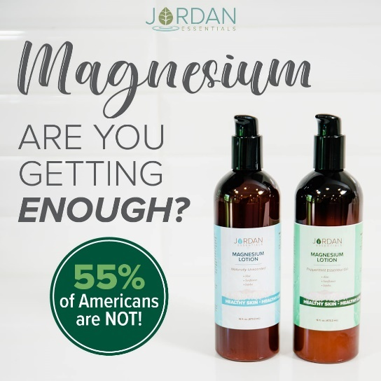
Benefits of Topical Magnesium  Studies have proven that Magnesium absorbs more quickly and efficiently in topical form compared to oral supplements.  Some people have issues processing magnesium through food and oral supplements, but using a topical form is simple and completely bypasses the digestive tract!  With a topical, you can apply it right where you need it. Sore leg muscles? Apply it right to the spot! |  | 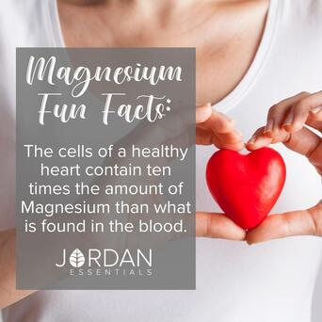
Why Choose Peppermint?  Peppermint is an essential oil known for its invigorating aroma and a cooling sensation that soothes fatigued muscles. It partners will with magnesium for the soothing of muscles and helps perk up your senses too! |  | 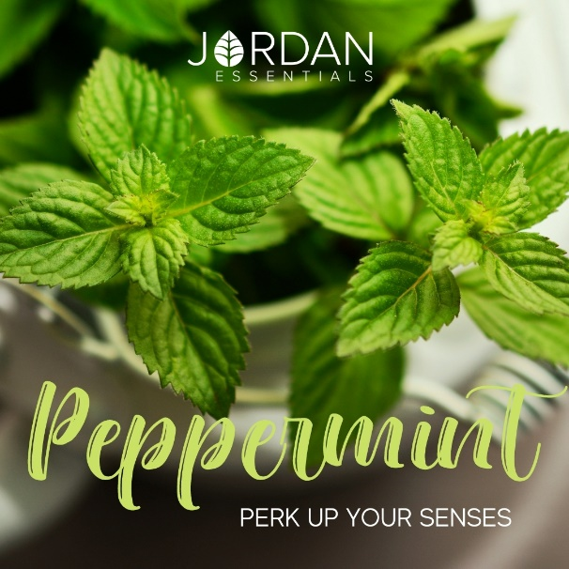
The Top Selling Blue Stick  This fan favorite in in the Premium Collection and in our Core 4 Starter System.  Our Magnesium Plus stick helps relieve minor pain from stiff muscles and sore joints with natural ingredients and essential oils.  It has 4 key essential oils – Peppermint, Sweet Basil, Lavender and Frankincense in our lotion bar base along with a boost of Magnesium.  This stick is a must-have for those working from home suffering from “tech neck”! |  | 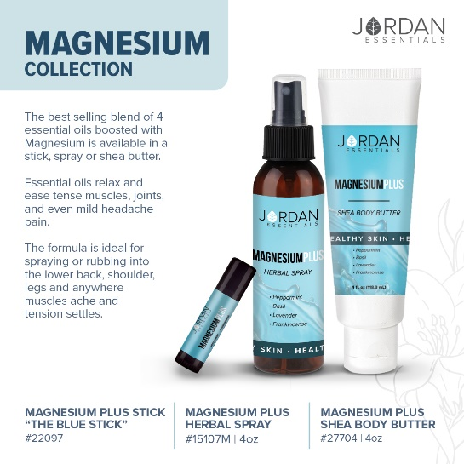
The Core 4 Starter System  The Core 4 includes your choice of unscented or peppermint magnesium lotion, a magnesium stick, lotion bar, plus Skin Relief to soothe and care for even the driest skin. It is more focused on magnesium and wellness products.  Not only is this bundle a significant savings, but it makes you an instant qualifier for this month’s customer special too! |  | 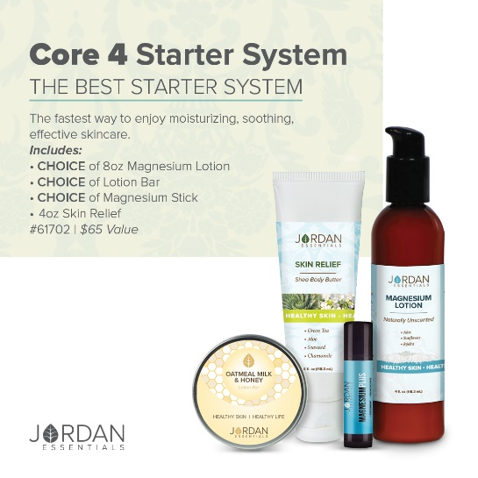
Core 4 Video – Learn why this is a must have collection for achy muscles, joints and dry skin!

Upload Core 4 Video or share Video Link: https://vimeo.com/327302443/a64285e7db

The Customer Special!  This month our Customer Special is really special! When you purchase just $50 (make it easy and grab a collection), you can purchase the special for just $5.  Life is a Journey of Discovery! This month you are discovering Jordan Essentials! This key clip will be a reminder of your healthy journey into 2022.  The 1 oz Resistance Spray is perfect for the purse or tucked away in a desk drawer. Resistance is our blend of 5 essential oils that protect you from the environmental toxins and threats we face everyday!  Spritz the tassel on the key clip for a boost of essential oil power and protection! |  | 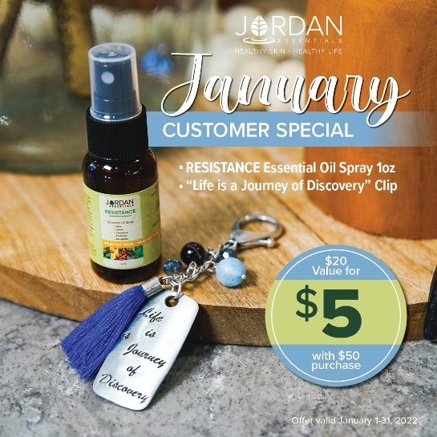
Speaking of Essential Oils…  This month our Joyful Jordan Box is a true wellness box! Essential oils pack a powerful punch and a huge boost to supporting our immune systems during the winter months.  We have two amazing products that help us feel good and stay healthy in this box. |  | 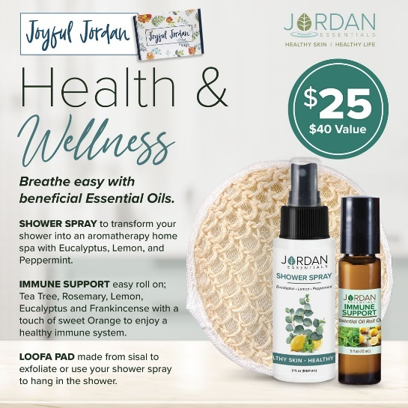
Roll On the Immune Support  The Immune Support roll on is a combination of six essential oils chosen specifically to boost wellness and support the immune system to keep us healthy and happy! They are carefully blended in a grapeseed oil carrier for easy application and absorption.  These six oils are well-known for their anti-bacterial, anti-viral and immune boosting properties. They are Tea Tree, Lemon, Rosemary, Eucalyptus and a touch of Sweet Orange. |  | 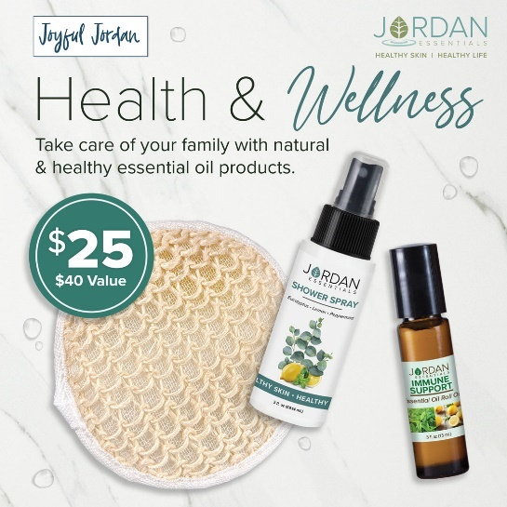
Shower Away Aches, Pains and Stuffiness  The Exclusive Shower Spray in this Joyful Jordan Box turns your home shower into a spa every day!  Spritz the shower walls or the loofah included in the box, turn on the shower and step into an aromatherapy experience that clears the airways and the mind.  Eucalyptus, Peppermint and Lemon smell amazing together!  Perfect for using when you are feeling a bit stuffy-headed or have minor body aches. |  | 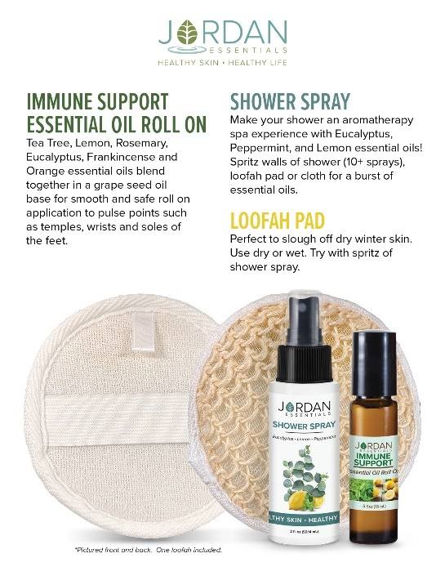
3 Ways to Enjoy JE

Did you know there are 3 ways to get Jordan Essentials products in your home?

The first way is by placing an order on XXX party!

Remember you can message me too with questions or to book your party!

How about free? And DOUBLE THE FREE!  The 2nd way to get JE products in your home is to become a host. We pamper our qualifying hosts with free products, ½ price items, a monthly special and more! I would love to share healthy, nontoxic products with your friends and family too and help you earn your favorite products for FREE.  In addition to the rewards mentioned above, our hosts receive a ½ price item for EVERY party booked from theirs!  We can do an online party like this one...or an in-person Spa Bar or even a Party On the Go. Let me know which would work for you. Comment which party type you are interested in below and I can answer any questions. When you select your date before _____ closes her party, she will receive credit for your booking.  In addition to face care, we can do theme parties, Magnesium Parties, Healthy Living Parties, Essential Oil parties and more! |  | 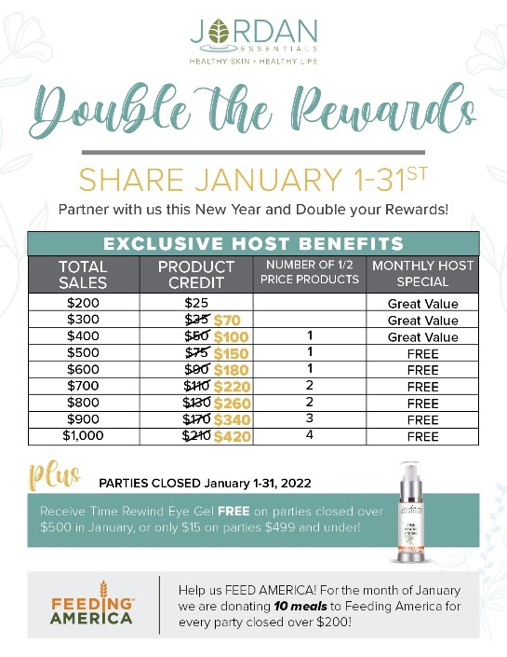
Enjoy it all…all the time!

Of course, if you were thinking, “I can do what she does!”, you are right! YOU can earn money by sharing healthy products with others too!

You can work this business online, part time or big time, the choice is yours! If you would like to learn more about starting your business, message me or type “Tell Me More” in the comments and I’ll send you some more information to look over and we can chat!
Be My VIP

We have so many products I didn’t get to share with all of you today, but great news! I have a VIP Facebook Group where I share valuable tips and information that focuses on Healthy Skin and a Healthy Life. Members also get access to promotions and notifications of special events! Go to _____________________(Insert VIP Group Link) and request to join for one final chance to win tonight’s drawing!

Wrap Up

I’m getting ready to gather all of the entries for our prize drawing! Want to make sure you didn’t miss a video or post? Click on PHOTOS or VIDEOS in this group to quickly jump to what you’re looking for!

Just a few reminders while I’m figuring out who our winner is tonight. If you would like to place your order directly, here is the party link:

If you would like me to contact you for your order, comment below and I will connect with you shortly.

We will be closing our party on…. (INSERT DATE AND TIME)

Thank YOU!  A big thank you to our host, ________, for getting everyone together for our fun online Spa Bar! You were an awesome host! And to every guest who participated, it was a pleasure having you. I hope you will join our mission of sharing Healthy Skin - Health Life.  Remember, you will want to place your order at _______ (insert party link) by ________ (close date) OR message me and I will review your wish list with you, answer your questions and get your order placed for you! Good night everyone! |  | 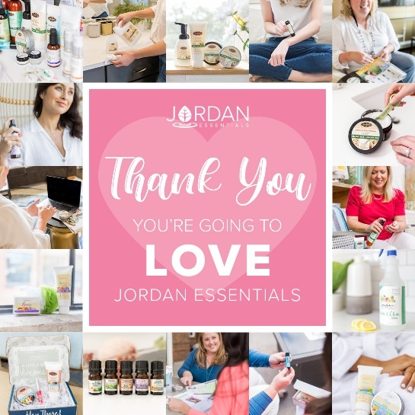
(The Next Morning)  Party Poll  Thank you all so much for attending live or viewing our online party! I had a great time sharing Jordan Essentials with all of you. Please take a minute to comment below with the letter that most describes you!  I look forward to continuing to serve you. Keep my contact information in your phone and stay connected with me in my VIP group at __________________.  Enjoy your new products and thanks again to _______, our awesome host!! |  | 