Copy Paste Facebook Party –Holiday Shopping & Gifting
There is a collection of Thanksgiving Trivia that you can incorporate into this party. They are located in JEU. There are also extra images included that you can insert as needed and to swap out for additional parties. There is a complete Copy/Paste that focuses on the Holiday Catalog.
Template Tip: Do not copy and paste comments in red that you see at the top of each post. Just copy the text under each post title. Paste it into Facebook and then publish or schedule to your group. Be sure to personalize the post with specific info for your party and to meet your personality.
Be sure to change out the Weekly Special and go Live to launch and close your party. Engagement with your guests is key. Host coach and have your host post a couple of posts as well. Additional engagement posts can be found in the JEU >> Media Center.
Posts can be posted 3-4 over the course of three days or posted 3-5 minutes apart during a 45 minute party. You can kick off a party with a LIVE in Facebook and then end with a live as well.
Insert emojis to make the posts festive and fun. Posts can also be used as stand alone posts on your business page, Instagram and personal profile.
Banner option for top of group
Pre-Party Posts  Pre-Party Post 1 (Mark as Announcement):  Welcome to our Be Summer Ready Party!  Your host, XXXX, and I are looking forward to having a fun time together online as we share products that support your self-care and springing forward with fresh, healthy skin! We are all ready to slough off winter!  Here’s how it works:  Check out the posts below to learn more about Jordan Essentials and join us here in this group on XXXX (date) at XXXX (time). You’ll receive chances to win fun prizes for commenting below to RSVP, for joining us on time, for participating in the event, and more!!  If you’d like to check out what Jordan Essentials has to offer, check out our online catalog at https://bit.ly/JEFall2021  You can place an order on XXXX’s party anytime before XXXX by going to: (insert party link).  As your JE consultant I’m available to answer any questions so reach out to me anytime in a personal message or call/text me at ______ (insert phone number)  Have someone who would like to join us? Share the link to this group and they can request to join!  I look forward to seeing everyone on ________ at _____!! Comment below if you will be joining us for a chance to win our prize drawing!! | Catalog Preview shows link when posted.
Pre Party Post

Jordan Essentials also has a holiday mailer packed with healthy holiday gifts!

Visit the digital version today!
bit.ly/JE2021Holiday

Pre Post  Feeding America -- Filling Fall Pantries  November is a month of gratitude and thanksgiving. Jordan Essentials continues its support on behalf of consultants and customers with our Feeding America Kitchen Collection. | INSERT CURRENT WEEKLY TOTAL GRAPHIC HERE
Pre Post  Feeding America Kitchen Collection  New for November is our Spiced Apple Pecan Reed Diffuser. It is the perfect addition to any room this holiday season.  Grab one for you and one for a friend and help feed America this holiday season. | 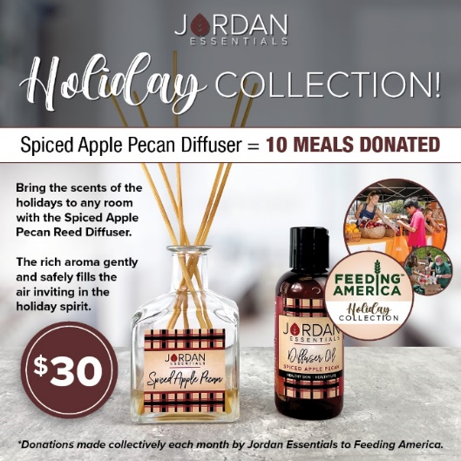
Pre Post  Say YES – To healthy products with healthy ingredients!  At Jordan Essentials our belief is that everyone deserves healthy skin—and joyful, healthy lives. When you say YES to Jordan Essentials products, you are saying YES to ingredients like magnesium, essential oils like lavender, purifiers like charcoal and rich moisturizers like shea butter.  Our products are made in fresh batches right in Nixa, MO. Delivered fresh from our manufacturing center to your doorstep! | 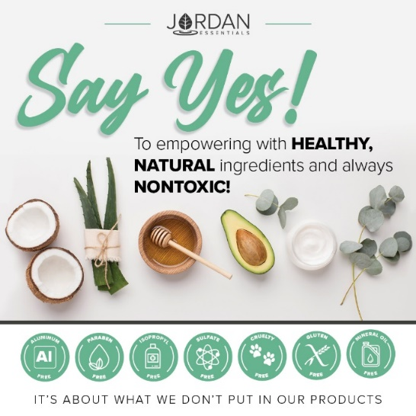
Pre-Party Post

And just as importantly, you will be saying NO to aluminum, parabens, mineral oil, SLS/SLES, gluten and phthalates that are found in many, if not most, bath, body and skincare products today.

If you want to read more, check out the Product Promise page on my website:

INSERT LINK HERE – Example:

https://XXXXXXX.jordanessentials.com/product-promise/
Pre-Party Post

Why is what’s in our products so important?

For two key reasons:

1. Our skin is our largest organ and what touches our skin affects all of our organs.

2. It takes just 26 seconds for what touches our skin to be absorbed into our bloodstream. The harmful effects of many chemicals used in skincare products are scary! And many include ingredients that prematurely age us or dry out our skin.

Jordan Essentials’ products use healthy, nontoxic ingredients combined to provide safe, healthy alternatives to their chemically-laden counterparts.

Pre-Party Post 4 (Day Before the Event):

Ready to Win?

If you are ready for some fun and some pampering tips, be sure to join our live event tomorrow at XXXX. We will be giving out virtual tickets for great prizes - the more tickets you earn, the more chances you have to win!

Not only do we provide natural and nontoxic solutions, but our products are also fun, pampering, and life-changing! Everyone needs and deserves pampering in their life. Right?

Who’s ready to win?
Pre-Party Post 5 (Morning of the Event):

Today’s the Day!!!

Join us TONIGHT at XXXX right here in this group for fun, connecting with friends, fabulous spa products, and some free giveaways!

Set an alarm on your phone, because everyone who responds during the live event gets extra chances to win!

Won’t be able to join the LIVE event or wondering how to order? Place your order anytime at ________ or contact me via messenger or phone to place your order or ask questions anytime!

30 Minutes Before:

Set A Reminder – We are Starting Soon!

The party starts in about 30 minutes! It is come-as-you-are so get comfy, grab a drink, get a pen and paper, and let’s get ready to party Facebook Style with Jordan Essentials! I am excited to share with Host’s friends who will be joining us tonight!

Comment below with an emoji or GIF that shows how excited you are for us to get started!

15 Minutes Before

Sharing Soap…and Sharing Hope!

I am so excited to be sharing Jordan Essentials with all of you! I am setting the mood for fun with our Blessed Candle.

Jordan Essentials candles are made with pure non-GMO soy wax. It melts clean and at a lower temperature than other traditional candles. The wick is made of pure cotton – no lead or metals!

The Blessed candle is the rich aroma of Chestnuts and Brown Sugar. Soothing and peaceful for long day too!
5 Minutes Before

Time sure flies by!

We will be starting in just a few minutes. During our party tonight, which will last about 45 minutes, be sure to refresh your screen often so you don’t miss anything such as chances to win our product drawing!

Tonight you’ll earn a ticket into the product prize drawing for every Like/Love, comment or question on the posts in our event!

Hint – Go live to kick off your party!
Post 1: Welcome

Welcome everyone! Both XXXX and I are so happy you could join us. We both love Jordan Essentials and are excited to share our favorite products with you. For inviting each of you and hosting our event, XXXX is receiving amazing perks from Jordan Essentials. Now tonight, when your wish list is bigger than your wallet, let me know and we can work together to make those wishes reality with free credits when you host too!

As we chat, feel free to comment, like and LOVE the posts. The more you do, the more chances you have to earn tickets. I’ll respond as quickly as I can to questions and if you have questions after, feel free to reach out directly on Messenger. Remember, refresh often, sit back and have fun!

Example:  No party is complete without prizes! If you win, I want to be sure I can connect with you. So, for your first 5 points, message me "Hello" at http://m.me/marian.smithje and then comment DONE below.  This takes them right to messenger without being friends!  You can find your profile name in the address bar when you are on your Facebook page.  You can post this as a pre-post also. | Use this tip and link anytime you want to get guests engaged with contacting you directly.
Roll Call – Who’s Here With Us!

Let’s start with an easy question and see who is here. Comment below letting us know where you are viewing from and your favorite fall activity is!

Comment with a gif for fun!

My Story POLL  That is so fun to see where everyone is watching from. I’m _________ and I am in ________.  Insert a sentence or two about your JE story. – | Insert a picture of YOU.
That’s my story, but I’d love to know more about YOUR story so I can best serve you tonight! Select any of these poll options that best describes you.

The JE Story

For those who have never heard of Jordan Essentials, it was started by Nancy Bogart in 2000. We are proud to be a woman-owned and “Made in America” company. All of our products are made with nontoxic ingredients and the healthiest ones available. We will feature a few of those products during this party.

If you HAVE heard of Jordan Essentials, go ahead and comment below with the products you have and love!

Ordering is Easy  There are two ways to order. Go to (enter party link) to shop OR contact me with your order or questions and I’ll place the order for you.  Remember, by commenting INTERESTED on any post, you’ll create a wish list for easy checkout at the end of our event! If you’ve read this post and are ready to get started, comment READY below! | 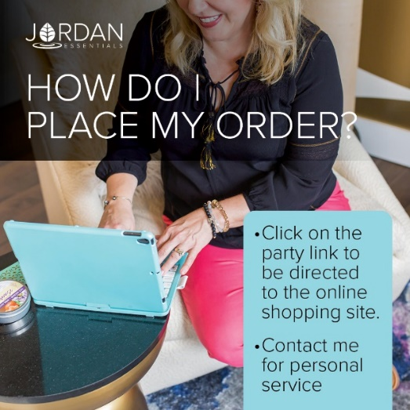
The Product that Started it All!  The Lotion Bar is a solid bar of lotion. It is made with beeswax to seal in the moisture and bonus – it doesn’t harbor bacteria – naturally!  Jordan Essentials is also fresh batch manufacturing. Meaning we are not mass-producing lotion bars that sit on a shelf for years!  They are hand-poured in our facility right here in Nixa, MO and then delivered right to you!  No cargo ships on the open seas for these! | 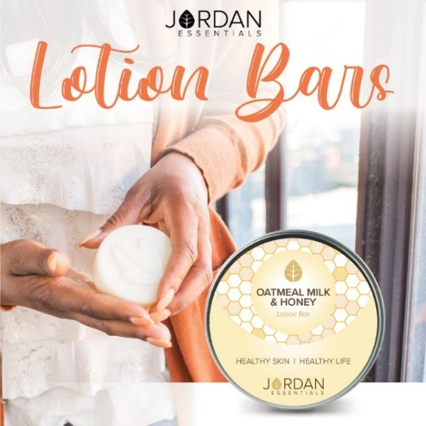
Perfect Stocking Stuffers

Lotion bars make excellent stocking stuffers! Our Oatmeal Milk and Honey is specially labeled for the Holiday Season!

It has a To/From label ready for gifting. Stock up on these for just $10 each. Have several on hand for those last minute gifts…and the ones on your list that weren’t listed!

Our Holiday Catalog also features the exclusive Resistance Lotion Bar. Five powerful essential oils make this immune-boosting bar a must have for the winter season.
And More Fragrances

What’s Your Fragrance?

In addition to our Resistance fragrance, Jordan Essentials offers Signature Fragrances plus Unscented in many of our products and collections.

Along with our most popular Oatmeal Milk & Honey, we offer have two that have been fan favorites since their release and our new Vanilla Pear.

Promise is a light citrus flower of sweet clementine and freesia flowers. One of our most popular fragrances.

Hope is our newest fragrance made with essential oils of lemon, lavender and rosemary. It is fresh and rejuvenating!

Vanilla Pear is a rich, warm and crisp scent perfect for the changing seasons.

Which fragrances are your favorite?

Collections Make Great Gifts!

Collections make great gifts! Jordan Essentials offers Bath & Body Collections that are ready for gifting. One great collection ready to gift is the Basic Collection.

This trio is everything you need to exfoliate, moisturize and protect your skin. The perfect set to start or to gift to a friend too!

The Premier Collection is five great products you can gift or mix and match for smaller gift sets.

Gifts Galore!
The November Joyful Jordan Box is packed with fun products. The box can be gifted as one box….or separated out into one…two…three or four gifts!
Pear Spice Soap is an exclusive french-milled soap.
What holiday box would be complete without Oatmeal Milk & Honey Shea Butter.
Cranberry Lip Butter protects and soothes lips.
The Brown Sugar & Fig Reed Diffuser adds a warm holiday fragrance to any room.
Holiday Scented Soap
Pear Spice Soap is an exclusive french-milled soap. Made with love in America, this soap’s scent is divine. The creamy rich lather softens and moisturizes as it cleanses too.
Perfect as a gift for your holiday host or partnered with another item or two such as Oatmeal Milk & Honey Shea Butter in the box or any Vanilla Pear item such as Vanilla Pear Shea Butter or a Mini Vanilla Pear Hand & Body Lotion.

Slather on the Shea Butter!  Another Joyful Jodan box goodie!  Shea butter is a fat extracted from the nut of the African shea tree.  🍃High in Vitamin A, benefits of shea butter to the skin include superior moisturizing capabilities, healing properties, and improving skin conditions.  It is a deeply penetrating and soothing lotion that soothes and moisturizes fall and winter skin. | 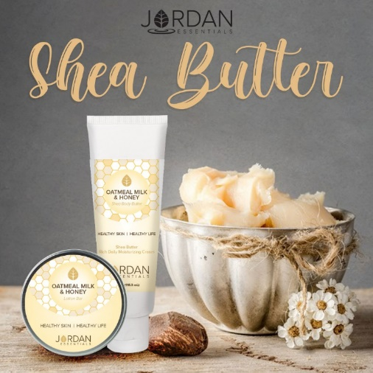
We Love Shea Butter!

Shea Butter is one of the most popular Jordan Essentials products. Shea butter is rich, moisturizing and non-greasy.

The customer special this month is an exclusive fragrance of Cranberry Orange Shea Butter.

With your $50 order, you can add on this November special for just $5 – a $15 Value.
Holiday Shea Butter Scents

For those that love holiday scents and shea body butters, the Holiday Trio is a wise choice.

Gift as the trio of Wintermint (Peppermint), Christmas Cookie (OMH) and Apple Cider.

These are also fun to gift individually with their festive labels!
Back to the Box

Cranberry Lip Butter protects and soothes lips. Healthy ingredients make it perfect for use throughout the day. Lightly scented with cranberry for the seasonal flair. Makes a great stocking stuffer.

Lip butter is creamy and smooth. It goes on with a smooth glide – no pulling or stretching the delicate skin on the lips.

It can be partnered up with other lip butters and our Lip Care Duo which includes the sugar-based Lip Exfoliant. It gently exfoliates dry skin revealing healthy lips
.
NOTE – If there is a weekly special partners with the box, you can insert it here.

Fill the Room with Aroma

The Brown Sugar & Fig Reed Diffuser adds a warm holiday fragrance to any room. Flip the reeds before the company arrives for a fresh burst of aroma. This one might just be a gift for yourself!

Reed diffusers are a great options to candles and electric diffusers. They can be left on a shelf and will lightly scent a room for several months. They are also great office companions on a desk.
Love Figs and Brown Sugar?

If you love the scent of brown sugar and figs, the Bath Bombs are da bomb!

Two bath bombs in this yummy fragrance are ready for gifting in an organa bag. They can also be separately gifting with another item or two.

These bath bombs are made with a propriety formula that makes them reusable. They are solid so they can be dropped in the bath for a minute or two and then removed. Store them in a baggie for another use or two.
Another Reed Diffuser Option

November introduced our new Feeding America Kitchen Collection. For November and December, Jordan Essentials will donate 10 emails for each Holiday Reed Diffuser purchased.

This reed diffuser comes with a heavy (solid) and beautiful glass jar and tall reeds to diffuser this warm, spiced scent.

It is the perfect room accent to create a holiday feeling.

Remember, just flip the reeds for a burst of scent!

Frankincense - The Traditional Holiday Fragrance

Frankincense was a special holiday gift and can be a special gift you give as Jordan Essentials has created three Frankincense boosted products and a special Frankincense Gift Set.

Complete Gift Set

Beautiful to wear year-round as your guiding star is the stunning North Star Necklace. This is only available with the purchase of the Frankincense Gift Set. This set includes Frankincense Skin Relief, Frankincense & Orange Magnesium Stick and the exclusive necklace. A wonderful gift for anyone on your list

Frankincense and Orange Stick

We LOVE our sticks! Jordan Essentials has a stick for just about everything and this is one I’ll call our Holiday Helper Stick! Frankincense and Orange Essential oils blend together to give you a warm, calm and uplifted feeling. Magnesium boosts our mood and can ease those little stresses too! The convenient stick is perfect for busy on-the-go moms, dads and kiddos this time of year. Pop one in a purse, backpack or pocket!

Exclusive Host Special

If you love Frankincense and Orange like I do, talk to me about booking your holiday party! This month only – we have the big bag of Dead Sea Salts in Frankincense and Orange!

Easy to book and earn this FREE!
3 Ways to Enjoy JE  Did you know there are 3 ways to get Jordan Essentials products in your home?  The first way is by placing an order on XXX party!  Remember you can message me too with questions or to book your party! | 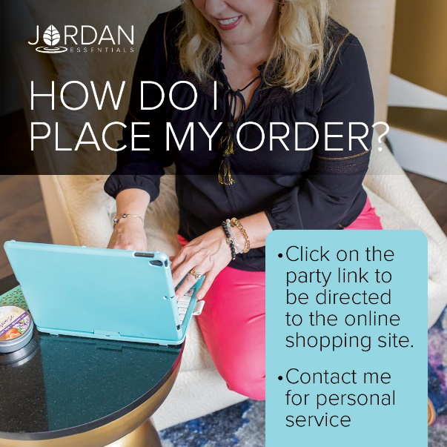
How about free?  The 2nd way to get JE products in your home is to become a host. We pamper our qualifying hosts with free products, ½ price items, a monthly special and more! I would love to share healthy, nontoxic products with your friends and family too and help you earn your favorite products for FREE.  In addition to the rewards mentioned above, our hosts receive a ½ price item for EVERY party booked from theirs!  We can do an online party like this one...or an in-person Spa Bar or even a Party On the Go. Let me know which would work for you. Comment which party type you are interested in below and I can answer any questions. When you select your date before _____ closes her party, she will receive credit for your booking.  In addition to face care, we can do theme parties, Magnesium Parties, Healthy Living Parties, Essential Oil parties and more! | Insert Host special  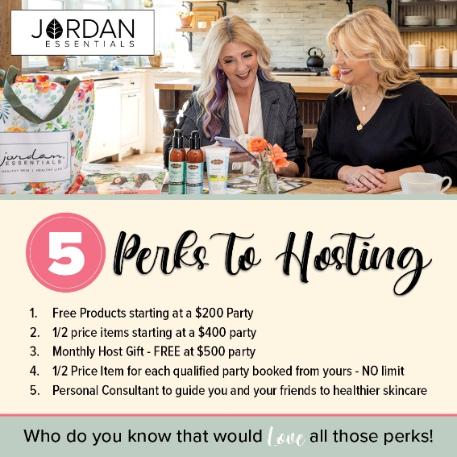
Enjoy it all…all the time!  Of course, if you were thinking, “I can do what she does!”, you are right! YOU can earn money by sharing healthy products with others too!  You can work this business online, part time or big time, the choice is yours! If you would like to learn more about starting your business, message me or type “Tell Me More” in the comments and I’ll send you some more information to look over and we can chat! | Insert Join Special
Be My VIP  We have so many products I didn’t get to share with all of you today, but great news! I have a VIP Facebook Group where I share valuable tips and information that focuses on Healthy Skin and a Healthy Life. Members also get access to promotions and notifications of special events! Go to _____________________(Insert VIP Group Link) and request to join for one final chance to win tonight’s drawing! | Link Displays image.
Wrap Up  I’m getting ready to gather all of the entries for our prize drawing! Want to make sure you didn’t miss a video or post? Click on PHOTOS or VIDEOS in this group to quickly jump to what you’re looking for!  Just a few reminders while I’m figuring out who our winner is tonight. If you would like to place your order directly, here is the party link:  If you would like me to contact you for your order, comment below and I will connect with you shortly.  We will be closing our party on…. (INSERT DATE AND TIME) | Link displays image
Thank YOU!  A big thank you to our host, ________, for getting everyone together for our fun online Spa Bar! You were an awesome host! And to every guest who participated, it was a pleasure having you. I hope you will join our mission of sharing Healthy Skin - Health Life.  Remember, you will want to place your order at _______ (insert party link) by ________ (close date) OR message me and I will review your wish list with you, answer your questions and get your order placed for you! Good night everyone! | 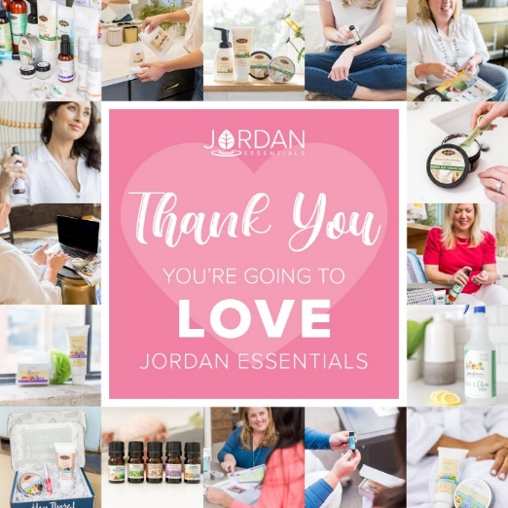
(The Next Morning)  Party Poll  Thank you all so much for attending live or viewing our online party! I had a great time sharing Jordan Essentials with all of you. Please take a minute to comment below with the letter that most describes you!  I look forward to continuing to serve you. Keep my contact information in your phone and stay connected with me in my VIP group at __________________.  Enjoy your new products and thanks again to _______, our awesome host!! | 