Countdown to Christmas –
Personalize and add emojis as you post and share.
12 Fridays Until Christmas  Holiday Tip - Start shopping now and tuck away small gifts for teachers, bus drivers, neighbors, nurses, and others.  It is always handy to have a few extra small gifts for those last-minute gift exchanges too!  The Oatmeal Milk and Honey Lotion bar is ready for gifting with a fillable tag right on the label. | October 8
11 Fridays Until Christmas  Raking leaves, fall sports and activities or after a day of shopping, a nice hot bath feels amazing after a long day!  Organic bath bombs are a healthy & fun gift for a holiday host this season too or special treat for yourself! | October 15
10 Fridays Until Christmas  Fall winds dry and chap our hands.  These adorable 1 oz Hand & Body Lotions are perfect stocking stuffers and handy for our purses now!  Boosted with Vitamin E and Vitamin B5, the non-greasy and healthy formula soothes, protects, and moisturizes.  🥰Choose from two fan favorite scents – Vanilla Pear or Oatmeal Milk and Honey – and grab up several for yourself and for gifts! | October 22
9 Fridays Until Christmas  Frankincense…not to be confused with Frankinstein….is the King of Essential Oils.  Frankincense is a traditional Christmas scent. It is also historically used for calming, in meditation and prayer time.  Grab one or both of these Frankincense-boosted favorites for your own stocking or to gift to a friend. | October 29
8 Fridays Until Christmas  Pamper your skin with this silky, smooth serum boosted with Frankincense Essential Oil.  Age Defying Serum contains ingredients proven effective on reducing wrinkles up to 84%.  Frankincense promotes healthy skin rejuvenation and relieves stress. Perfect for the holiday season! | November 5
7 Fridays Until Christmas  Peppermint is the star of the show in the Happy Feet Collection. Fresh and invigorating, Peppermint essential oil soothes achy muscles and wakes up tired toes!  Peppermint Foot Cream and Peppermint Pedistick are a great duo and are part of the special Happy Feet Holiday Collection which includes Peppermint Foot Scrub and a cozy pair of Jordan Essentials Spa Socks. | November 12  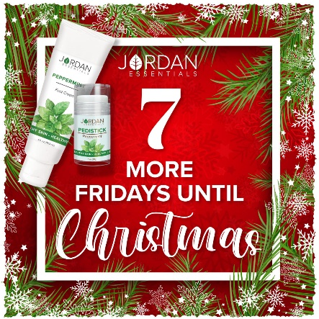
6 Fridays Until Christmas  Three amazing shea butters! This trio of shea butters is a perfect gift as one or as three individual gifts.  Bright labels add to the festive scents of Wintermint - uplifting peppermint, Apple Cider - warm and inviting, and Christmas Cookie - like a fresh cookie straight from the oven.  Shea butter is rich, creamy and ultra-moisturizing for dry winter skin. It is easily absorbed and non-greasy too!  Stock up for stocking stuffers with a trio or two! | November 19
5 Fridays Until Christmas  Lotions with a purpose! Practical gifts are in this year!  Skin Relief is lovingly referred to as "Momma's Best Friend". Botanically based, unscented and packed with the power of Green Tea, Aloe, Seaweed, and Chamomile it is amazing on sunburns, windburns, dry skin, scrapes, and more!  Great gift for the moms and dads on your gift list this year. | November 26
4 Fridays Until Christmas  Don’t let sore muscles and joints hold you back from enjoying winter activities.  Magnesium helps sore, tired muscles, achy joints, promotes better sleep and can increase your overall well-being.  “The Blue Stick” is a fan favorite with all the benefits of Magnesium plus 5 essential oils. Don’t be stuck without a stick!  The gift of magnesium is a gift of wellness! | December 3
3 Fridays Until Christmas  Lay back and relax after a long day at work or prepping for the holidays. Dead Sea Salt Soaks contain healthy minerals boosted with extra magnesium for soothing muscles and soaking away stresses!  Dead Sea Salts come pre-scented or unscented. With unscented Dead Sea Salts you can add essential oils of your choice to make it a more personal experience.  Add lavender for relaxation, orange for uplifting or frankincense for calming.  Stock up salts for the holiday and for gifting too! | December 10  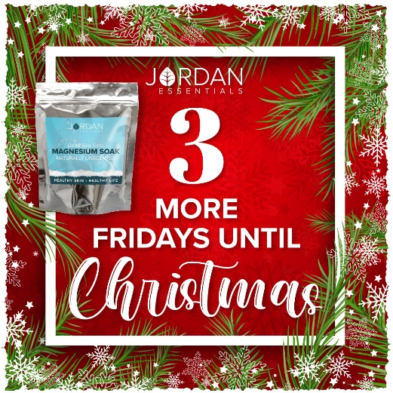
2 Fridays Until Christmas  Pretty soaps can be healthy too!  Plant-based 🌿 glycerin soaps can help lock in your skin’s natural moisture and prevent over-drying. They do not use harsh chemicals which are often detergents!  In addition to helping hydrate skin, glycerin is also non-greasy. It is an ideal choice for those with normal, oily, or combination skin. 🛀  🧼 It is safe for facial use and may help even out skin tone and reduce the appearance of fine lines and wrinkles.  Packed in a convenient travel case, Jordan Essential glycerin soaps are perfect traveling companions and stocking stuffers too! | December 17
1 Friday Until Christmas  ‘Twas the night before Christmas and all through the house wonderful aromas filled the air with diffusing a must!  Essential oil droppers are 100% pure essential oils. JE chooses essential oils that are ethically produced and that are produced without harmful chemical fertilizers or pesticides.  Choose from Blender Buddies, blends and single essential oil droppers to fill your home with natural, healthy aromas supporting wellness. | December 24

