Ho ho ho…Happy Holidays! It is not too early to start thinking about holiday gifts for friends, family and yourself! This holiday season give healthy, nontoxic gifts that fit under the tree or in a stocking…or even your purse for everyday use now! | 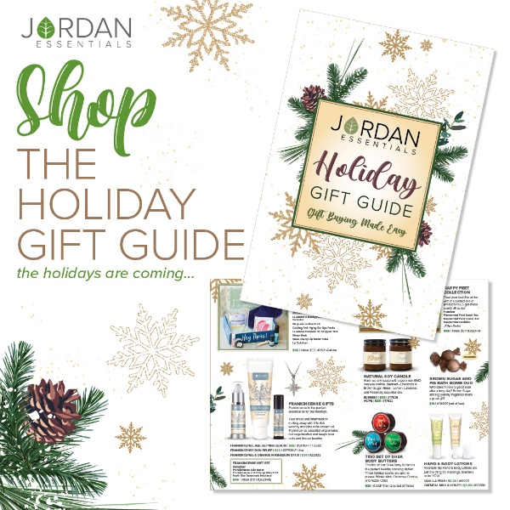
The Resistance Lotion bar is a seasonal favorite. Packed with 5 powerful essential oils, it’s the healthy way to maintain wellness. With all the handwashing we are still doing, lotion bars seal in moisture with beeswax and do not harbor bacteria. Great for purse, backpack, and on the desk.  Available with a special gift tag label so no wrapping needed is our fan favorite Oatmeal Milk and Honey Lotion Bar. Think about teachers, nurses and office workers too! | 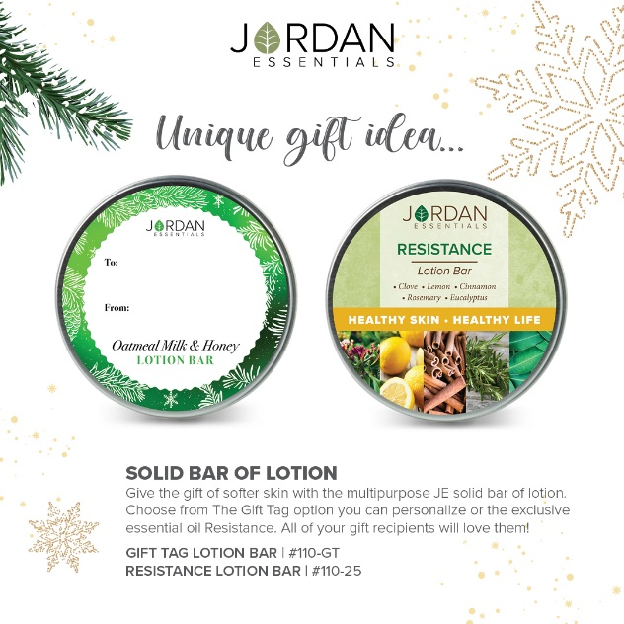
Another must-have for handwashing season are these adorable 1 oz Hand & Body Lotions. A smooth, soothing and easy-to-absorb formula is non-greasy and smells amazing. Boosted with Vitamin E and Vitamin B5 it protects against those free radicals that can make our hands look older than they are! Choose from two fan favorite scents – Vanilla Pear or Oatmeal Milk and Honey. | 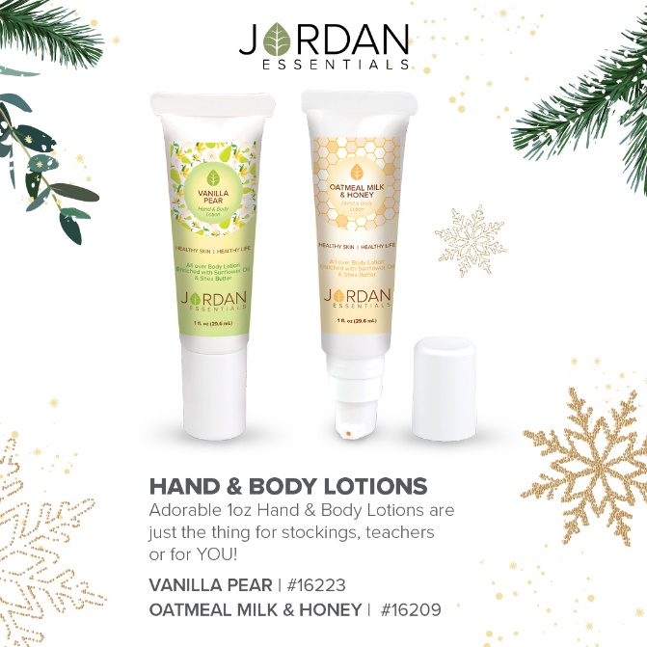
Full-size products make great gifts too! Our Hand & Body Lotion is available in all 6 of our signature fragrances. Buy one for the office and one for the nightstand too! | 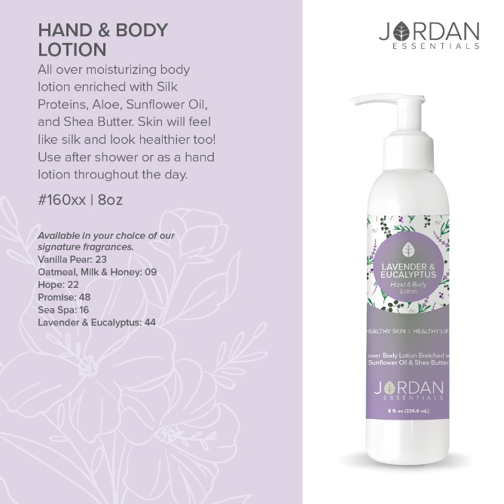
From hands to feet, we got you covered. Our Happy Feet Collection is a gift you will want to keep! Drier fall and winter air, stuffy shoes and boots are hard on our feet. This collection is spa treatment for your feet in the comfort of your home! Foot Scrub to slough off dry skin, foot cream to soften and moisturize and a Pedistick for an extra boost and to seal in the goodness! Soak it all in and be comfy with cozy JE socks after!

Why Peppermint? Peppermint is an essential oil known for its invigorating aroma and a cooling sensation that soothes fatigued muscles. It wakes up tired feet and eases aches and pains. | 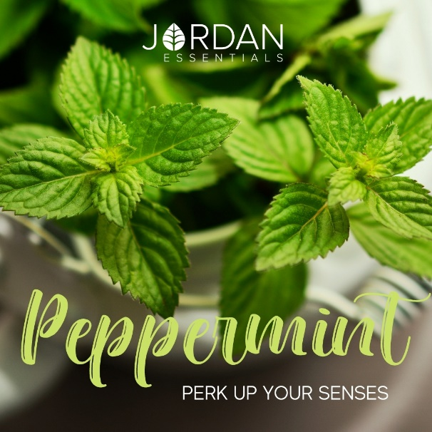
Rich, thick, shea butter! Deeply moisturizing for even the driest skin, shea butter is a year-round favorite. High in Vitamin A, shea butter has superior moisturizing capabilities, healing properties, and supports overall healthy skin. Just in time for the holiday, we have this trio of shea body butters in three yummy scents. Wintermint, known for its bold, airway clearing aroma. Christmas Cookie, warm, soothing and just like Grandma’s kitchen! And crisp, bright, home for the holidays, Apple Cider. Grab a couple of sets to gift or to break up for smaller gifting as well. | 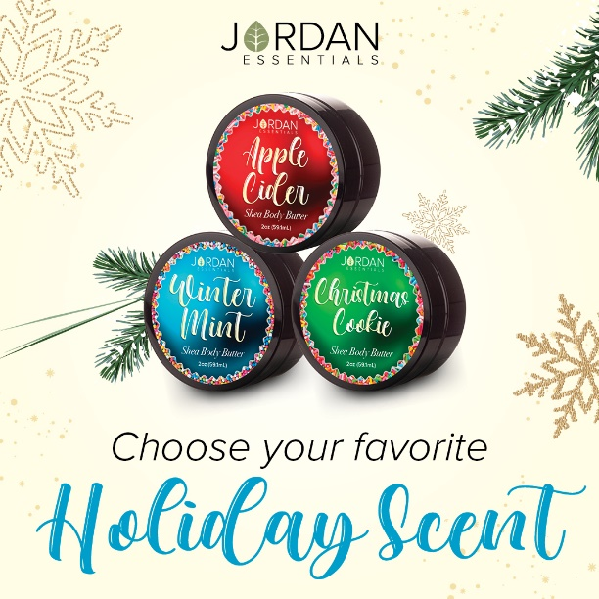
Raking leaves, fall sports and activities or maybe you are out shopping, a nice hot bath feels amazing after a long day! Surround yourself with the yummy fragrance of Brown Sugar and Fig with this organic bath bomb duo. A fun gift for a holiday host this season too or special treat for yourself!

Brown sugar is a scent of the holiday season. For this holiday season, enjoy a natural soy candle scented with Chestnuts and Brown Sugar. JE’s Blessed candle is made with pure non-GMO soy wax and a cotton wick for clean burning. If you are looking for something with uplifting notes, the Hope candle is a fan favorite with essential oils of Lemon, Lavender & Rosemary. | 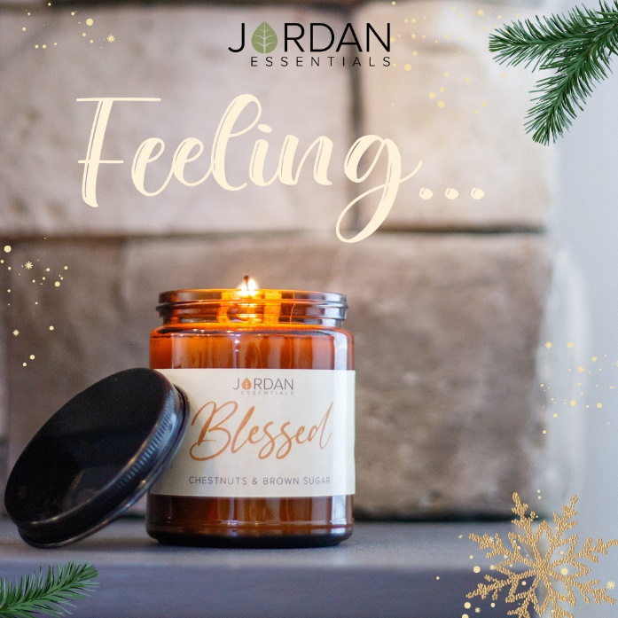
Speaking of essential oils, truly the oil of the holidays is Frankincense. It was a special gift and can be a special gift you give as Jordan Essentials has created three Frankincense boosted products and a special Frankincense Gift Set. | 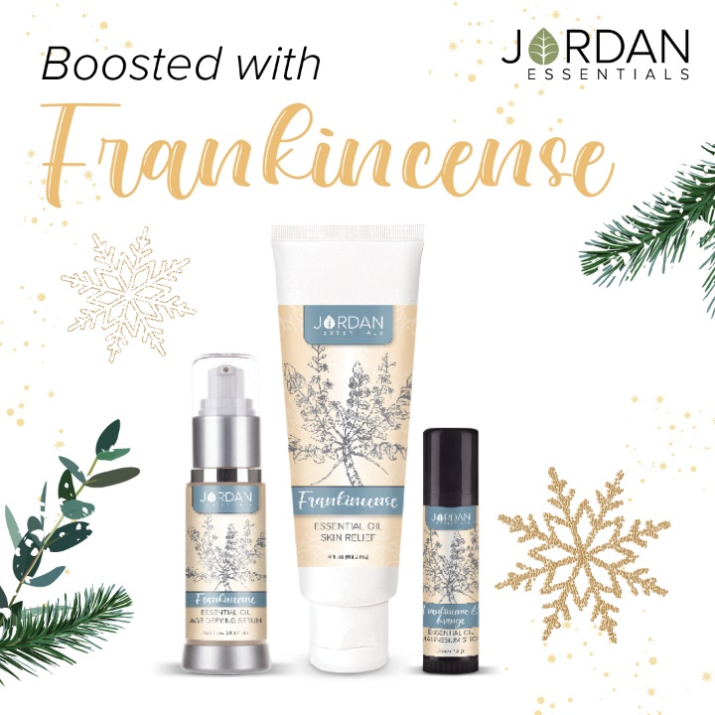
Keeping our skin healthy is one of the main keys for looking younger! Age Defying Serum contains ingredients proven effective on reducing wrinkles up to 84%. We have boosted that with the natural age-defying benefits of Frankincense Essential Oil. It is a silky smooth serum you will want to use morning and night because it just feels so good! | 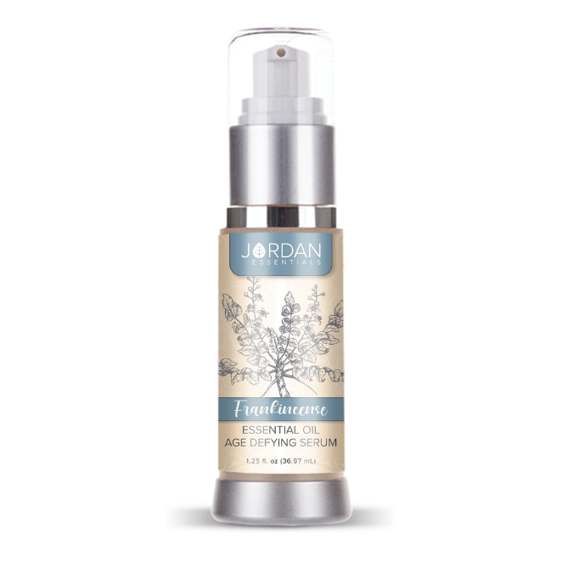
We LOVE our sticks! Jordan Essentials has a stick for just about everything and this is one I’ll call our Holiday Helper Stick! Frankincense and Orange Essential oils blend together to give you a warm, calm and uplifted feeling. Magnesium boosts our mood and can ease those little stresses too! The convenient stick is perfect for busy on-the-go moms, dads and kiddos this time of year. Pop one in a purse, backpack or pocket! | 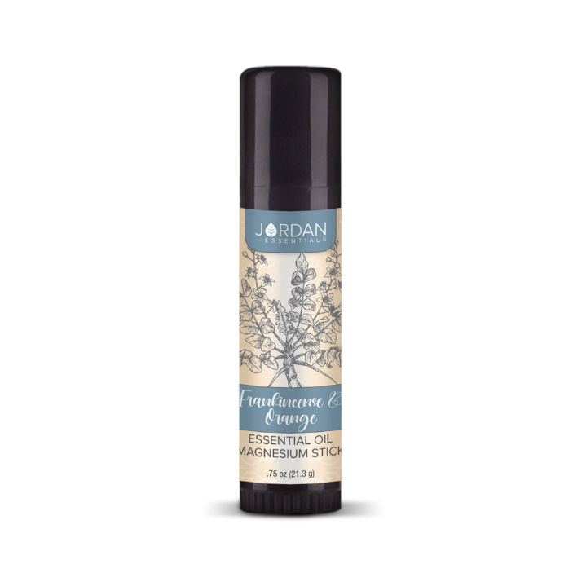
Skin Relief has been a must-have for several years. It is one of our top selling products. And…this has been kicked up a notch for the holiday season as well. Skin Relief with Frankincense is the ultimate in skincare care! Skin Relief is botanically based packed with the power of Green Tea, Aloe, Seaweed and Chamomile. Frankincense takes it even deeper to aid in soothing and supporting skin’s natural healing abilities. | 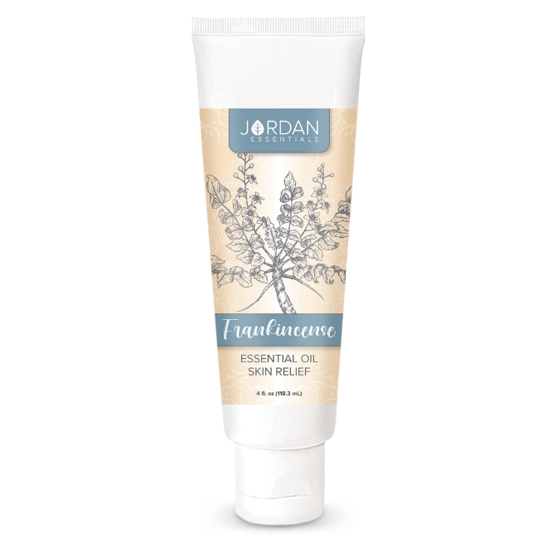
Beautiful to wear year-round as your guiding star is the stunning North Star Necklace. This is only available with the purchase of the Frankincense Gift Set. This set includes Frankincense Skin Relief, Frankincense & Orange Magnesium Stick and the exclusive necklace. A wonderful gift for anyone on your list

