Copy Paste Facebook Party –Perk Up Your Fall
There is a collection of 10 Coffee Fun Facts that you can incorporate into this party. They are located in the Album in the FB Resources Group and in JEU.
Template Tip: Do not copy and paste comments in red that you see at the top of each post. Just copy the text under each post title. Paste it into Facebook and then publish or schedule to your group. Be sure to personalize the post with specific info for your party and to meet your personality.
Be sure to change out the Weekly Special and go Live to launch and close your party. Engagement with your guests is key. Host coach and have your host post a couple of posts as well. Additional engagement posts can be found in the JEU >> Media Center.
Posts can be posted 3-4 over the course of three days or posted 3-5 minutes apart during a 45 minute party. You can kick off a party with a LIVE in Facebook and then end with a live as well.
Insert emojis to make the posts festive and fun. Posts can also be used as stand alone posts on your business page, Instagram and personal profile.
Banner option for top of group
Pre-Party Posts  Pre-Party Post 1 (Mark as Announcement):  Welcome to our Perk Up Your Fall party!  Your host, XXXX, and I are looking forward to having a fun time together online as we share products that support your self-care and our changing skin care needs as we head into fall.  Here’s how it works:  Check out the posts below to learn more about Jordan Essentials and join us here in this group on XXXX (date) at XXXX (time). You’ll receive chances to win fun prizes for commenting below to RSVP, for joining us on time, for participating in the event, and more!!  If you’d like to check out what Jordan Essentials has to offer, check out our online catalog at https://bit.ly/JEFall2021  You can place an order on XXXX’s party anytime before XXXX by going to: (insert party link).  As your JE consultant I’m available to answer any questions so reach out to me anytime in a personal message or call/text me at ______ (insert phone number)  Have someone who would like to join us? Share the link to this group and they can request to join!  I look forward to seeing everyone on ________ at _____!! Comment below if you will be joining us for a chance to win our prize drawing!! | Catalog Preview shows link when posted.
Pre Post  Feeding America -- Filling Fall Pantries  September is Hunger Action Month. It is a push month to help fill food banks and pantries with much-needed supplies for the fall and winter months. This year with the pandemic not behind us and devastating weather across the south and northeast, the need continues to rise.  Jordan Essentials continues to support Feeding America. | INSERT CURRENT WEEKLY TOTAL GRAPHIC HERE
Pre Post  The Kitchen Collection  Jordan Essentials has enhanced donations this fall with the Kitchen Collection. Each product individually purchased donates 10 meals and the collection donates 20 meals.  The Kitchen Collection features our healthy for the hands Foaming Hand Wash in fresh lemon scent and our soothing Hand & Body Lotion in lemon too!  Grab a collection for you and one for a friend and help feed America this fall. | 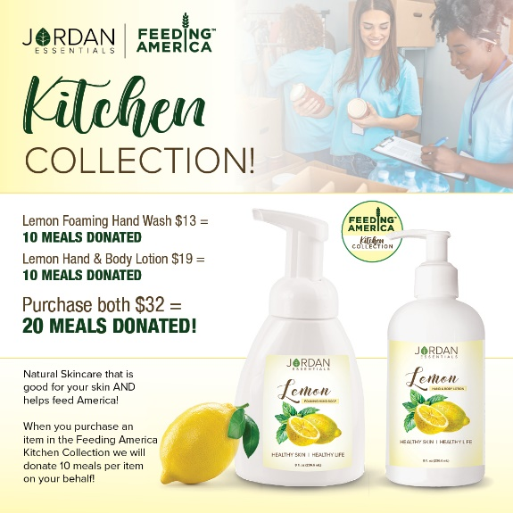
A little about our Foaming Hand Soap  Jordan Essentials Foaming Hand Soap is a rich, moisturizing soap made with healthy ingredients. Its soft, silky lather feels like a mini pampering session every time you wash your hands!  Free from DEA, SLS and parabens, JE Foaming Hand Soap is safe for the entire family.  In addition to the lemon scent, you can also choose your favorite scent from our signature fragrances. Maybe its classic Oatmeal Milk & Honey or, our fall favorite Vanilla Pear or the ultimate powerhouse Resistance!  (More about Resistance later!) | 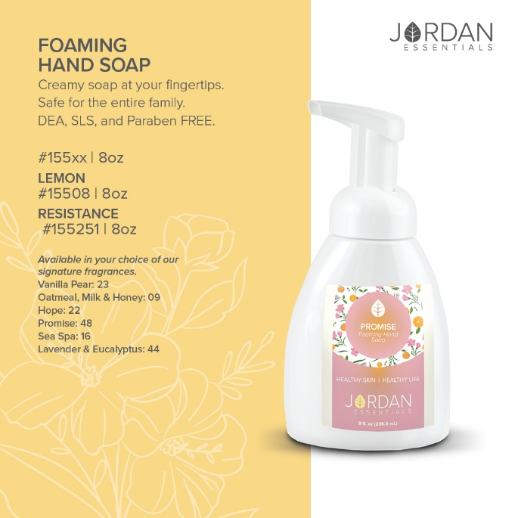
Pre Post  Say YES – To healthy products with healthy ingredients!  At Jordan Essentials our belief is that everyone deserves healthy skin—and joyful, healthy lives. When you say YES to Jordan Essentials products, you are saying YES to ingredients like magnesium, essential oils like lavender, purifiers like charcoal and rich moisturizers like shea butter.  Our products are made in fresh batches right in Nixa, MO. Delivered fresh from our manufacturing center to your doorstep! | 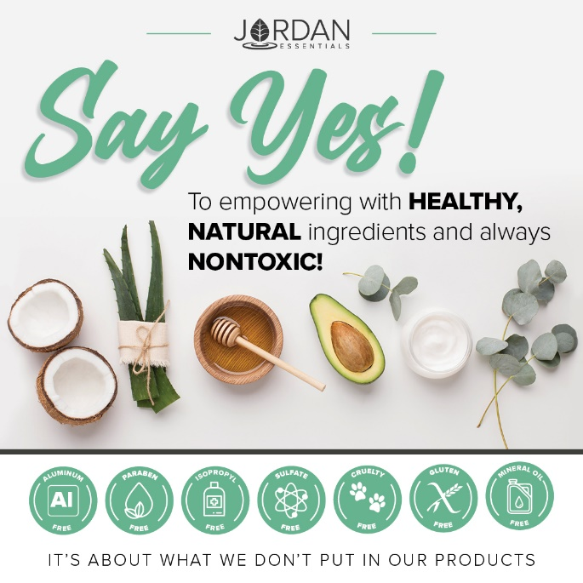
Pre-Party Post  And just as importantly, you will be saying NO to aluminum, parabens, mineral oil, SLS/SLES, gluten and phthalates that are found in many, if not most, bath, body and skincare products today.  If you want to read more, check out the Product Promise page on my website:  INSERT LINK HERE – Example:  https://XXXXXXX.jordanessentials.com/product-promise/ | 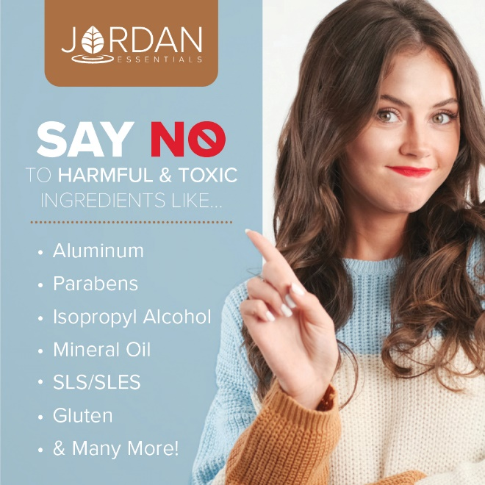
Pre-Party Post  Why is what’s in our products so important?  For two key reasons:  1. Our skin is our largest organ and what touches our skin affects all of our organs.  2. It takes just 26 seconds for what touches our skin to be absorbed into our bloodstream. The harmful effects of many chemicals used in skincare products are scary! And many include ingredients that prematurely age us or dry out our skin.  Jordan Essentials’ products use healthy, nontoxic ingredients combined to provide safe, healthy alternatives to their chemically-laden counterparts. | 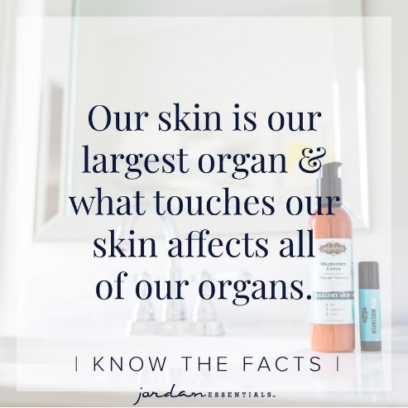
Pre-Party Post 4 (Day Before the Event):

Ready to Win?

If you are ready for some fun and some pampering tips, be sure to join our live event tomorrow at XXXX. We will be giving out virtual tickets for great prizes - the more tickets you earn, the more chances you have to win!

Not only do we provide natural and nontoxic solutions, but our products are also fun, pampering, and life-changing! Everyone needs and deserves pampering in their life. Right?

Who’s ready to win?
Pre-Party Post 5 (Morning of the Event):

Today’s the Day!!!

Join us TONIGHT at XXXX right here in this group for fun, connecting with friends, fabulous spa products, and some free giveaways!

Set an alarm on your phone, because everyone who responds during the live event gets extra chances to win!

Won’t be able to join the LIVE event or wondering how to order? Place your order anytime at ________ or contact me via messenger or phone to place your order or ask questions anytime!

30 Minutes Before:

Set A Reminder – We are Starting Soon!

The party starts in about 30 minutes! It is come-as-you-are so get comfy, grab a drink, get a pen and paper, and let’s get ready to party Facebook Style with Jordan Essentials! I am excited to share with Host’s friends who will be joining us tonight!

Comment below with an emoji or GIF that shows how excited you are for us to get started!

15 Minutes Before  Sharing Soap…and Sharing Hope!  I am so excited to be sharing Jordan Essentials with all of you! I am setting the mood for fun with our Hope Aromatherapy Candle.  Jordan Essentials offers 100% pure, ethically-produced essential oils.  For the burst of energy and excitement, I am using our new HOPE Candle!  Later tonight when I am ready to wind down, I’ll be using our Orange Lavender Blender Buddy in the unscented shea butter for a relaxing foot massage! It is also a great combo to diffuse for the kiddos!  We are offer a fabulous collection of essential oils Perfect for mixing and matching with our unscented products too! | 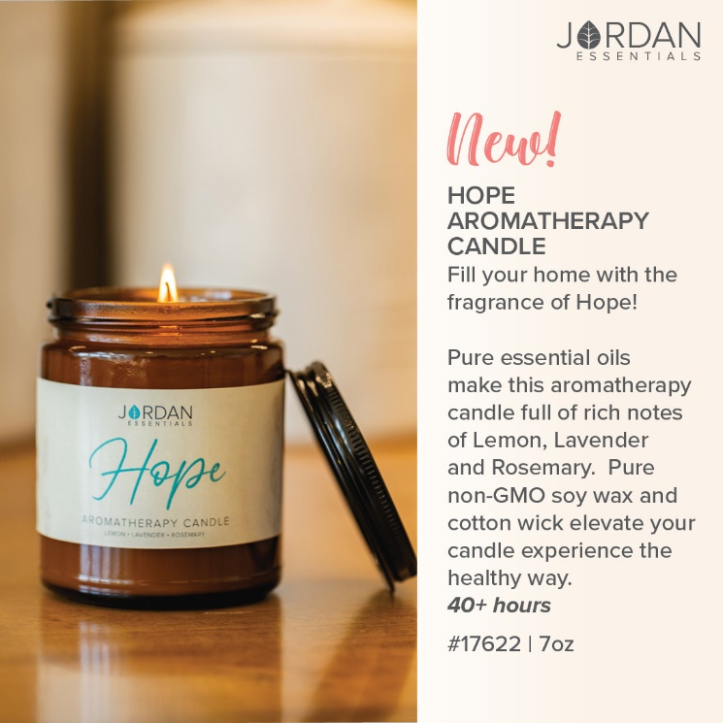
Speaking of Foot Massage…  One of my favorite new fall products is the Peppermint Foot Cream! Rich shea butter enhanced with Peppermint Essential Oil wakes up tired toes and feet and soothes them too!  Great for before and after hiking, raking and other fall activities.  To seal in moisture or just before a long day on your feet, grab the Peppermint Pedistick for that boost of energy. It also makes a great traveling companion or tucked away in a workout bag! | 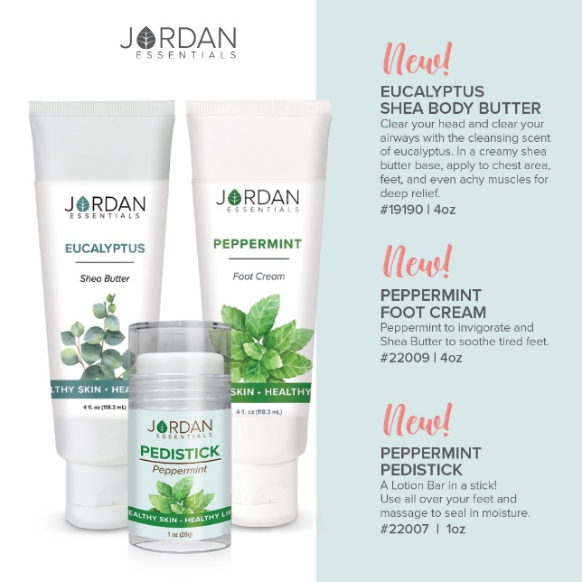
5 Minutes Before

Time sure flies by!

We will be starting in just a few minutes. During our party tonight, which will last about 45 minutes, be sure to refresh your screen often so you don’t miss anything such as chances to win our product drawing!

Tonight you’ll earn a ticket into the product prize drawing for every Like/Love, comment or question on the posts in our event!

Hint – Go live to kick off your party!
Post 1: Welcome  Welcome everyone! Both XXXX and I are so happy you could join us. We both love Jordan Essentials and are excited to share our favorite products with you. For inviting each of you and hosting our event, XXXX is receiving amazing perks from Jordan Essentials. Now tonight, when your wish list is bigger than your wallet, let me know and we can work together to make those wishes reality with free credits when you host too!  As we chat, feel free to comment, like and LOVE the posts. The more you do, the more chances you have to earn tickets. I’ll respond as quickly as I can to questions and if you have questions after, feel free to reach out directly on Messenger. Remember, refresh often, sit back and have fun! | 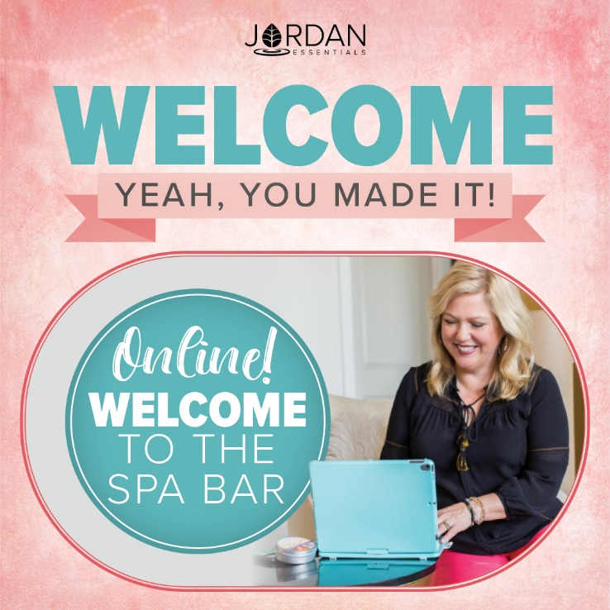
Example:  No party is complete without prizes! If you win, I want to be sure I can connect with you. So, for your first 5 points, message me "Hello" at http://m.me/marian.smithje and then comment DONE below.  This takes them right to messenger without being friends!  You can find your profile name in the address bar when you are on your Facebook page.  You can post this as a pre-post also. | Use this tip and link anytime you want to get guests engaged with contacting you directly.
Roll Call – Who’s Here With Us!

Let’s start with an easy question and see who is here. Comment below letting us know where you are viewing from and your favorite fall activity is!

Comment with a gif for fun!

Flat Nancy!  WooHoo….Nancy Bogart is here with us! | Incorporate the Flat Nancy promo here.
My Story POLL  That is so fun to see where everyone is watching from. I’m _________ and I am in ________.  Insert a sentence or two about your JE story. – | Insert a picture of YOU.
That’s my story, but I’d love to know more about YOUR story so I can best serve you tonight! Select any of these poll options that best describes you. | 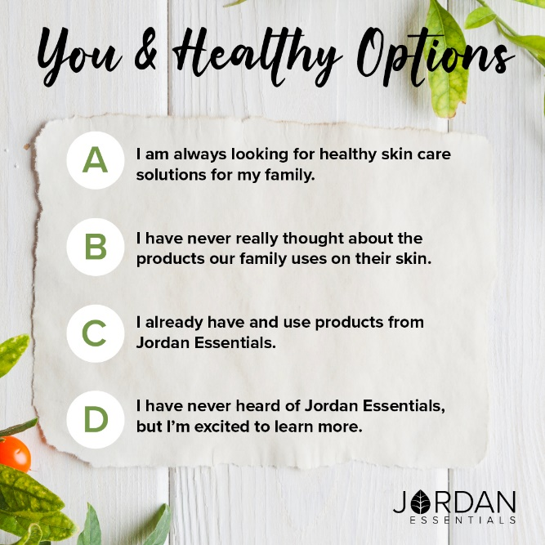
The JE Story

For those who have never heard of Jordan Essentials, it was started by Nancy Bogart in 2000. We are proud to be a woman-owned and “Made in America” company. All of our products are made with nontoxic ingredients and the healthiest ones available. We will feature a few of those products during this party.

If you HAVE heard of Jordan Essentials, go ahead and comment below with the products you have and love!

Ordering is Easy  There are two ways to order. Go to (enter party link) to shop OR contact me with your order or questions and I’ll place the order for you.  Remember, by commenting INTERESTED on any post, you’ll create a wish list for easy checkout at the end of our event! If you’ve read this post and are ready to get started, comment READY below! | 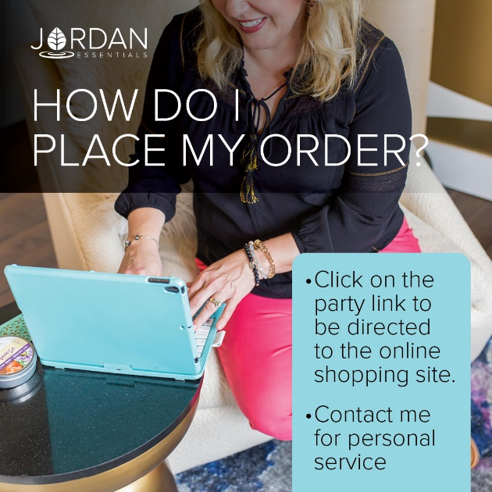
The Product that Started it All!  The Lotion Bar is a solid bar of lotion. It is made with beeswax to seal in the moisture and bonus – it doesn’t harbor bacteria – naturally!  Jordan Essentials is also fresh batch manufacturing. Meaning we are not mass-producing lotion bars that sit on a shelf for years!  They are hand-poured in our facility right here in Nixa, MO and then delivered right to you!  No cargo ships on the open seas for these!  Special Lotion Bar – Don’t Miss Out On This One!  ‘Tis the season for colds and more! Build up your resistance with these 5 power essential oils in a Customer Exclusive special.  The Resistance Lotion bar is just $5 with a $50 purchase … this month only. The Resistance Lotion Bar is only available as the customer special.  It contains 5 essential oils – clove, lemon, rosemary, cinnamon, and eucalyptus – in our lotion bar base. | 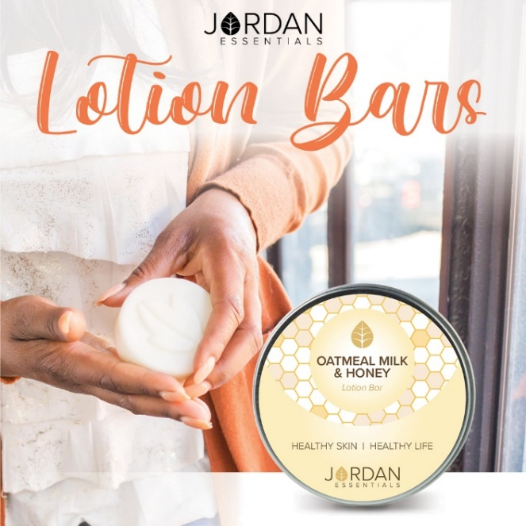
Another Fall Exclusive - Joyful Jordan Box  Exclusives are falling like leaves this month! The September Joyful Jordan box features favorite products in a warm, light fall scent of coffee and café latte!  Glycerin soap, Caffeine scrub, and Cafe Latte shea butter cleanse, polish, and moisturize summer skin as we transition into dryer fall air.  Great for gifting! Stock up now!  My monthly Joyful Jordan box subscribers enjoy getting the box with FREE shipping. | 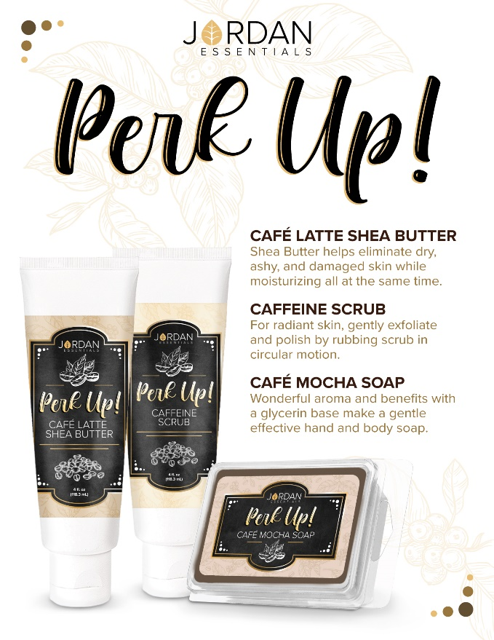
Why a Glycerin Soap?  Glycerin is a healthy, effective ingredient that is plant-based!  Plant-based 🌿 glycerin soaps, shampoos, and body washes can help lock in your skin's natural moisture and prevent over-drying. This is very important during the warmer summer months!  JE Glycerin Soaps do not use harsh chemicals, which are often detergents!  In addition to helping hydrate skin, glycerin is also non-greasy. It is an ideal choice for those with normal, oily, or combination skin. 🛀  🧼 It is safe for facial use and may help even out skin tone and reduce the appearance of fine lines and wrinkles. | 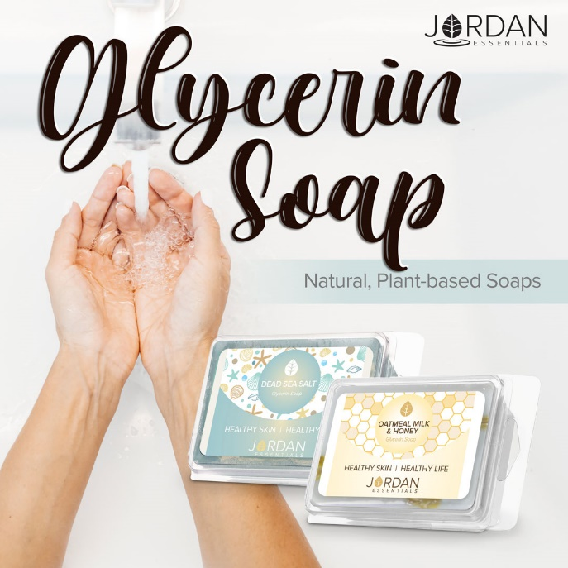
Slather on the Shea Butter!  Shea butter is found in many JE products inlcuing our Shea Body Butters, Hand & Body Lotions, Helio Superfood Skin Lotion, and Skin Relief Lotion.  Shea butter is a fat extracted from the nut of the African shea tree.  🍃High in Vitamin A, benefits of shea butter to the skin include superior moisturizing capabilities, healing properties, and improving skin conditions.  It is a deeply penetrating and soothing lotion that soothes and moisturizes fall and winter skin.  The caffe latte shea butter in the Joyful Jordan box as the light, warm fragrance of a hot latte on a brisk fall day! | 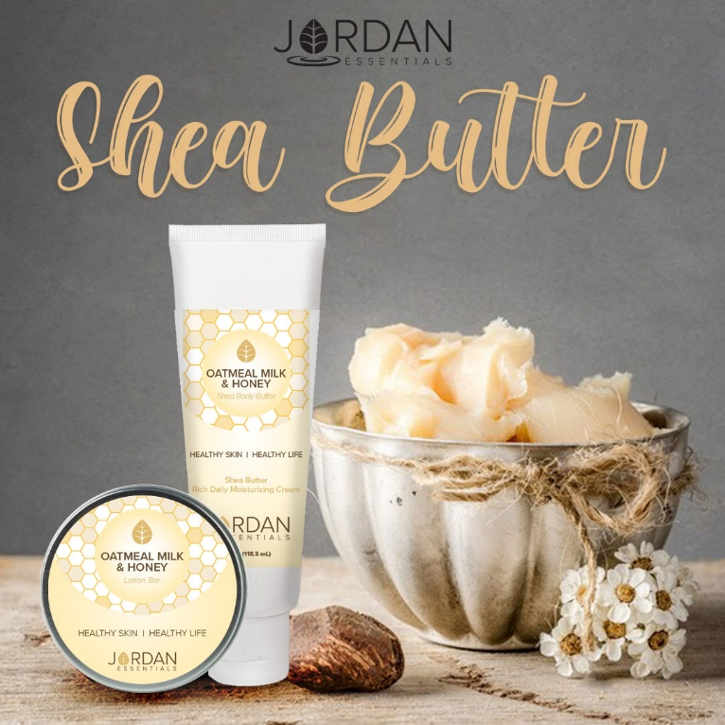
Perk Up the Scents and Skin with a Caffeine Scrub  As the seasons change from summer to fall, we need to slough off summer skin to reveal new, fresh skin cells.  Caffeine Scrub is a gentle scrub with jojoba and walnut shells to exfoliate dry skin. The boost of caffeine stimulates blood flow to increase circulation and improve the appearance of fine lines and wrinkles. This is excellent for the thighs and upper arms! | 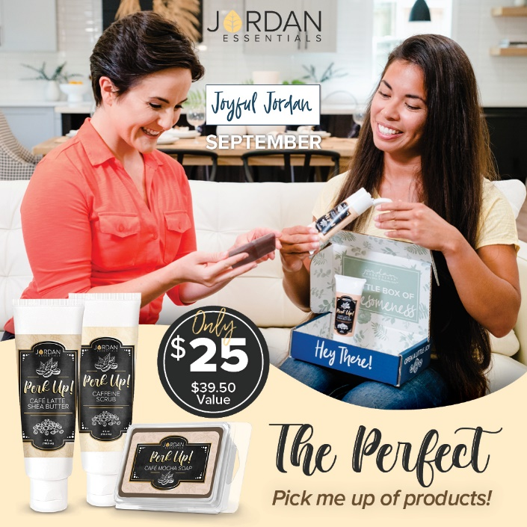
NOTE – If there is a weekly special partners with the box, you can insert it here.

You can also insert the Customer Special here also.
What’s Your Fragrance?  In addition to our special fragrances, Jordan Essentials offers Signature Fragrances plus Unscented in many of our products and collections.  Along with our most popular Oatmeal Milk & Honey, we offer have two that have been fan favorites since their release and our new Vanilla Pear.  Promise is a light citrus flower of sweet clementine and freesia flowers. One of our most popular fragrances.  Hope is our newest fragrance made with essential oils of lemon, lavender and rosemary. It is fresh and rejuvenating!  Vanilla Pear is a rich, warm and crisp scent perfect for the changing seasons.  Which fragrances are your favorite? | 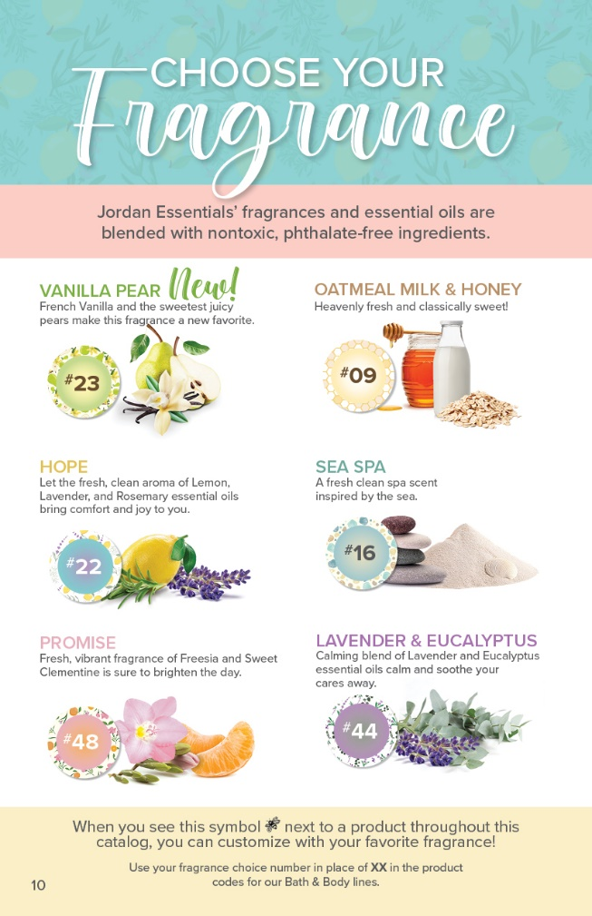
NOTE – If there is a weekly special featuring a scent, insert it here.
Layering on the Fragrances  Jordan Essentials offers healthy products to from head to toe! One great way to enjoy your favorite fragrance is through layering!  Our Bath and Body Collections provide the ultimate everyday pampering!  Soak, cleanse, exfoliate, moisturize, protect, and nourish your skin.  If you see several of the items on your list, the collection is the best way to go! | 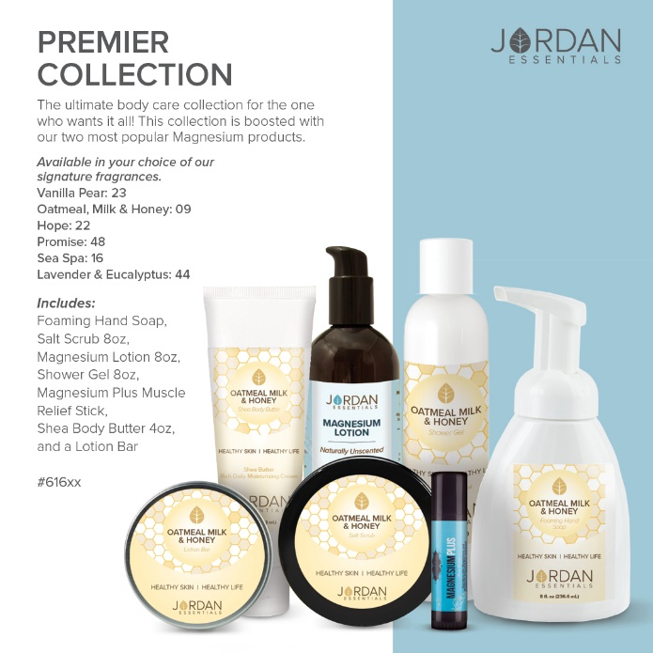
Keeping Active!  I noticed several of you love fall activities. I am guessing you don’t like the aches and pains that might go along with them!  I don’t either! That is why I love our Magnesium products! | 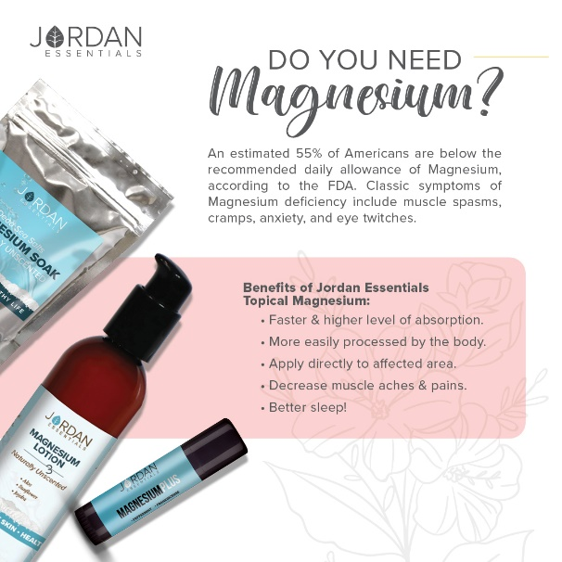
Magnesium is amazing!  Magnesium is the fourth most abundant mineral in the body, and your body naturally absorbs it through the foods you eat.  But, we don't always eat right...and our foods may not contain the vital nutrients we need.  Magnesium is responsible for over 300 essential metabolic functions! Everything from energy production, to nerve and muscle function, to healthy bones and teeth, and so much more!  Topical application (Transdermal absorption) can help fill the gap! | 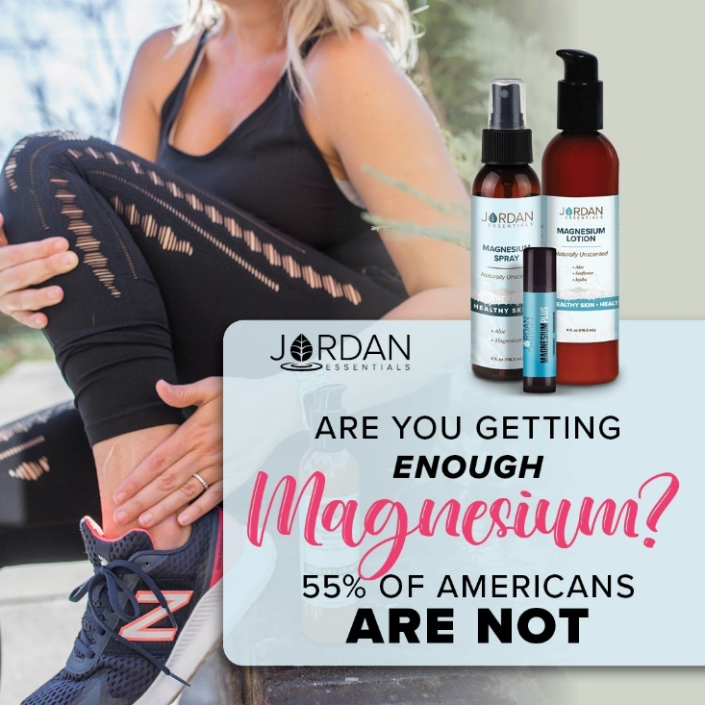
Let's start talking about Magnesium Lotion!  Did you know 55% of America’s are deficient in magnesium?  Our topical magnesium lotion comes both with and without peppermint essential oil and is made with healthy ingredients like aloe, sunflower oil and jojoba oil along with magnesium.  These ingredients have been shown to help relieve those minor aches and pains, muscle spasms, eye twitches and support the body’s need for magnesium.  How many of you or someone you love suffers from occasional leg cramps, muscle spasms like eye twitches, or achy, sore muscles? | 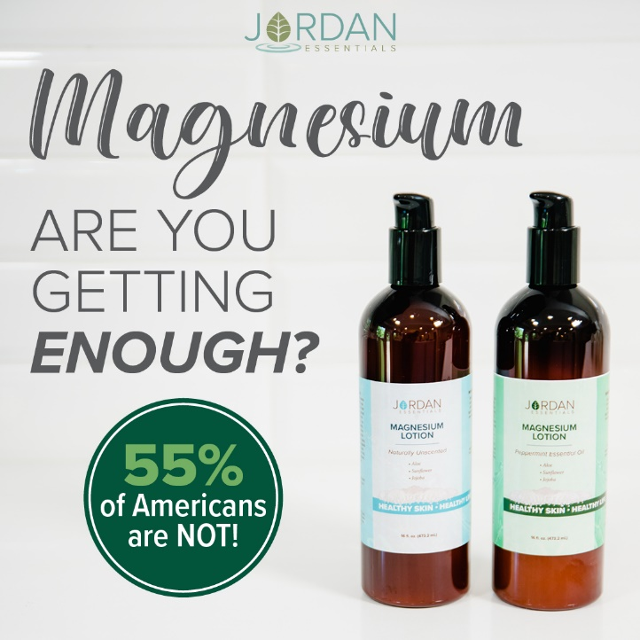
Core 4 Starter System  If you are new to JE or new to magnesium, the Core 4 Starter System is a must-have combo!  Core 4 includes your choice of unscented or peppermint magnesium lotion, a magnesium stick, lotion bar, plus Skin Relief to soothe and care for even the driest skin.  Not only is this bundle a significant savings, but it makes you an instant qualifier for this month’s guest special of our Resistance Lotion Bar. | 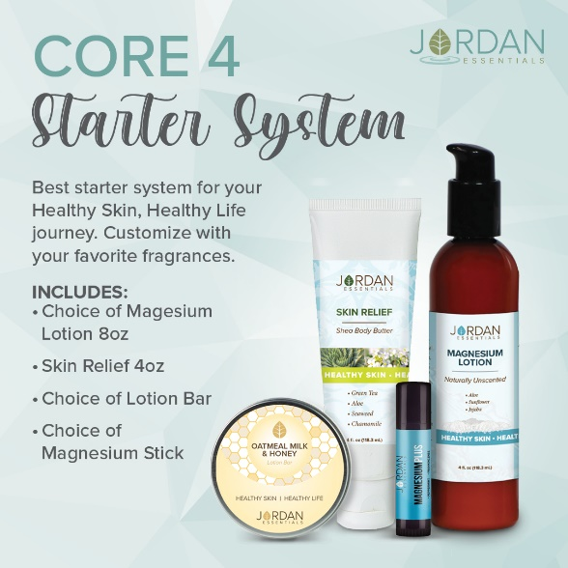
Core 4 Video – Learn why this is a must have

Upload Core 4 Video or share Video Link: https://vimeo.com/327302443/a64285e7db
Why We LOVE Peppermint!  Peppermint Essential Oil is a versatile and beneficial essential oil. It is used for digestive relief, minor headache pain, and for soothing sore muscles. All of this support is available by using it aromatically or topically blended in a base like our Peppermint Magnesium Lotion and Dead Sea Salt.  It is invigorating aromatically as well and is excellent for soothing aching feet. This makes the Peppermint Lotion our first choice for Foot Spas! Boost it up and use the Peppermint Magnesium Lotion to help with foot cramps at night!  This essential oil is featured in several of Jordan Essentials products, such as our Magnesium lotion and Dead Sea Salt Soaks. | 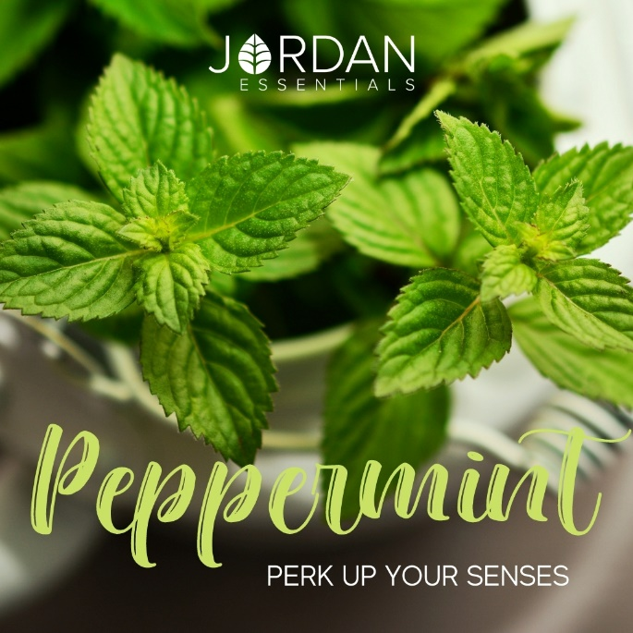
Magnesium Sticks – Convenient Carry and Go!  One of the items in our Core 4 is our Magnesium Stick. These convenient on-the-go sticks are perfect for your purse or gym bag! Simply rub on your wrists, temples, back of your neck… wherever you want soothing relief!  If ordering the Core 4, choose from the Magnesium Plus Muscle Relief, Magnesium Plus Peace, Soothing , Allergy or our Helio Magnesium Stick. | 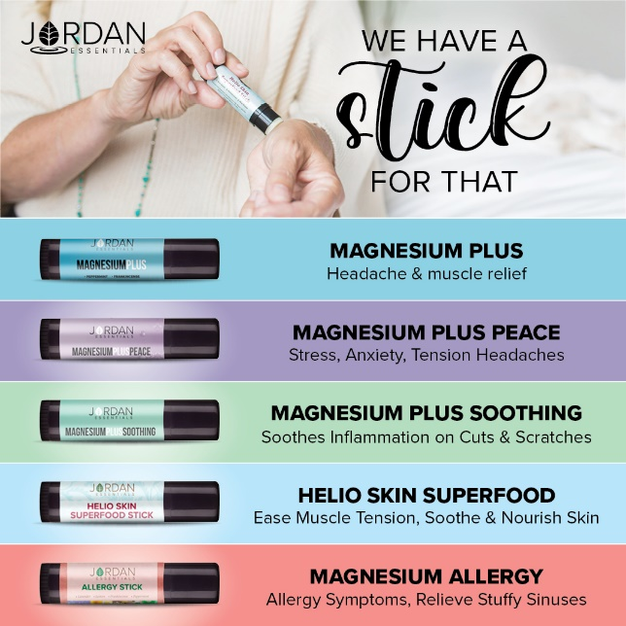
Fall Favorite Stick  A favorite fall stick is the Allergy Stick. Magnesium and essential oils are added to our soothing lotion bar base.  The essential oils are selected specifically for their traditional use in relieving allergy symptoms like itchy eyes and stuffing nose. | 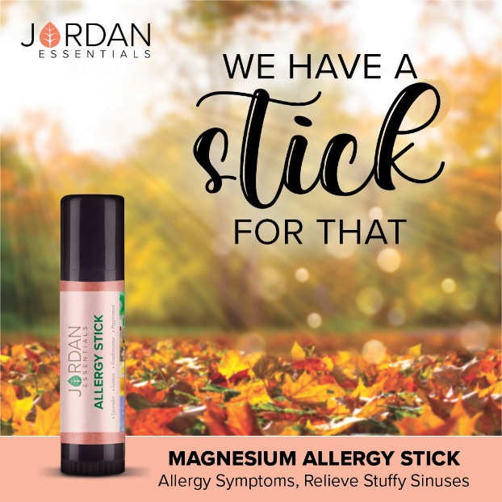
Year-Round Must Have  This incredible, all-purpose lotion is available in 3 sizes, and it’s also part of our Core 4 Starter Bundle! It combines nutrient-rich Aloe, Green Tea, Chamomile, Vitamin E, and super-powered with Shea Butter to help skin reduce inflammation.  I have this beside everyone’s bed in our home! Apply to cracked heels, extreme dry spots or use as an overall body lotion to keep your skin super soft. | 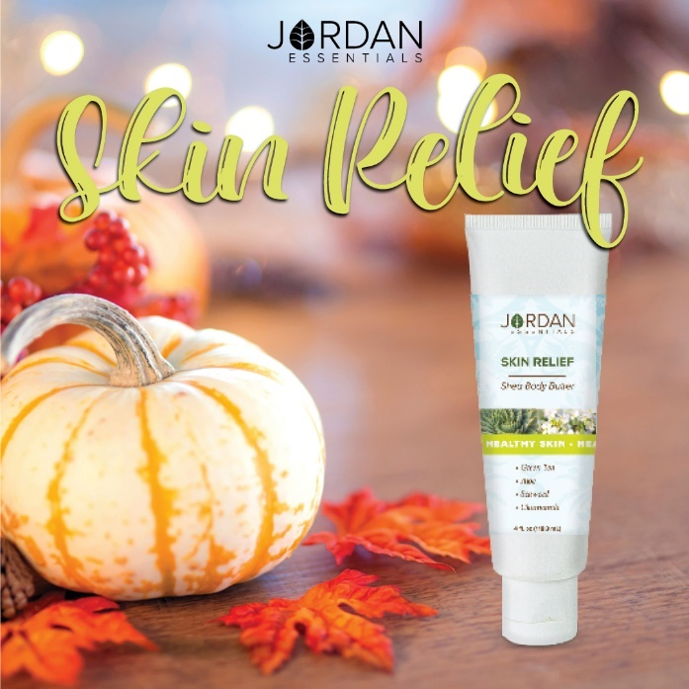
We have Magnesium Spray too!  Sprays provide the benefits of Magnesium in an easy-to-use and convenient option. Sprays work for those harder to reach places. They are absorbed quickly and are a great option for those who may not want a lotion.  We have 3 Key Sprays – Helio, Mag Plus Herbal and the Unscented Magnesium Spray.  All three are wonderful sprays to soothe muscles after fall activities! Raking, hiking and just enjoying the colorful season! | 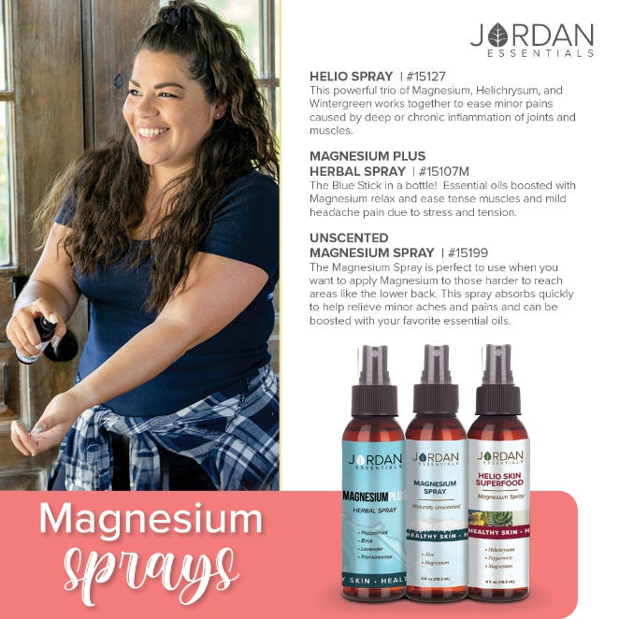
A Powerful Combination!  Magnesium is vital for the overall wellness and well-being. Essential oils support the body, mind and spirit.  Jordan Essentials has combined them to provide purposeful sprays with safe topical application of essential oils and magnesium.  Topical absorption of magnesium and essential oils in a witch hazel for moisturizing the skin! | 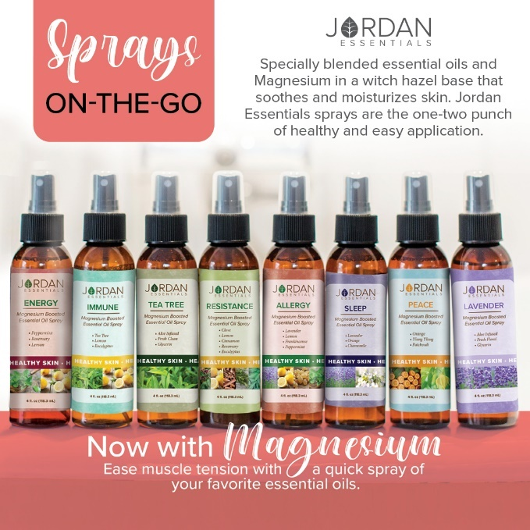
Why Witch Hazel?  No…we are not getting ready for Halloween!  Witch Hazel is a secret weapon in many Jordan Essential's products.  🌳Extracted from the bark, leaves, and twigs of a North American shrub with the same name, Witch Hazel has been used for hundreds of years for a wide variety of skin issues including acne, bruises, insect bites, poison ivy, burns, and more.  With its effectiveness and versatility, Witch Hazel can be found in Jordan Essentials' Essential Oil Sprays, Toner Mist, Acne Support Gel, and Spritz Your Pits Deodorant Spray. | 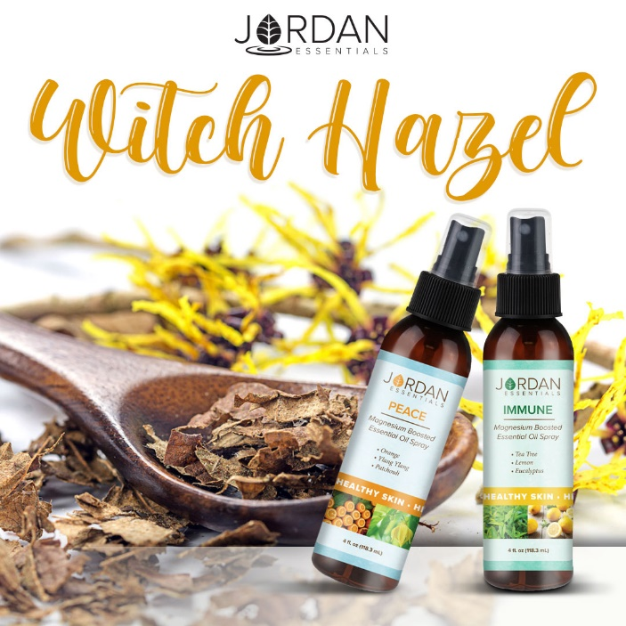
3 Ways to Enjoy JE  Did you know there are 3 ways to get Jordan Essentials products in your home?  The first way is by placing an order on XXX party!  Remember you can message me too with questions or to book your party! | 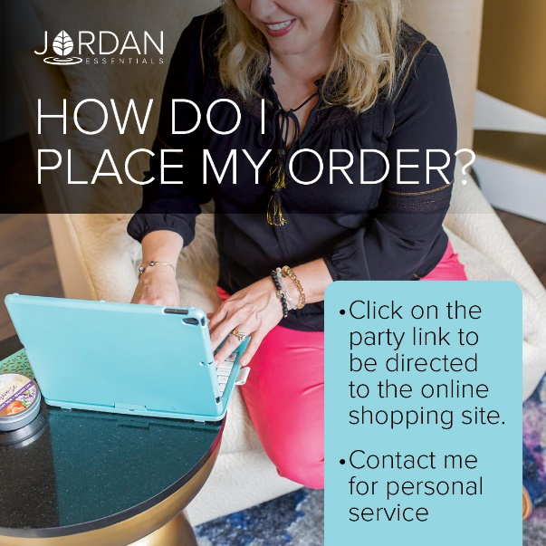
How about free?  The 2nd way to get JE products in your home is to become a host. We pamper our qualifying hosts with free products, ½ price items, a monthly special and more! I would love to share healthy, nontoxic products with your friends and family too and help you earn your favorite products for FREE.  In addition to the rewards mentioned above, our hosts receive a ½ price item for EVERY party booked from theirs!  We can do an online party like this one...or an in-person Spa Bar or even a Party On the Go. Let me know which would work for you. Comment which party type you are interested in below and I can answer any questions. When you select your date before _____ closes her party, she will receive credit for your booking.  In addition to face care, we can do theme parties, Magnesium Parties, Healthy Living Parties, Essential Oil parties and more! | Insert Host special  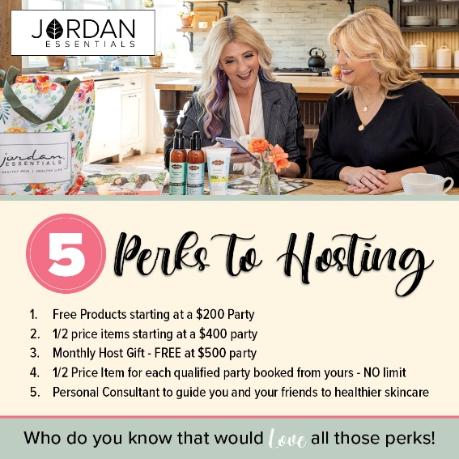
Enjoy it all…all the time!  Of course, if you were thinking, “I can do what she does!”, you are right! YOU can earn money by sharing healthy products with others too!  You can work this business online, part time or big time, the choice is yours! If you would like to learn more about starting your business, message me or type “Tell Me More” in the comments and I’ll send you some more information to look over and we can chat! | Insert Join Special
Be My VIP  We have so many products I didn’t get to share with all of you today, but great news! I have a VIP Facebook Group where I share valuable tips and information that focuses on Healthy Skin and a Healthy Life. Members also get access to promotions and notifications of special events! Go to _____________________(Insert VIP Group Link) and request to join for one final chance to win tonight’s drawing! | Link Displays image.
Wrap Up  I’m getting ready to gather all of the entries for our prize drawing! Want to make sure you didn’t miss a video or post? Click on PHOTOS or VIDEOS in this group to quickly jump to what you’re looking for!  Just a few reminders while I’m figuring out who our winner is tonight. If you would like to place your order directly, here is the party link:  If you would like me to contact you for your order, comment below and I will connect with you shortly.  We will be closing our party on…. (INSERT DATE AND TIME) | Link displays image
Thank YOU!  A big thank you to our host, ________, for getting everyone together for our fun online Spa Bar! You were an awesome host! And to every guest who participated, it was a pleasure having you. I hope you will join our mission of sharing Healthy Skin - Health Life.  Remember, you will want to place your order at _______ (insert party link) by ________ (close date) OR message me and I will review your wish list with you, answer your questions and get your order placed for you! Good night everyone! | 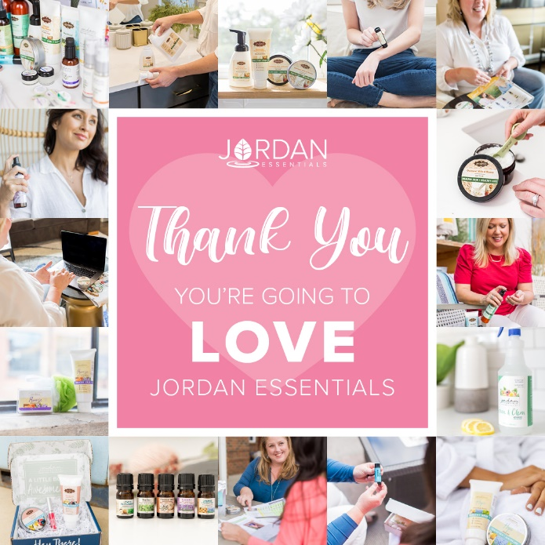
(The Next Morning)  Party Poll  Thank you all so much for attending live or viewing our online party! I had a great time sharing Jordan Essentials with all of you. Please take a minute to comment below with the letter that most describes you!  I look forward to continuing to serve you. Keep my contact information in your phone and stay connected with me in my VIP group at __________________.  Enjoy your new products and thanks again to _______, our awesome host!! | 