Copy Paste Facebook Party –Pit-y Party
The focus of this is to have a party focused on the pits! This is for a very quick one day party. The posts can be used on facebook, Instagram or as a zoom – use the text as your script.
Template Tip: Do not copy and paste comments in red that you see at the top of each post. Just copy the text under each post title. Paste it into Facebook and then publish or schedule to your group. Be sure to personalize the post with specific info for your party and to meet your personality.
Be sure to change out the Weekly Special and go Live to launch and close your party. Engagement with your guests is key. Host coach and have your host post a couple of posts as well. Additional engagement posts can be found in the JEU >> Media Center.
Insert emojis to make the posts festive and fun. Posts can also be used as stand alone posts on your business page, Instagram and personal profile.
Banner option for top of group
Pre-Party Posts  Pre-Party Post 1 (Mark as Announcement). This can be divided into two or three posts if you choose.  Welcome to our Pit-y Party!  Your host, XXXX, and I are looking forward to having a fun time together online as we share products that support healthy pits…without smelly odor…and without harmful chemicals like aluminum, parabens and other toxins.  Here’s how it works:  Check out the posts below to learn more about Jordan Essentials and join us here in this group on XXXX (date) at XXXX (time). You’ll receive chances to win fun prizes for commenting below to RSVP, for joining us on time, for participating in the event, and more!!  If you’d like to check out what Jordan Essentials has to offer, check out our online catalog at https://bit.ly/JEFall2021  You can place an order on XXXX’s party anytime before XXXX by going to: (insert party link).  As your JE consultant I’m available to answer any questions so reach out to me anytime in a personal message or call/text me at ______ (insert phone number)  Have someone who would like to join us? Share the link to this group and they can request to join!  I look forward to seeing everyone on ________ at _____!! Comment below if you will be joining us for a chance to win our prize drawing!! | Catalog Preview shows link when posted.
Today’s the Day!!!

Join us TONIGHT at XXXX right here in this group for fun, connecting with friends, fabulous spa products, and some free giveaways!

Set an alarm on your phone, because everyone who responds during the live event gets extra chances to win!

Won’t be able to join the LIVE event or wondering how to order? Place your order anytime at ________ or contact me via messenger or phone to place your order or ask questions anytime!

Healthy Skin Healthy Life  Head to toe skincare for the whole family!  ⬇️⬇️  https://bit.ly/JEFall2021  Find something in this catalog that begins with the fist letter of your name and comment below! | 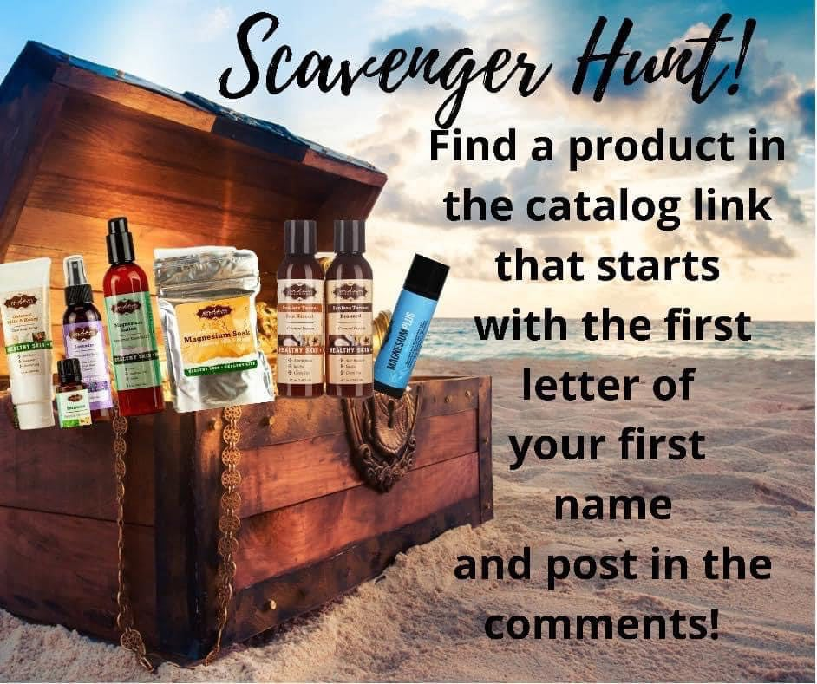
Party Kick Off – Go Live!  Say YES – To healthy products with healthy ingredients!  At Jordan Essentials our belief is that everyone deserves healthy skin—and joyful, healthy lives. When you say YES to Jordan Essentials products, you are saying YES to ingredients like magnesium, essential oils like lavender, purifiers like charcoal and rich moisturizers like shea butter.  Our products are made in fresh batches right in Nixa, MO. Delivered fresh from our manufacturing center to your doorstep! | 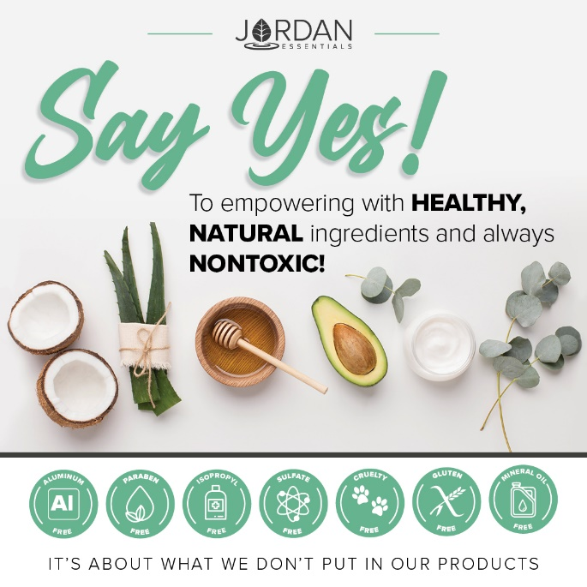
And just as importantly, you will be saying NO to aluminum, parabens, mineral oil, SLS/SLES, gluten and phthalates that are found in many, if not most, bath, body and skincare products today.  If you want to read more, check out the Product Promise page on my website:  INSERT LINK HERE – Example:  https://XXXXXXX.jordanessentials.com/product-promise/ | 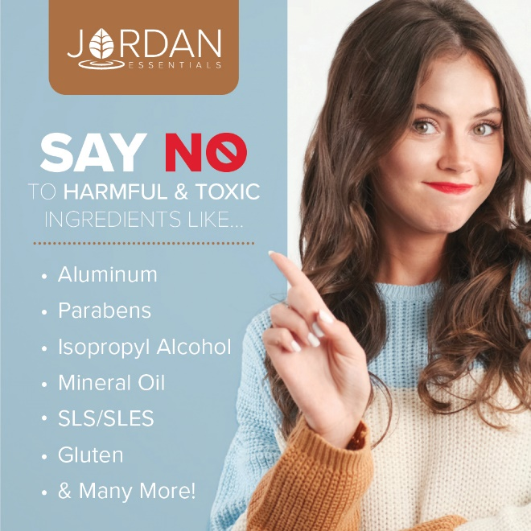
Why is what’s in our products so important?

For two key reasons:

1. Our skin is our largest organ and what touches our skin affects all of our organs.

2. It takes just 26 seconds for what touches our skin to be absorbed into our bloodstream. The harmful effects of many chemicals used in skincare products are scary! And many include ingredients that prematurely age us or dry out our skin.

Jordan Essentials’ products use healthy, nontoxic ingredients combined to provide safe, healthy alternatives to their chemically-laden counterparts.

OPTIONAL

Ready to Win?

If you are ready for some fun and some pampering tips, be sure to join our live event tomorrow at XXXX. We will be giving out virtual tickets for great prizes - the more tickets you earn, the more chances you have to win!

Not only do we provide natural and nontoxic solutions, but our products are also fun, pampering, and life-changing! Everyone needs and deserves pampering in their life. Right?

Who’s ready to win?
Post 1: Welcome

Welcome everyone! Both XXXX and I are so happy you could join us. We both love Jordan Essentials and are excited to share our favorite products with you. For inviting each of you and hosting our event, XXXX is receiving amazing perks from Jordan Essentials. Now tonight, when your wish list is bigger than your wallet, let me know and we can work together to make those wishes reality with free credits when you host too!

As we chat, feel free to comment, like and LOVE the posts. The more you do, the more chances you have to earn tickets. I’ll respond as quickly as I can to questions and if you have questions after, feel free to reach out directly on Messenger. Remember, refresh often, sit back and have fun!

Example:  No party is complete without prizes! If you win, I want to be sure I can connect with you. So, for your first 5 points, message me "Hello" at http://m.me/marian.smithje and then comment DONE below.  This takes them right to messenger without being friends!  You can find your profile name in the address bar when you are on your Facebook page.  You can post this as a pre-post also. | Use this tip and link anytime you want to get guests engaged with contacting you directly.
Roll Call – Who’s Here With Us!

Let’s start with an easy question and see who is here. Comment below letting us know where you are viewing from and your favorite fall activity is!

Comment with a gif for fun!

Flat Nancy!  WooHoo….Nancy Bogart is here with us! | Incorporate the Flat Nancy promo here.
Ordering is Easy  There are two ways to order. Go to (enter party link) to shop OR contact me with your order or questions and I’ll place the order for you.  Remember, by commenting INTERESTED on any post, you’ll create a wish list for easy checkout at the end of our event! If you’ve read this post and are ready to get started, comment READY below! | 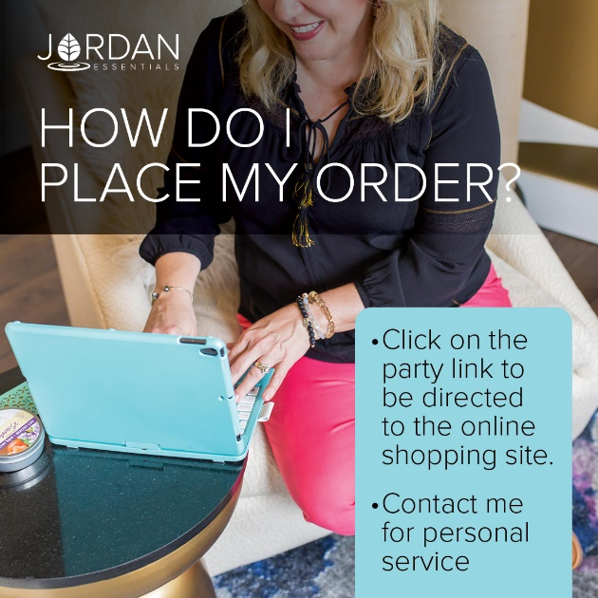
Why a Pit-y Party?

I want to help you change the way you think about your pits!

Yes…your underarms. They can be the pits!

Sweating is ok…it is great! A normal, healthy body process.

Stinking…not so much ok! It is caused by the bacteria under our arms.

Sweating we want….stinking we don’t.

We want sweating to be healthy, natural. We don’t want to be using harmful – TOXIC - chemicals to block it or stop it.
Aluminum – Just Say NO!  This controversial ingredient was linked in a 2005 study to be related to an increase in breast cancer cells because it blocks the ability to sweat, which is why is it used in commercial deodorants.  Our bodies were made to sweat we just do not have to stink!  The evidence is still coming in on the dangers of aluminum in health products. This includes a 50 year debate that prolonged use of aluminum can cause Alzheimer’s or lead to earlier onset of this disease.  At Jordan Essentials we have solutions, so you do not need to temp fate or use ingredients that are questionable. | 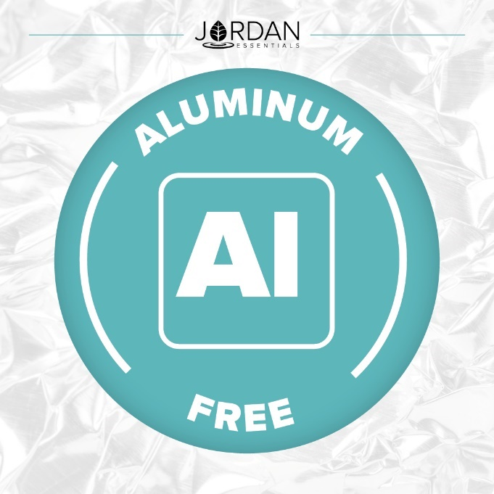
Parabens – Another No No Ingredient!  Cosmetic companies, including anti-perspirants add parabens to their products to preserve them from bacteria, yeast, and mold.  Scientific studies have linked use of parabens, that are absorbed into the body from daily use to the disruption of hormone balances, affect fertility and reproductive organs and increase the risk of cancers, including breast cancer.  Studies at the University of California-Berkley have linked parabens to the increase the growth of breast cancer cells. | 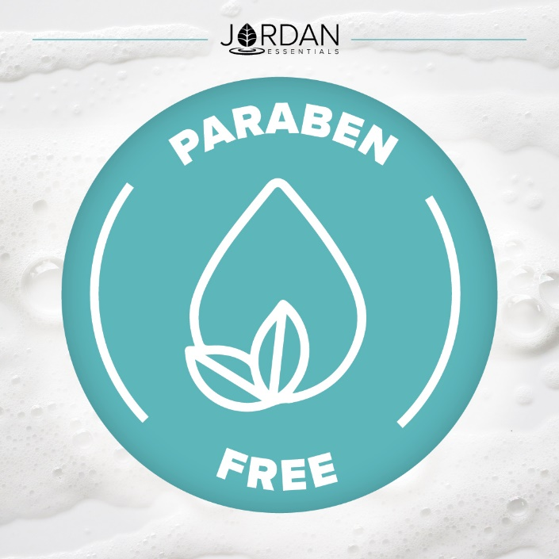
The Body Retains These Harmful Chemicals

The harmful chemicals, like aluminum and parabens, not only go on our body…they go in our bodies too!

As our children, especially females start using anti-perspirants and other products at younger and younger ages, this will become a growing health concern.

Using healthy products from the start is key!
We Have Options!  Healthy choices are available. Jordan Essentials offers deodorants, sprays and products that are made with healthy, nontoxic ingredients that let you sweat naturally without the smell!  We have a Spritz Your Pits routine! | 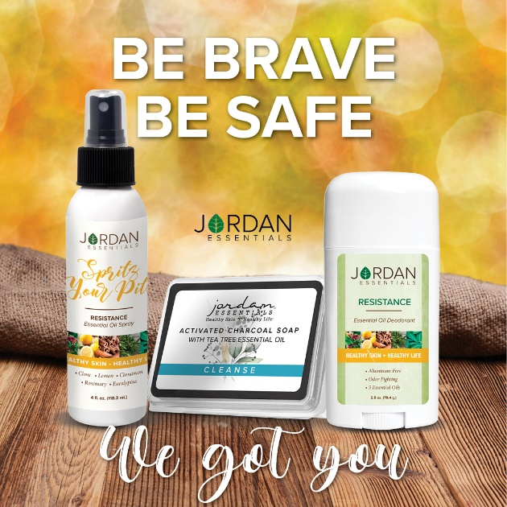
It’s Detox Time! A Pit-y Party….1, 2. 3

The first step to healthy pits is detox. We need to remove the harmful chemicals that are stored in our bodies, specifically the pits area.

JE features Charcoal Soap with Tea Tree and a Purifying Charcoal Mask.
Why Charcoal?  Activated Charcoal is created by super-heating carbon-rich materials such as wood, peat, or coconut shells.  JE uses coconut charcoal. 🥥Not to be confused with charcoal used for grilling, Activated Charcoal is super-absorbent, detoxifying, purifying, and offers many benefits to the body and skin.🍃  Jordan Essentials uses Activated Charcoal in many of our products, including Activated Charcoal Glycerin Soap, Charcoal Deodorant, and Purifying Charcoal Mask. | 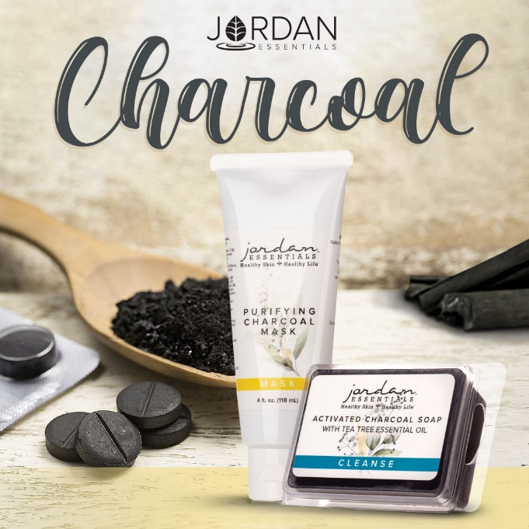
The Spritz Your Pits Resistance spray is a powerful combination of 5 essential oils that ward off odors all day long.  It is an ancient blend used for centuries; Clove, Cinnamon, Lemon, Rosemary and Eucalyptus  Spritz Your Pits helps prevent the bacteria growth in our pits which causes the odor.  We want to sweat…but not stink!  It can be used alone or in combination with one of our deodorants.  We have it as a spray in our special bundle for Breast Cancer Awareness and we have this blend as a solid deodorant too. | 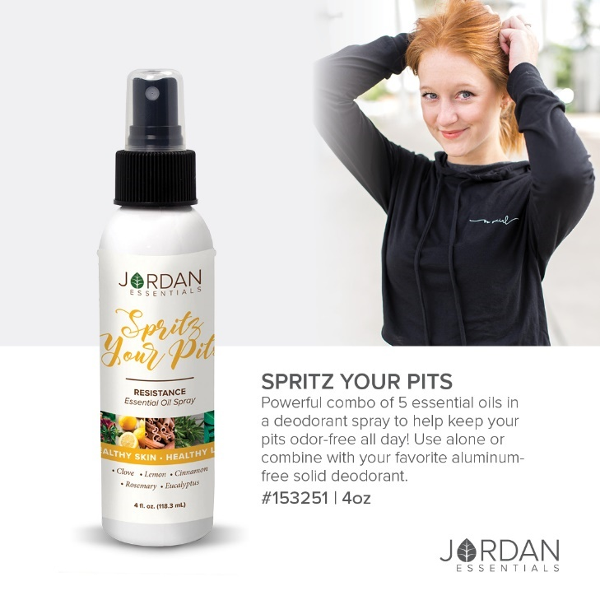
Glides on Smooth!

After allowing the Spritz Spray to dry, apply deodorant.

Jordan Essentials deodorant glides on smooth and clear! It is not wet, sticky or grainy.

Using plant-based science, it is the healthy alternative to chemicals! Chamomile and aloe, key ingredients, soothe delicate underarm skin too. So, YES you can apply after shaving!
NOW is the Ideal Time  Our Breast Cancer Awareness combo is one of the best ways to get started. It features our Black Raspberry Vanilla Deodorant and a 1 oz Spritz Your Pits Resistance Spray.  In addition to making a healthy choice for you, you will also be supporting the Breast Cancer Awareness of the Ozarks with a donation of $1 or $5 if you purchase the Bangle Combo. | 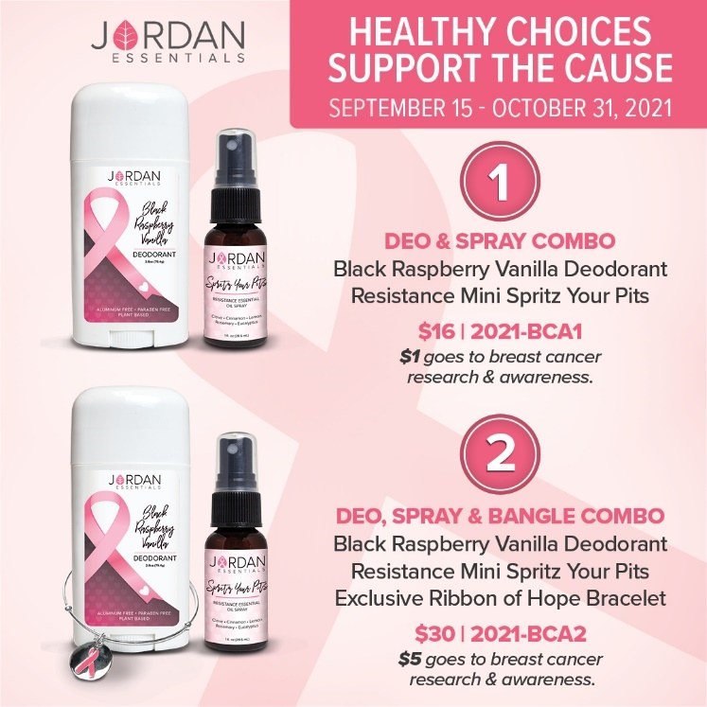
How to Get Started  We suggest a 2-week transition time to detox the harmful toxins and let your body find its new normal. | 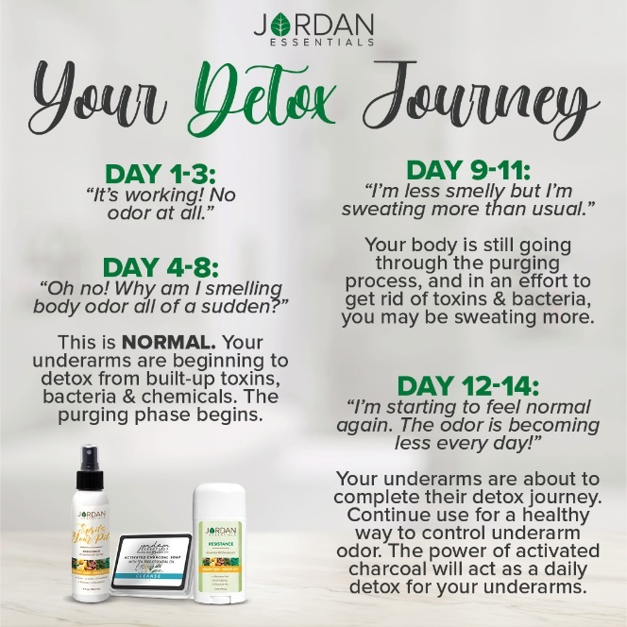
Continue with Healthy Habits  After the initial “detox”, you can continue with healthy skincare habits and a routine that lends to a healthy lifestyle! | 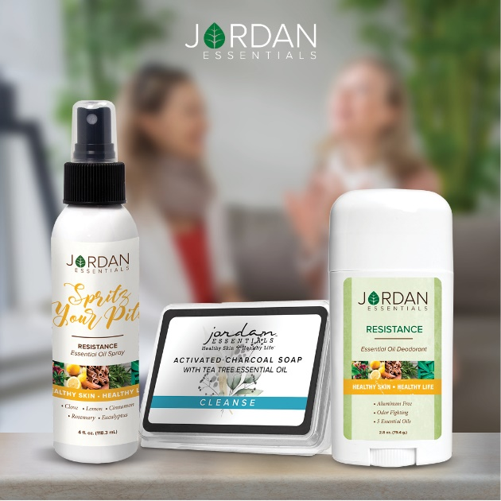
Special Lotion Bar – Don’t Miss Out On This One!  Build up your resistance with 5 power essential oils in a Customer Exclusive special.  The Resistance Lotion bar is just $5 with a $50 purchase … this month only. The Resistance Lotion Bar is only available as the customer special.  It contains the 5 essential oils – clove, lemon, rosemary, cinnamon, and eucalyptus – from the Spritz Your Pit in our lotion bar base.  Great for use on hands and on feet too! | 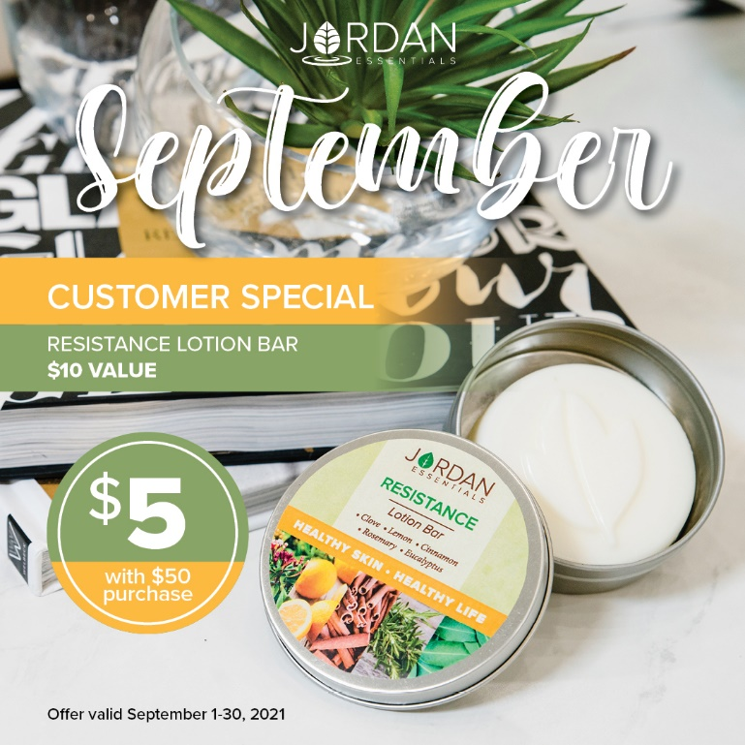
Feeding America -- Filling Fall Pantries  September is Hunger Action Month. It is a push month to help fill food banks and pantries with much-needed supplies for the fall and winter months. This year with the pandemic not behind us and devastating weather across the south and northeast, the need continues to rise.  Jordan Essentials continues to support Feeding America on behalf of our consultants and customers. | INSERT CURRENT WEEKLY TOTAL GRAPHIC HERE
The Kitchen Collection  Jordan Essentials has enhanced donations this fall with the Kitchen Collection. Each product individually purchased donates 10 meals and the collection donates 20 meals.  The Kitchen Collection features our healthy for the hands Foaming Hand Wash in fresh lemon scent and our soothing Hand & Body Lotion in lemon too!  Grab a collection for you and one for a friend and help feed America this fall. | 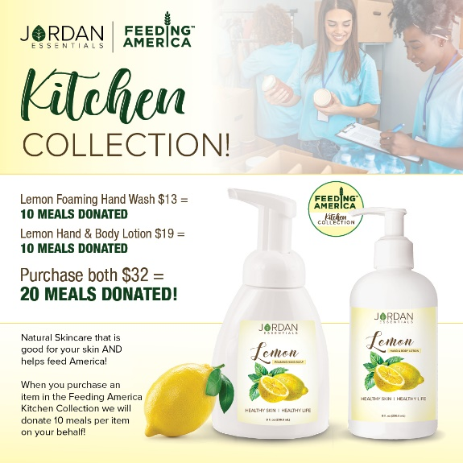
Ready for your Own Pit-y Party?  Let me know if you would love to host a Pit-y Party with your friends and family! Quick, easy and free stuff too! | 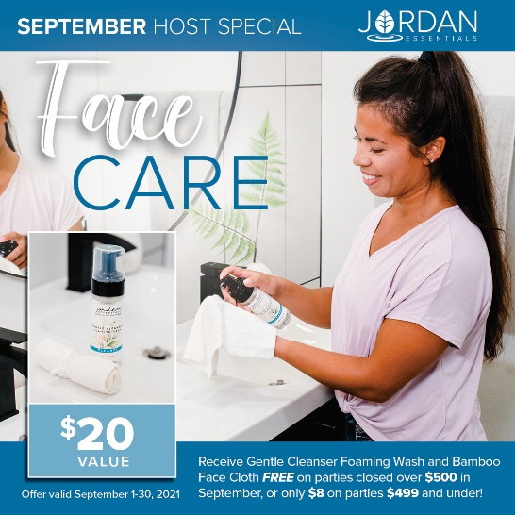
Be My VIP  We have so many products I didn’t get to share with all of you today, but great news! I have a VIP Facebook Group where I share valuable tips and information that focuses on Healthy Skin and a Healthy Life. Members also get access to promotions and notifications of special events! Go to _____________________(Insert VIP Group Link) and request to join for one final chance to win tonight’s drawing! | Link Displays image.
Wrap Up  I’m getting ready to gather all of the entries for our prize drawing! Want to make sure you didn’t miss a video or post? Click on PHOTOS or VIDEOS in this group to quickly jump to what you’re looking for!  Just a few reminders while I’m figuring out who our winner is tonight. If you would like to place your order directly, here is the party link:  If you would like me to contact you for your order, comment below and I will connect with you shortly.  We will be closing our party on…. (INSERT DATE AND TIME) | Link displays image
Thank YOU!  A big thank you to our host, ________, for getting everyone together for our fun online Spa Bar! You were an awesome host! And to every guest who participated, it was a pleasure having you. I hope you will join our mission of sharing Healthy Skin - Health Life.  Remember, you will want to place your order at _______ (insert party link) by ________ (close date) OR message me and I will review your wish list with you, answer your questions and get your order placed for you! Good night everyone! | 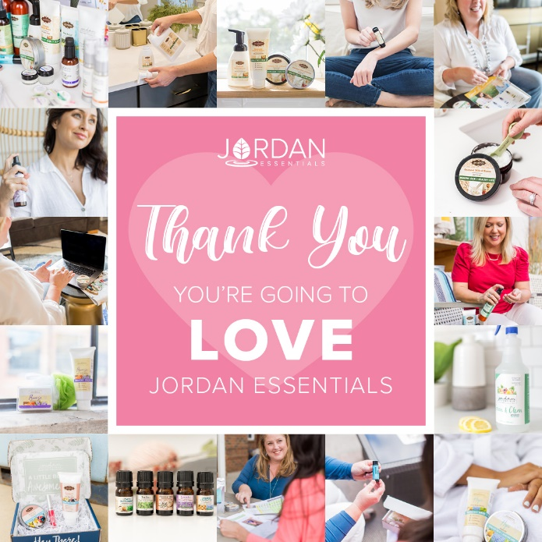
(The Next Morning)  Party Poll  Thank you all so much for attending live or viewing our online party! I had a great time sharing Jordan Essentials with all of you. Please take a minute to comment below with the letter that most describes you!  I look forward to continuing to serve you. Keep my contact information in your phone and stay connected with me in my VIP group at __________________.  Enjoy your new products and thanks again to _______, our awesome host!! | 