Copy Paste Facebook Party –Face Fall with a Fresher Face!
Template Tip: Do not copy and paste comments in red that you see at the top of each post. Just copy the text under each post title. Paste it into Facebook and then publish or schedule to your group. Be sure to personalize the post with specific info for your party and to meet your personality.
Be sure to change out the Weekly Special and go Live to launch and close your party. Engagement with your guests is key. Host coach and have your host post a couple of posts as well. Additional engagement posts can be found in the JEU >> Media Center.
Posts can be posted 3-4 over the course of three days or posted 3-5 minutes apart during a 45 minute party. You can kick off a party with a LIVE in Facebook and then end with a live as well.
Insert emojis to make the posts festive and fun. Posts can also be used as stand alone posts on your business page, Instagram and personal profile.
Banner option for top of group
Pre-Party Posts  Pre-Party Post 1 (Mark as Announcement):  Welcome to our Be Summer Ready Party!  Your host, XXXX, and I are looking forward to having a fun time together online as we share products that support your self-care and springing forward with fresh, healthy skin! We are all ready to slough off winter!  Here’s how it works:  Check out the posts below to learn more about Jordan Essentials and join us here in this group on XXXX (date) at XXXX (time). You’ll receive chances to win fun prizes for commenting below to RSVP, for joining us on time, for participating in the event, and more!!  If you’d like to check out what Jordan Essentials has to offer, check out our online catalog at https://bit.ly/JEFall2021  You can place an order on XXXX’s party anytime before XXXX by going to: (insert party link).  As your JE consultant I’m available to answer any questions so reach out to me anytime in a personal message or call/text me at ______ (insert phone number)  Have someone who would like to join us? Share the link to this group and they can request to join!  I look forward to seeing everyone on ________ at _____!! Comment below if you will be joining us for a chance to win our prize drawing!! | Catalog Preview shows link when posted.
Pre Post  In addition to helping our host have a great party and earn items from her wish list, each party helps Feeding America too!  Jordan Essentials donates 10 meals to Feeding America for each party closed. We have donated over 200,000 meals so far!  If you would like to be part of making a difference, message me and we can schedule your party too! | INSERT CURRENT WEEKLY TOTAL GRAPHIC HERE
Pre Post  Say YES – A Fresh Face Starts with Fresh Products  At Jordan Essentials our belief is that everyone deserves healthy skin—and joyful, healthy lives. When you say YES to Jordan Essentials products, you are saying YES to ingredients like magnesium, essential oils like lavender, purifiers like charcoal and rich moisturizers like shea butter.  Our products are made in fresh batches right in Nixa, MO. Delivered fresh from our manufacturing center to your doorstep! | 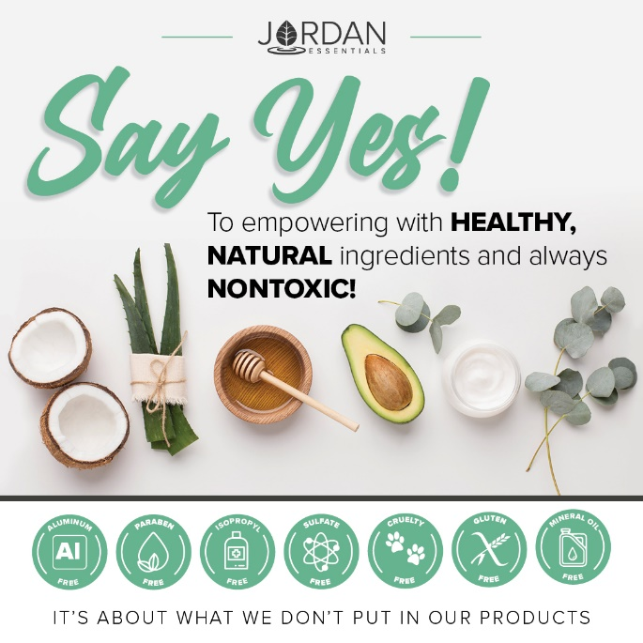
And just as importantly, you will be saying NO to aluminum, parabens, mineral oil, SLS/SLES, gluten and phthalates that are found in many, if not most, bath, body and skincare products today.

Pre-Party Post  We will be talking more about our No No list throughout the party and why these ingredients made the list!  If you want to read more, check out the Product Promise page on my website:  INSERT LINK HERE – Example:  https://XXXXXXX.jordanessentials.com/product-promise/ | 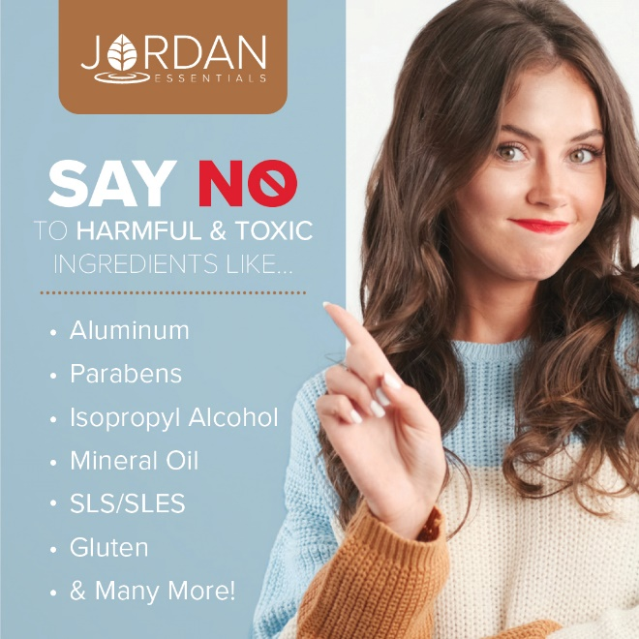
Pre-Party Post  Why is what’s in our products so important?  For two key reasons:  1. Our skin is our largest organ and what touches our skin affects all of our organs.  2. It takes just 26 seconds for what touches our skin to be absorbed into our bloodstream. The harmful effects of many chemicals used in skincare products are scary! And many include ingredients that prematurely age us or dry out our skin.  Jordan Essentials’ products use healthy, nontoxic ingredients combined to provide safe, healthy alternatives to their chemically-laden counterparts. | 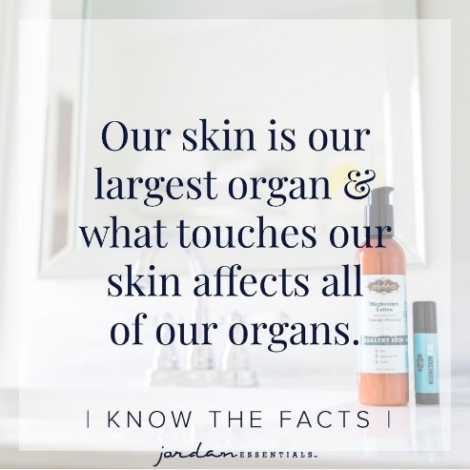
Pre-Party Post 4 (Day Before the Event):

Ready to Win?

If you are ready for some fun and some pampering tips, be sure to join our live event tomorrow at XXXX. We will be giving out virtual tickets for great prizes - the more tickets you earn, the more chances you have to win!

Not only do we provide natural and nontoxic solutions, but our products are also fun, pampering, and life-changing! Everyone needs and deserves pampering in their life. Right?

Who’s ready to win?
Pre-Party Post 5 (Morning of the Event):

Today’s the Day!!! Join us TONIGHT at XXXX right here in this group for fun, connecting with friends, fabulous spa products, and some free giveaways!

Set an alarm on your phone, because everyone who responds during the live event gets extra chances to win!

Won’t be able to join the LIVE event or wondering how to order? Place your order anytime at ________ or contact me via messenger or phone to place your order or ask questions anytime!

30 Minutes Before:

Set A Reminder – We are Starting Soon!
The party starts in about 30 minutes! It is come-as-you-are so get comfy, grab a drink, get a pen and paper, and let’s get ready to party Facebook Style with Jordan Essentials! I am excited to share with Host’s friends who will be joining us tonight!

Comment below with an emoji or GIF that shows how excited you are for us to get started!

15 Minutes Before  I am so excited to be sharing Jordan Essentials with all of you! I am setting the mood for fun with our Hope Aromatherapy Candle.  Jordan Essentials offers 100% pure, ethically-produced essential oils.  For the burst of energy and excitement, I am using our new HOPE Candle!  Later tonight when I am ready to wind down, I’ll be using our Orange Lavender Blender Buddy in the unscented shea butter for a relaxing foot massage! It is also a great combo to diffuse for the kiddos!  We are offer a fabulous collection of essential oils Perfect for mixing and matching with our unscented products too! | 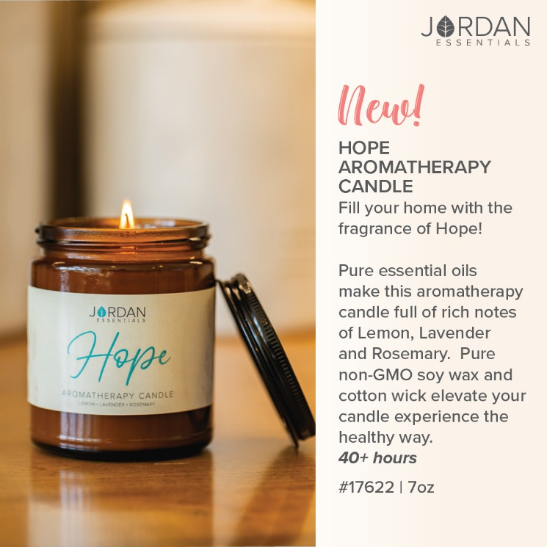
5 Minutes Before

Time sure flies by! We will be starting in just a few minutes. During our party tonight, which will last about 45 minutes, be sure to refresh your screen often so you don’t miss anything such as chances to win our product drawing!

Tonight you’ll earn a ticket into the product prize drawing for every Like/Love, comment or question on the posts in our event!

Hint – Go live to kick off your party!
Post 1: Welcome

Welcome everyone! Both XXXX and I are so happy you could join us. We both love Jordan Essentials and are excited to share our favorite products with you. For inviting each of you and hosting our event, XXXX is receiving amazing perks from Jordan Essentials. Now tonight, when your wish list is bigger than your wallet, let me know and we can work together to make those wishes reality with free credits when you host too!

As we chat, feel free to comment, like and LOVE the posts. The more you do, the more chances you have to earn tickets. I’ll respond as quickly as I can to questions and if you have questions after, feel free to reach out directly on Messenger. Remember, refresh often, sit back and have fun!

Example:  No party is complete without prizes! If you win, I want to be sure I can connect with you. So, for your first 5 points, message me "Hello" at http://m.me/marian.smithje and then comment DONE below.  This takes them right to messenger without being friends!  You can find your profile name in the address bar when you are on your Facebook page.  You can post this as a pre-post also. | Use this tip and link anytime you want to get guests engaged with contacting you directly.
Roll Call – Who’s Here With Us!  Let’s start with an easy question and see who is here. Comment below letting us know where you are viewing from and your favorite summer activity is! | 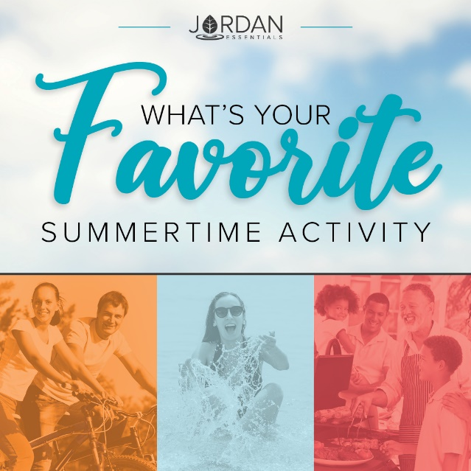
My Story POLL  That is so fun to see where everyone is watching from. I’m _________ and I am in ________.  (Insert a sentence or two about your JE story. – What attracted you to JE, your favorite product, what you are most excited about.) | Insert a picture of YOU.
That’s my story, but I’d love to know more about YOUR story so I can best serve you tonight! Select any of these poll options that best describes you. | 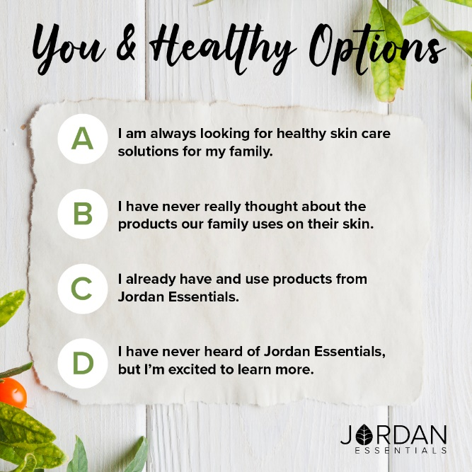
The JE Story  For those who have never heard of Jordan Essentials, it was started by Nancy Bogart in 2000. We are proud to be a woman-owned and “Made in America” company. All of our products are made with nontoxic ingredients and the healthiest ones available. We will feature a few of those products during this party.  If you HAVE heard of Jordan Essentials, go ahead and comment below with the products you have and love! | 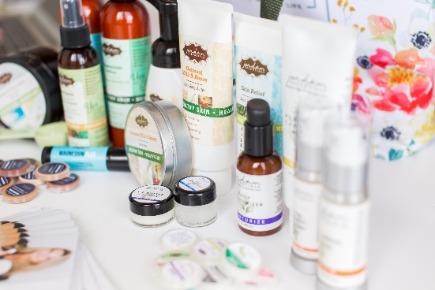
Ordering is Easy  There are two ways to order. Go to (enter party link) to shop OR contact me with your order or questions and I’ll place the order for you.  Remember, by commenting INTERESTED on any post, you’ll create a wish list for easy checkout at the end of our event! If you’ve read this post and are ready to get started, comment READY below! | 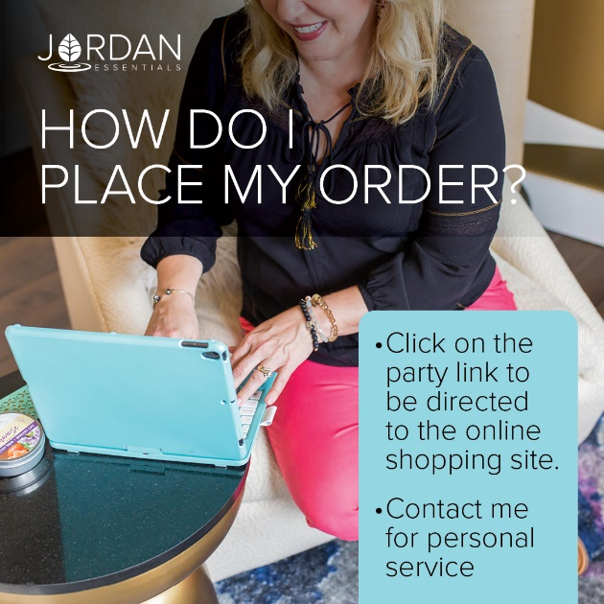
The Product that Started it All!  The Lotion Bar is a solid bar of lotion. It is made with beeswax to seal in the moisture and bonus – it doesn’t harbor bacteria – naturally!  Jordan Essentials is also fresh batch manufacturing. Meaning we are not mass-producing lotion bars that sit on a shelf for years!  They are hand-poured in our facility right here in Nixa, MO and then delivered right to you!  No cargo ships on the open seas for these! | 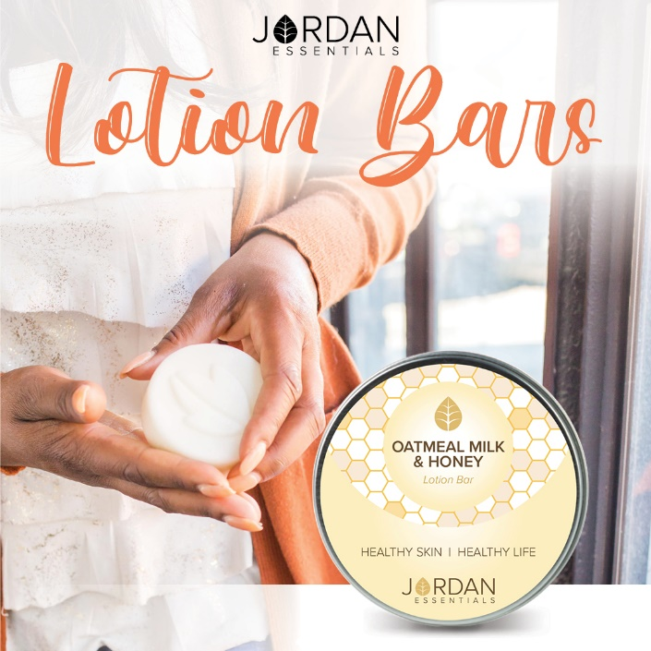
Joyful Jordan Box

This month the Lotion Bar is one of the products featured in our Joyful Jordan Box. This box contains amazing and often exclusive products each month at a savings!

It is a great way to try new products and fall in love with JE.

My monthly subscribers enjoy getting the box with FREE shipping. This month the products are in the exclusive – Joyful Jordan Box only, CHEER Fragrance!

A Little Bit About Cheer!  Cheer is an exclusive scent this month. It is a special blend of three essential oils – Lemon, Orange and Lime – that are known for their uplifting properties.  The aroma is clean, clear and crisp – like a bright summer day!  Jordan Essentials uses 100% pure essential oils that are ethically produced and produced without chemical fertilizers or pesticides. You enjoy only the healthy benefits of the essential oils and healthy ingredients in JE products! | 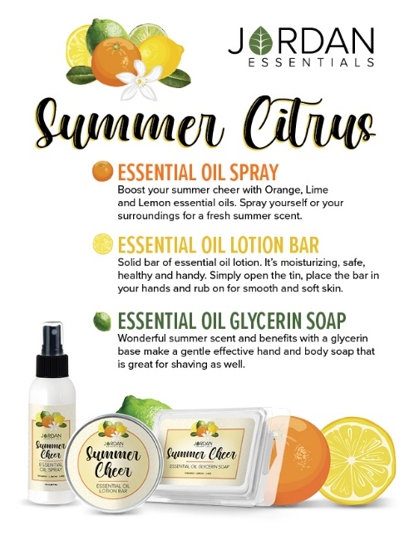
Speaking of Plant-Based Goodness…  Glycerin is a healthy, effective ingredient that is plant-based!  Plant-based 🌿 glycerin soaps, shampoos, and body washes can help lock in your skin's natural moisture and prevent over-drying. This is very important during the warmer summer months!  JE Glycerin Soaps do not use harsh chemicals, which are often detergents!  In addition to helping hydrate skin, glycerin is also non-greasy. It is an ideal choice for those with normal, oily, or combination skin. 🛀  🧼 It is safe for facial use and may help even out skin tone and reduce the appearance of fine lines and wrinkles.  A special bar of CHEER glycerin soap is also in this month’s Joyful Jordan Box! | 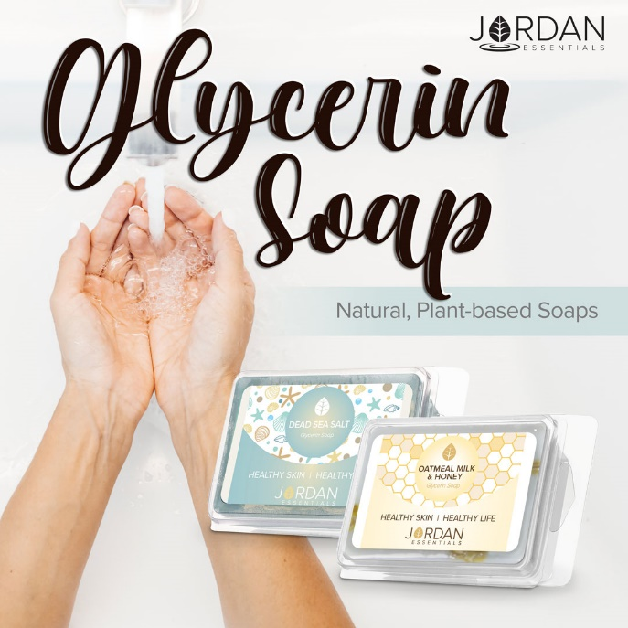  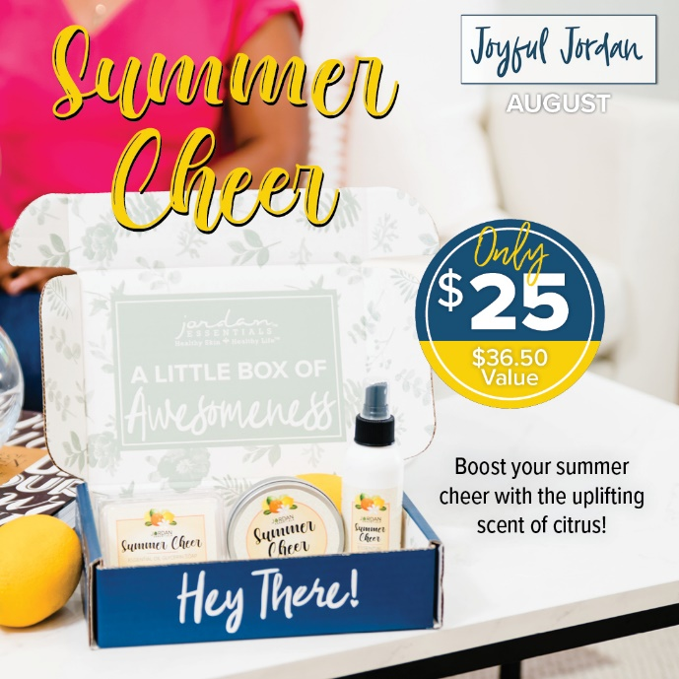
The Third Item – Room & Body Spray  Yes – a room spray that can be used as a body spray too! CHEER is perfect for a room spray – doggy odor, kitchen smells, musty, dusty spaces – be gone with Summer Cheer!  But…the healthy, non-toxic ingredients also mean it is a refreshing body spray too. One of the key ingredients is witch hazel.  🌳Extracted from the bark, leaves, and twigs of a North American shrub with the same name, Witch Hazel has been used for hundreds of years for a wide variety of skin issues including acne, bruises, insect bites, poison ivy, burns, and more.  Given its effectiveness and versatility, Witch Hazel can be found in Jordan Essentials' Essential Oil Sprays, Toner Mist, Acne Support Gel, and Spritz Your Pits Deodorant Spray.  It is soothing, moisturizing and calming to the skin! | 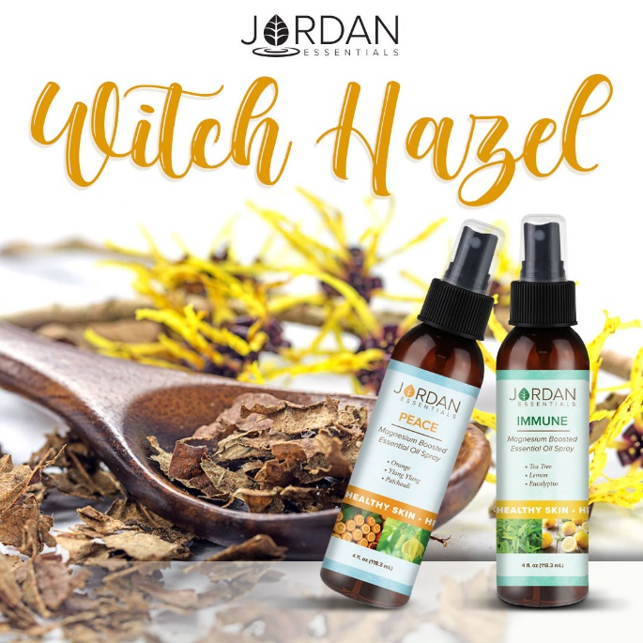
NOTE – If there is a weekly special partners with the box, you can insert it here.

You can also insert the Customer Special here also.
What’s Your Fragrance?  Jordan Essentials offers Signature Fragrances plus Unscented in many of our products and collections.  Along with our most popular Oatmeal Milk & Honey, we offer have two that have been fan favorites since their release and our new Vanilla Pear.  Promise is a light citrus flower of sweet clementine and freesia flowers. One of our most popular fragrances.  Hope is our newest fragrance made with essential oils of lemon, lavender and rosemary. It is fresh and rejuvenating!  Vanilla Pear is a rich, warm and crisp scent perfect for the changing seasons.  Which fragrances are your favorite? | 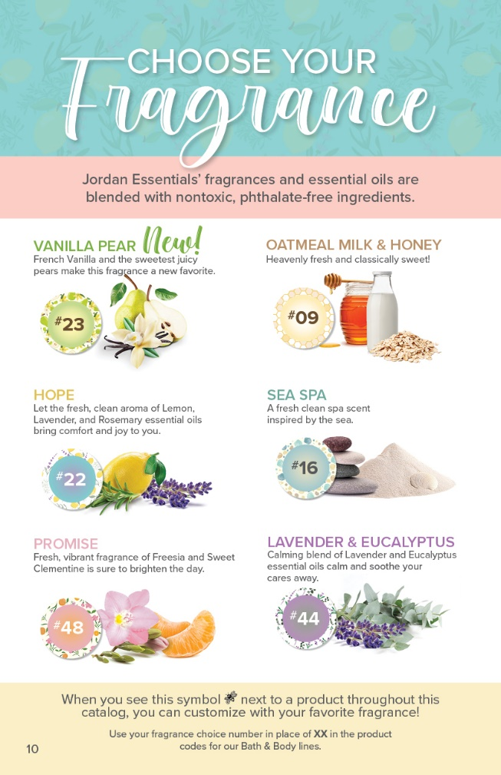
NOTE – If there is a weekly special featuring a scent, insert it here.
Layering on the Fragrances  Jordan Essentials offers healthy products to from head to toe! One great way to enjoy your favorite fragrance is through layering!  Our Bath and Body Collections provide the ultimate everyday pampering!  Soak, cleanse, exfoliate, moisturize, protect, and nourish your skin.  If you see several of the items on your list, the collection is the best way to go! | 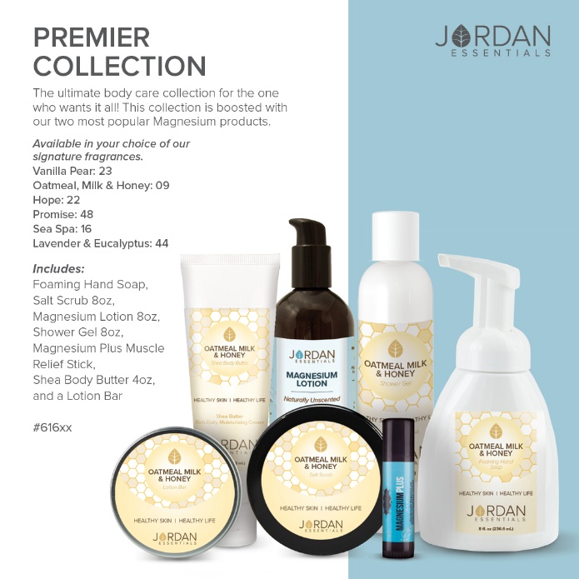
August is Birthday Month  August is our Founder & CEO Nancy Bogart’s Birthday. Her gift to us this month is FREE shipping on our Face Care Systems!  Systems are a great way to save money and to start your face care routine the best way.  We have a system for each face care skin type: Normal, Dry, Oily or Acne. | 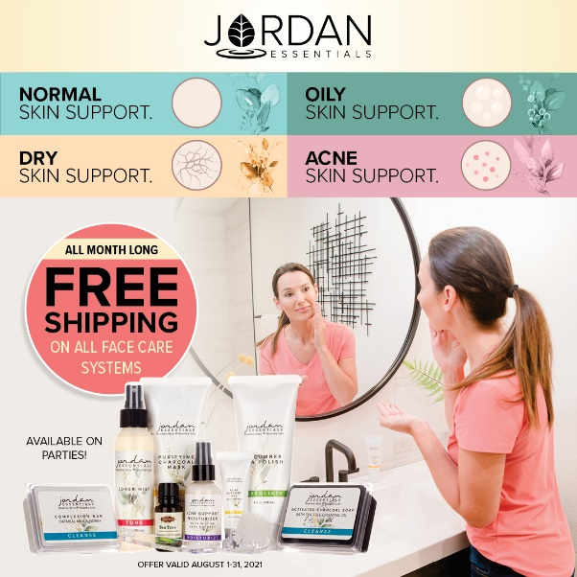
Why a System?  Systems are a great way to save money and to start your face care routine the best way.  We have a system for each face care skin type: Normal, Dry, Oily or Acne. | 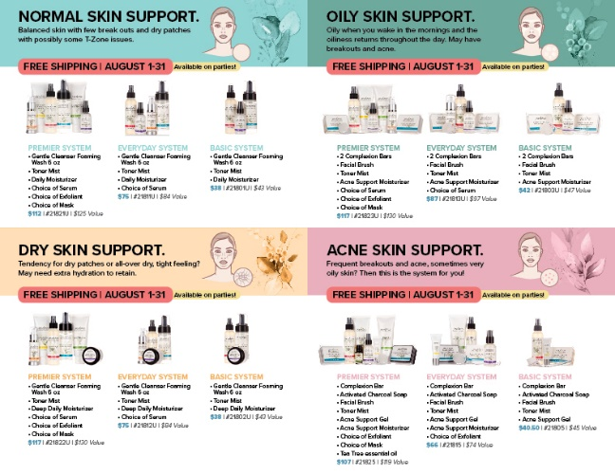
Personalize What You Need Too!  Each of our systems has three levels. Both the Premier and the Everyday Systems are also customizable with products that you choose. For example, with the Premier System in the Normal, Oily and Dry systems, you choose your serum, Exfoliant and Mask. | 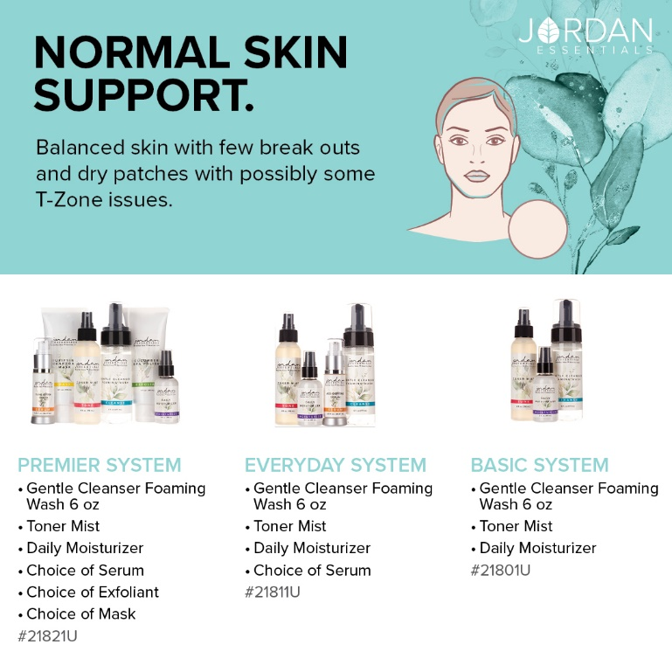
A few key components  Like a paining starting on a clean canvas, our face needs to be a clean surface too! JE’s Gentle Cleanser Foaming Wash gently and effectively removes the toxins our face is exposed to everyday. It is also great for removing makeup.  Keeping your face clean is Step 1 to radiant, healthier skin! | 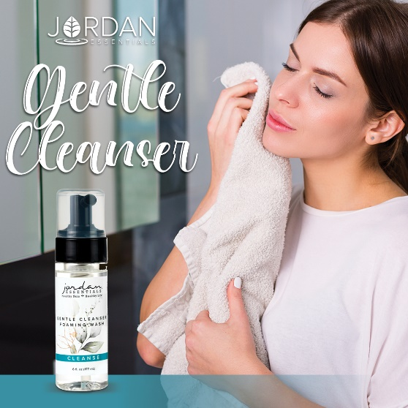
Cleansing for all Skin Types  Jordan Essentials knows the cleansing step is one of if not the most important steps. We offer a variety of products to fit the needs of all skin type. The Face Care Collections include the cleaner that is best for that type. Items can also be purchased individually when you are ready for a refill! | 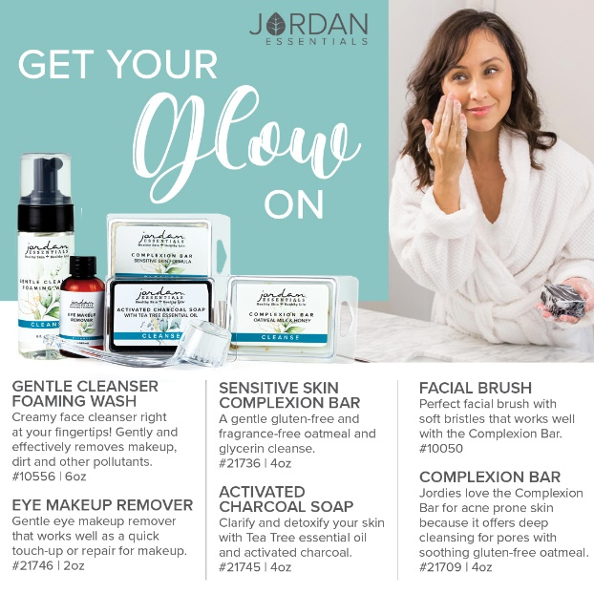
Out with the old and reveal the new!  Sloughing off old skin helps to promote new skin cells and reveals the vibrant, healthy and glowing skin below.  Exfoliating can be done daily with oily skin, weekly with normal skin and biweekly for those with a dry skin type.  Safe, eco-friendly ingredients are used in our exfoliants. | 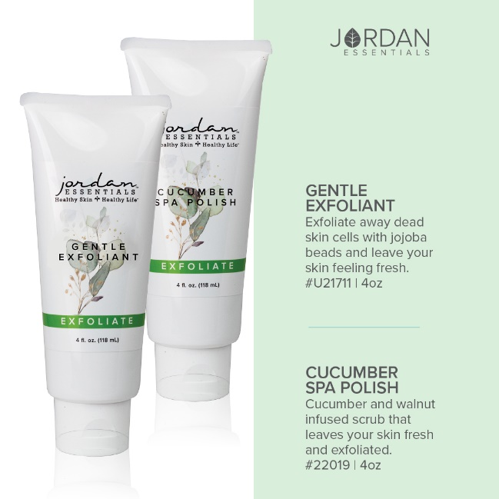
Mask up for An At-Home Spa Treatment  Like with exfoliating, how often we masks depends on our skin type. We have two amazing masks that not only remove the toxins from our face, they can be used on our “pits” and feet too!  Purifying Charcoal is a natural way to cleanse and clear pores. It is great for those with oily skin.  Detoxifying Clay Mask will leave your face dewy soft. Bentonite clay pulls pollutants and toxins from your skin leaving it radiant and healthy. | 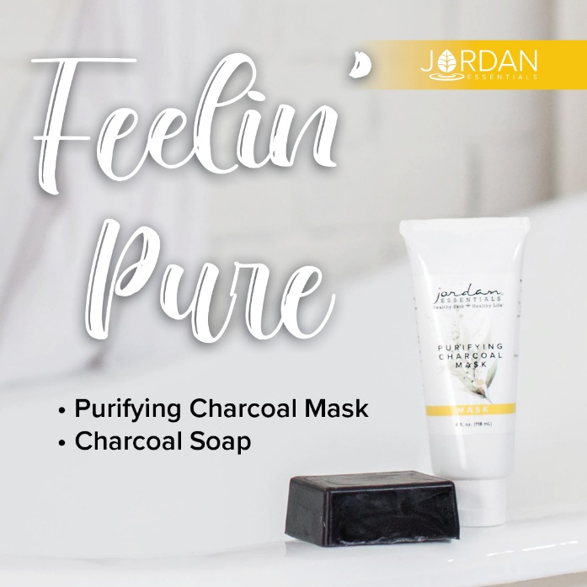
A little More about Charcoal  🥥Not to confuse charcoal used for grilling during the summer, Activated Charcoal is super-absorbent, detoxifying, purifying, and offers many benefits to the body and skin.🍃  Jordan Essentials uses Activated Charcoal in many of our products including our Activated Charcoal Soap. Gentle enough for our face and strong enough to remove permanent marker!  (Suggestion: go live with a mask or the marker challenge here) | 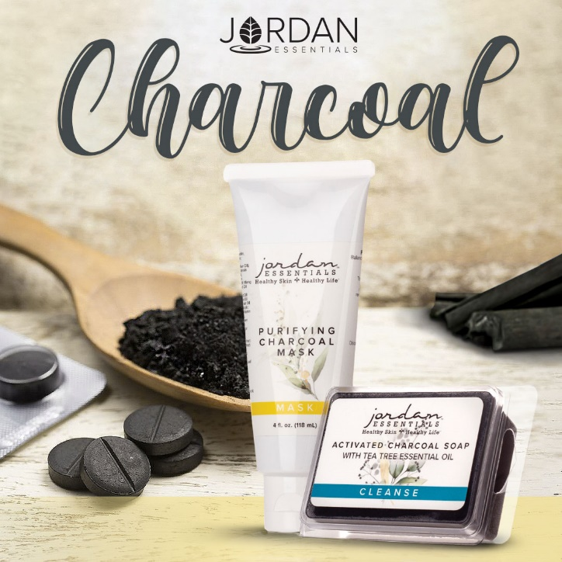
Super Charge with Toner Mist  Toner Mist is like vitamins for your face. It is a hydrating and moisturizing for all skin types.  We feel it is so important it is included in all of the Face Care Collections. (Remember…this month FREE Shipping on those collections!)  OPTIONAL  It is also excellent for use under protective face masks.  Spritz your face, let it set and absorb in before wearing a mask. Then, spritz again when you take off your mask for adding back in the moisture that has been pulled from your skin while wearing the mask.  Toner Mist is a must have all year long. It is nourishment our skin needs! It contains one of my favorite ingredients – Witch Hazel!  Boost with a few drops of orange essential oil for a soothing and uplifting feel or tea tree essential oil for acne prone skin. | 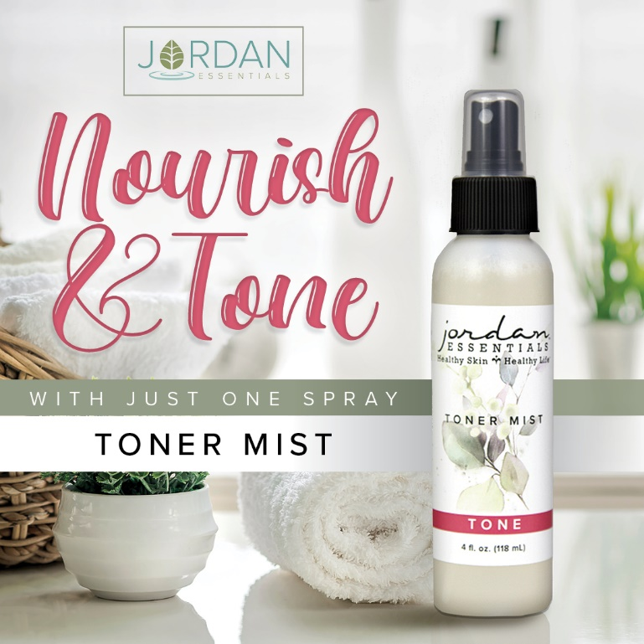
Hydrate from the inside to the outside!

Healthy skin not only comes from what we put on the outside, it comes from what we put inside too!

Be sure you are staying hydrated with water every day…and especially during the warmer months when you are losing water (sweating!) naturally.

Hydrate the Outside!  Moisturizing is the final step in our healthy face care routine. There are several options here depending on your skin type and your lifestyle.  We offer deep moisturizers, daily moisturizers, acne/oily skin moisturizers. We also have both a Tinted Moisturizer and BB Foundation for color.  You may want to do a mix-and-match with moisturizer. Choose your System (FREE Shipping!) for your night or weekend moisturizer and add on one of the mineral makeup moisturizers for day use. | 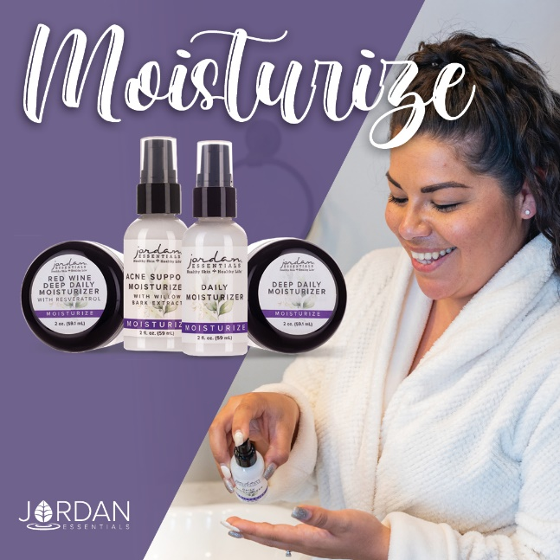
Just the Right Shade  Our Mineral Makeup offers moisturizing with color! Each is available in 9 shades so we can find the best match for you!  Both use natural minerals that provide a natural SPF for sun protection year-round. | 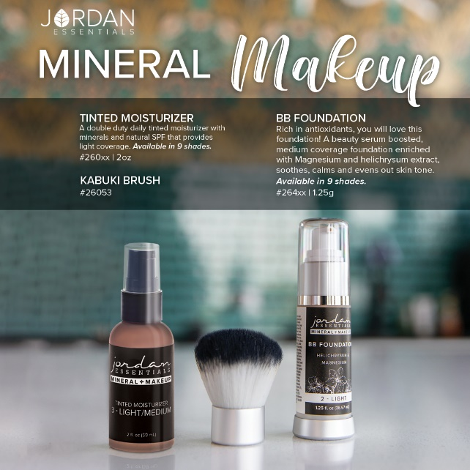
BONUS Step  Speaking of Hydration and Moisture  Serums provide the much-needed moisture and nutrients to keep your face looking and feeling its best.  Jordan Essentials offers three amazing serums to help reduce the appearance of fine lines and wrinkles.  Time Rewind Eye Gel: This serum is made for those thin skin layers around our eyes but can used anywhere! The cooling gel feels great and should be applied with a light touch.  Tone & Firm Serum: This serum is light and smells like grapefruit! It contains peptides that work hard to repair the skin's structure in just one to two pumps daily.  Age-Defying Serum: This serum works to balance the pH in our skin to keep it bouncy. It is perfect to use before applying makeup and will leave your skin feeling soft and dewy.  Your choice of serum is included in the Premier and Everyday Systems for Normal, Oily and Dry skin. | 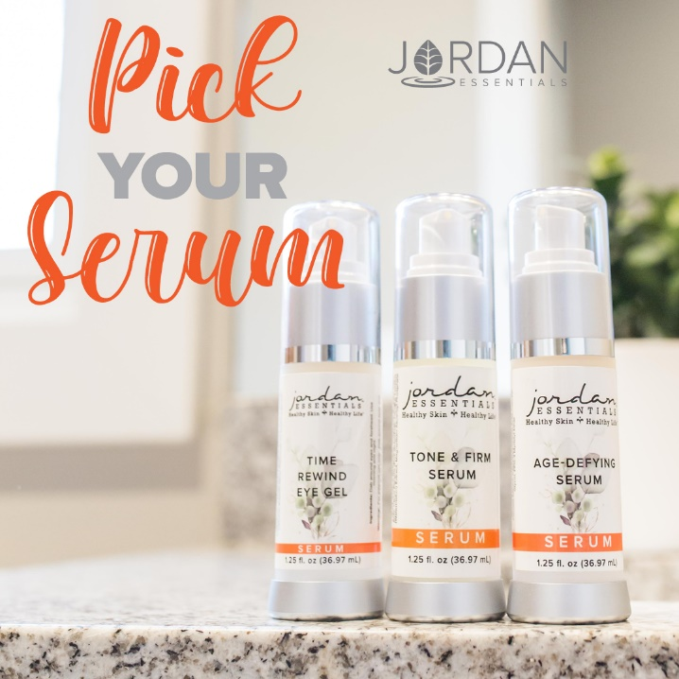
Which Skin Type Are You?  Normal – Balanced with a few breakouts or dry patches, maybe some t-zone issues.  Dry – Dry patches and overall dry, tight feeling.  Oily – Oily upon waking and oily throughout the day. Some acne or minor breakouts.  Acne – Frequent breakouts and very oily skin. | 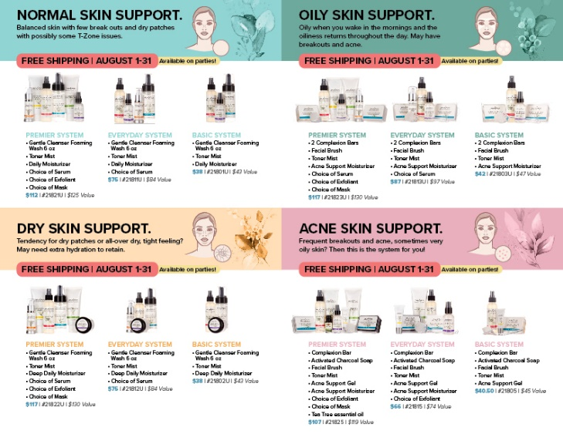
Are You Ready for Healthier Skin?  There is no time like the present to begin taking steps to have healthier, younger looking skin.  All three systems, in your choice of skin type, offer FREE SHIPPING.  I am here to assist you in choosing the right system and the products that will support you in looking and feeling younger! | 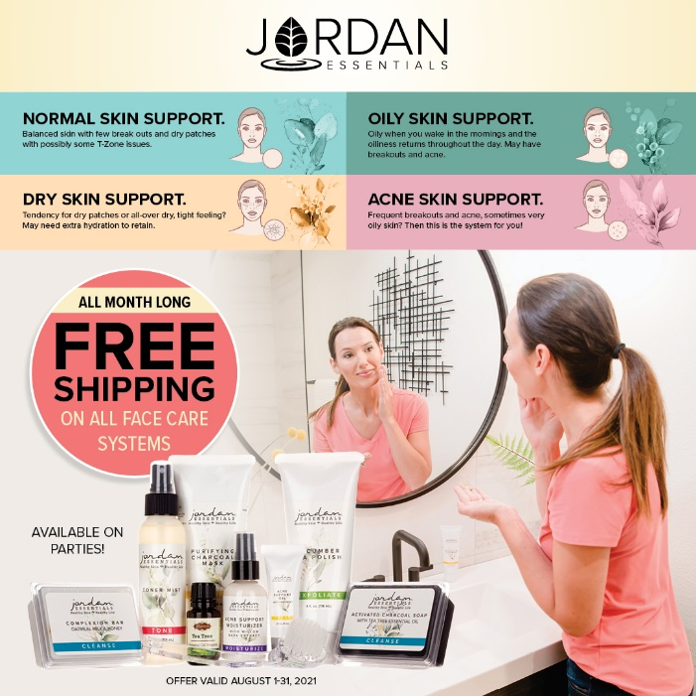
3 Ways to Enjoy JE  Did you know there are 3 ways to get Jordan Essentials products in your home?  The first way is by placing an order on XXX party!  Remember you can message me too with questions or to book your party! | 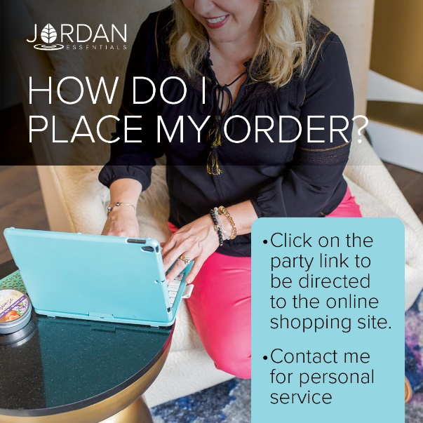
How about free?  The 2nd way to get JE products in your home is to become a host. We pamper our qualifying hosts with free products, ½ price items, a monthly special and more! I would love to share healthy, nontoxic products with your friends and family too and help you earn your favorite products for FREE.  In addition to the rewards mentioned above, our hosts receive a ½ price item for EVERY party booked from theirs!  We can do an online party like this one...or an in-person Spa Bar or even a Party On the Go. Let me know which would work for you. Comment which party type you are interested in below and I can answer any questions. When you select your date before _____ closes her party, she will receive credit for your booking.  In addition to face care, we can do theme parties, Magnesium Parties, Healthy Living Parties, Essential Oil parties and more! | Insert Host special
Enjoy it all…all the time!  Of course, if you were thinking, “I can do what she does!”, you are right! YOU can earn money by sharing healthy products with others too!  You can work this business online, part time or big time, the choice is yours! If you would like to learn more about starting your business, message me or type “Tell Me More” in the comments and I’ll send you some more information to look over and we can chat! | Insert Join Special
Be My VIP  We have so many products I didn’t get to share with all of you today, but great news! I have a VIP Facebook Group where I share valuable tips and information that focuses on Healthy Skin and a Healthy Life. Members also get access to promotions and notifications of special events! Go to _____________________(Insert VIP Group Link) and request to join for one final chance to win tonight’s drawing! | Link Displays image.
Wrap Up  I’m getting ready to gather all of the entries for our prize drawing! Want to make sure you didn’t miss a video or post? Click on PHOTOS or VIDEOS in this group to quickly jump to what you’re looking for!  Just a few reminders while I’m figuring out who our winner is tonight. If you would like to place your order directly, here is the party link:  If you would like me to contact you for your order, comment below and I will connect with you shortly.  We will be closing our party on…. (INSERT DATE AND TIME) | Link displays image
Thank YOU!  A big thank you to our host, ________, for getting everyone together for our fun online Spa Bar! You were an awesome host! And to every guest who participated, it was a pleasure having you. I hope you will join our mission of sharing Healthy Skin - Health Life.  Remember, you will want to place your order at _______ (insert party link) by ________ (close date) OR message me and I will review your wish list with you, answer your questions and get your order placed for you! Good night everyone! | 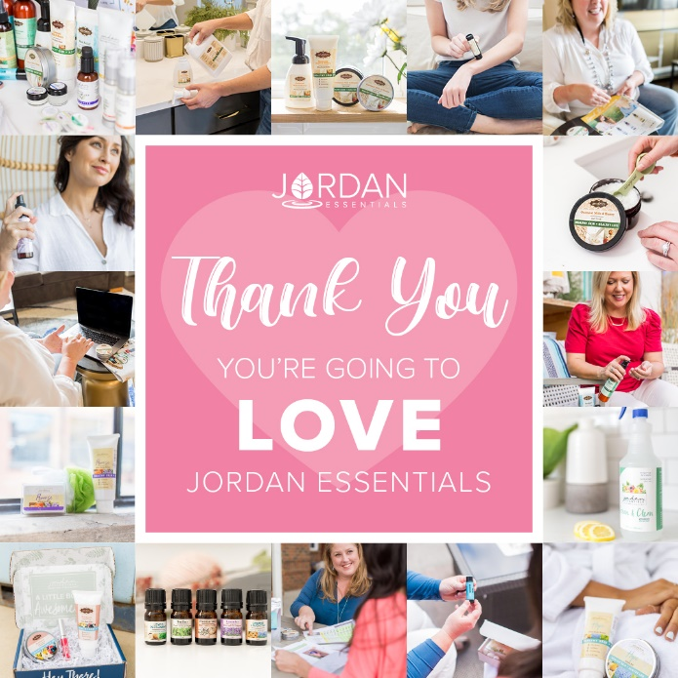
(The Next Morning)  Party Poll  Thank you all so much for attending live or viewing our online party! I had a great time sharing Jordan Essentials with all of you. Please take a minute to comment below with the letter that most describes you!  I look forward to continuing to serve you. Keep my contact information in your phone and stay connected with me in my VIP group at __________________.  Enjoy your new products and thanks again to _______, our awesome host!! | 