$49 Copy Paste Social Selling Kit
Copy/Paste the text into Facebook/Messenger/Text parties. Images may be saved from this document or from the ZIP File of images.
Be sure to personalize with host’s name and party link. Feel free to edit posts as needed and to fit with your party audience.
Make the posts fun and engaging by adding emojis.
Posts can be scheduled in a Facebook Group. If you set your party for 30-45 minutes the body of posts can be set for 1 - 3 minutes apart. It keeps the pace going quickly.
See the Social Selling Demo images ideas and instructions on going LIVE with demos.

Banner for the Party | 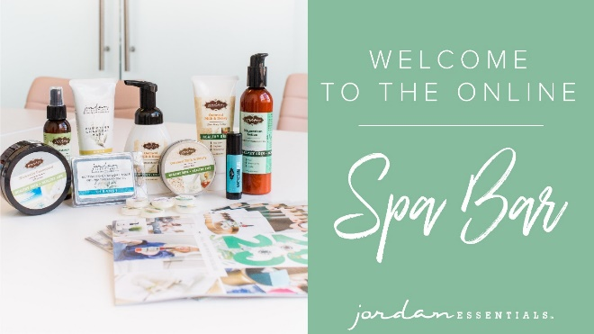
Pre-Party Post (Mark as Announcement):
Welcome to our Online Spa Bar with Jordan Essentials! Your host, ______, and I are looking forward to having a fun time together online as we share skincare treatments and solutions that aren’t only pampering, but part of having healthy skin for a healthy life!
Here’s how it works:
Check out the posts below to learn more about Jordan Essentials and join us here in this group on ___________ (date) at _______ (time). You’ll receive chances to win fun prizes for commenting below to RSVP, for joining us on time, for participating in the event, and more!!
If you’d like to check out what Jordan Essentials has to offer, check out our online catalog at bit.ly/JEFallWinter
You can also place an order on _____’s party anytime before _______ by going to: (insert party link).
As your JE consultant, I’m available to answer any questions so reach out to me anytime in a personal message or call/text me at ______ (insert phone number)
Have someone who would like to join us? Share the link to this group and they can request to join!
I look forward to seeing everyone on ________ at _____!!
Alternative Post:
Welcome to my online launch party! I have just started my home business with Jordan Essentials. I am looking forward to have a fun time with everyone sharing healthy body, skin and facecare.
JE products are more than pampering…although that is great…they are healthy solutions for the entire family!
Here is how this works:
Check out the posts in this group. On ________(date) at _______(time) we will start the party! For about 30 minutes, there will be posts and videos (and maybe a live or two) about Jordan Essentials products. You will even have chances to win fun prizes!
If you’d like to check out what Jordan Essentials has to offer before the party, check out our online catalog at http:bit.ly/JEFallWinter
You can place your order on this special party link: ______(insert link)
As your JE consultant, I’m available to answer any questions so reach out to me anytime in a personal message or call/text me at ______ (insert phone number)
Have someone who would like to join us? Share the link to this group and they can request to join!
I look forward to seeing everyone on ________ at _____!!

Pre Post  Prize Alert! This party will stay active for the next few days. (Insert end date)  Scroll the posts & interact for chances to win!  We will wrap it up on _______(Insert date) with some fun prize drawings!  Here is how to get your name into the drawings!  Like and comment - The more you do the more chances to win.  Bring a guest. Just share the link and we will let them in!  Ask me a question – more sharing, more drawing chances!  (Prizes can be samples or products you choose.) | 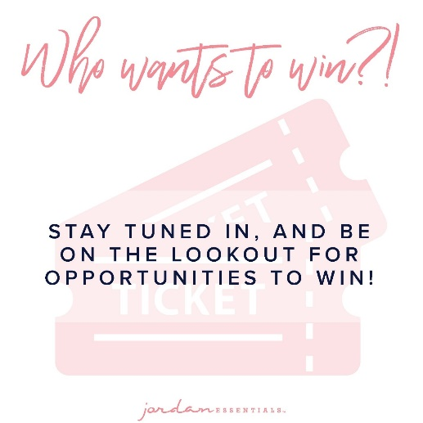
Pre-Party Post  At Jordan Essentials our belief is that everyone deserves healthy skin—and joyful, healthy lives. When you say YES to Jordan Essentials products, you are saying YES to ingredients like magnesium, essential oils like lavender, purifiers like charcoal and rich moisturizers like shea butter. | 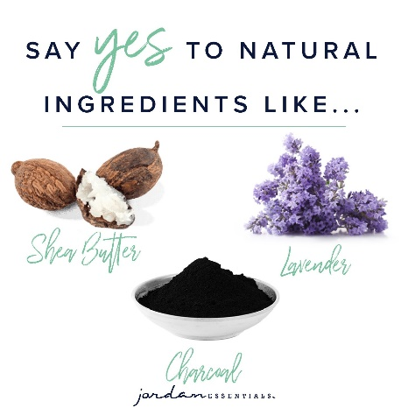
Pre-Party Post  And just as importantly, you will be saying NO to aluminum, parabens, mineral oil, SLS/SLES, gluten and phthalates that are found in many, if not most, bath, body and skincare products today. | 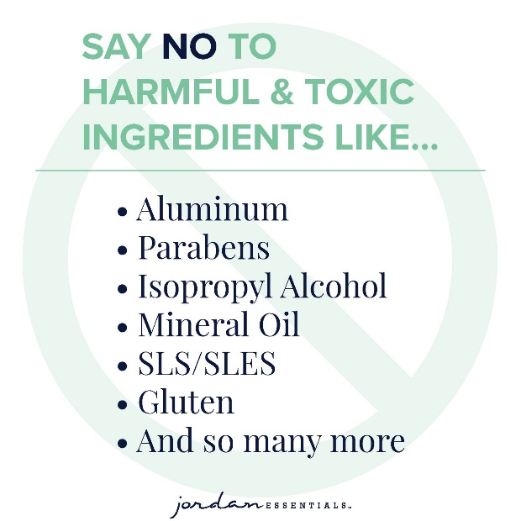
Self-care is so important. We know when we are at our best, we can best help others.  The flip side is giving others a way to have better self-care.  As you make your list you may want to treat yourself first and also book an online Spa Bar to get free and half price products so you can share with others. | 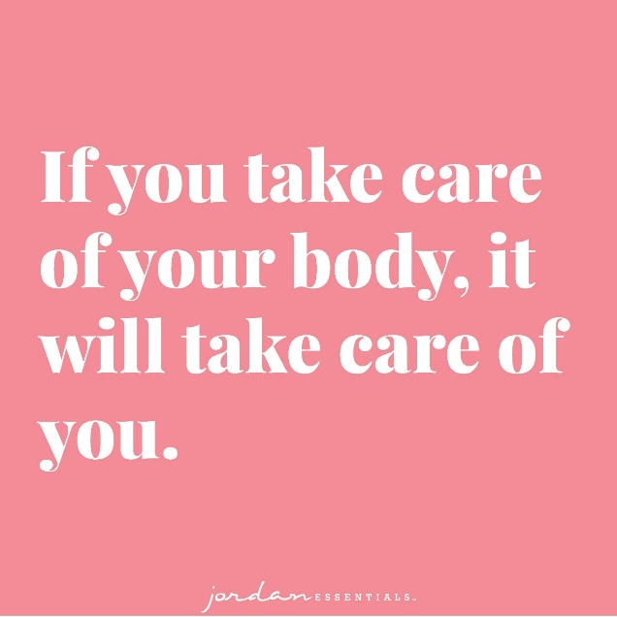
Pre-Party  Why is what’s in our products so important? For two key reasons:  - Our skin is our largest organ and what touches our skin affects all of our organs.  - It takes just 26 seconds for what touches our skin to be absorbed into our bloodstream. The harmful effects of many chemicals used in skincare products are scary! And many include ingredients that prematurely age us or dry out our skin.  Jordan Essentials’ products use healthy, nontoxic ingredients combined to provide safe, healthy alternatives to their chemically-laden counterparts. | 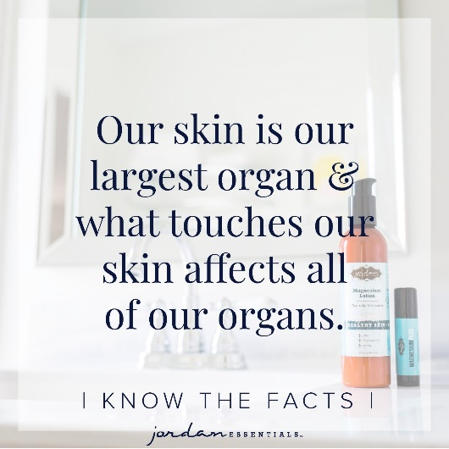
Pre-Party Post (Day Before the Event):  If you are ready for some fun and some pampering tips, be sure to join our live event tomorrow at _________. We will be giving out virtual tickets for great prizes - the more tickets you earn, the more chances you have to win!  Not only do we provide natural and nontoxic solutions, but our products are also fun, pampering, and life-changing! Everyone needs and deserves pampering in their life. Right? | 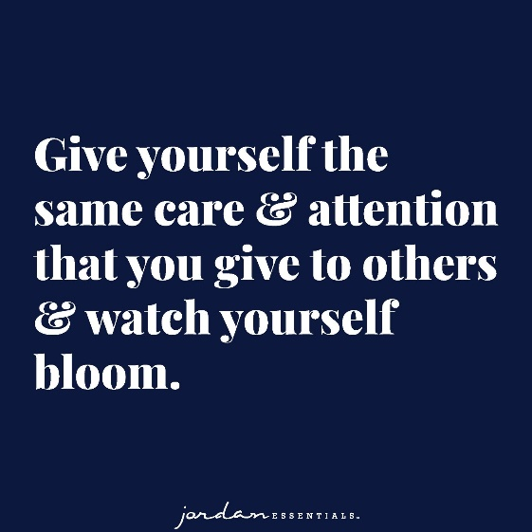
Day of Event  Pre-Party (Morning of the Event):  Today’s the Day!!! Join us TONIGHT at ______ right here in this group for fun, connecting with friends, fabulous spa products, and some free giveaways!  Set an alarm on your phone, because everyone who responds during the live event gets extra chances to win!  Won’t be able to join the LIVE event or wondering how to order? Place your order anytime at ________ or contact me via messenger or phone to place your order or ask questions anytime! | 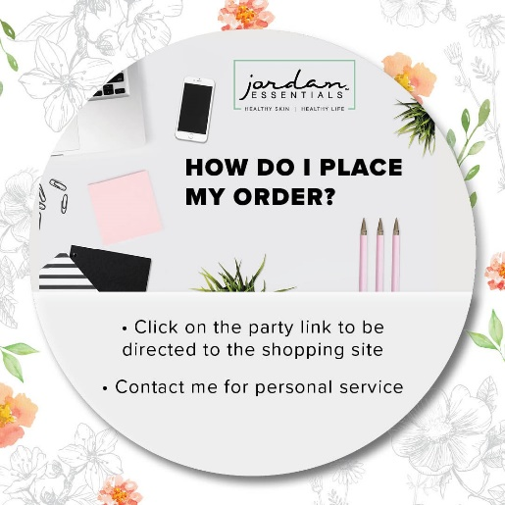
Pre-Party Post 6 (30 Minutes Before):  The party starts in about 30 minutes! It is "come as you are" so get comfy, grab a drink, get a pen and paper, and let’s get ready to party Facebook Style with Jordan Essentials! I am excited to share with Host’s friends who will be joining us tonight! Comment below with an emoji or GIF that shows how excited you are for us to get started! | 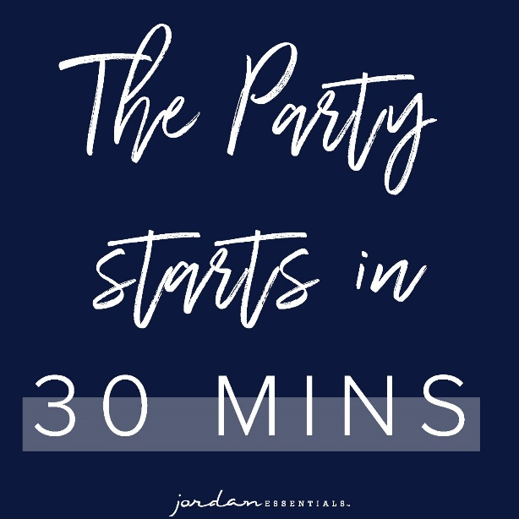
Pre-Party Post 7 (5 Minutes Before):
Time sure flies by! We will be starting in just a few minutes. During our party tonight, which will last about 45 minutes, be sure to refresh your screen often so you don’t miss anything such as chances to win our product drawing!
Tonight you’ll earn a ticket into the product prize drawing for every Like/Love, comment or question on the posts in our event!

Post 1: Welcome  Welcome, everyone! I am so happy you could join our party. I love Jordan Essentials and am excited to share products with you.  As we chat, feel free to comment, like and LOVE the posts. The more you do, the more chances you have to earn tickets. I’ll respond as quickly as I can to questions and if you have questions after, feel free to reach out directly on Messenger. Remember, refresh often, sit back and have fun! | 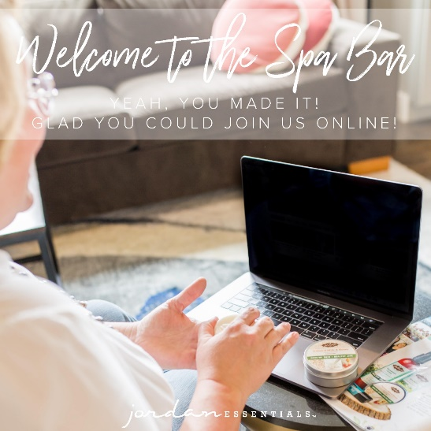
Post: Roll Call  Let’s start with an easy question and see who is here. Comment below letting us know where you are viewing from? Who is the farthest away today? | 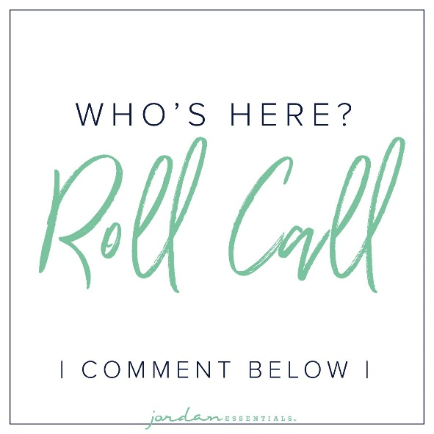
Post: My Story POLL  That is so fun to see where everyone is watching from. I’m _________ and I am in ________. (Insert a sentence or two about your JE story.)  That’s my story, but I’d love to know more about YOUR story so I can best serve you tonight! Select any of these poll options that best describes you.  A - I am always looking for healthy skin care solutions for my family.  B - I have never really thought about the products our family uses on their skin.  C - I already have and use products from Jordan Essentials.  D - I have never heard of Jordan Essentials, but excited to learn more! | Insert a fun picture of your choice.
Post: JE Story  For those who have never heard of Jordan Essentials, it was started by Nancy Bogart in 2000. We are proud to be a woman-owned and “Made in America” company. All of our products are made with non-toxic ingredients and the healthiest ones available. We will feature a few of those products during this party.  If you HAVE heard of Jordan Essentials, go ahead and comment below with the products you have and love! | 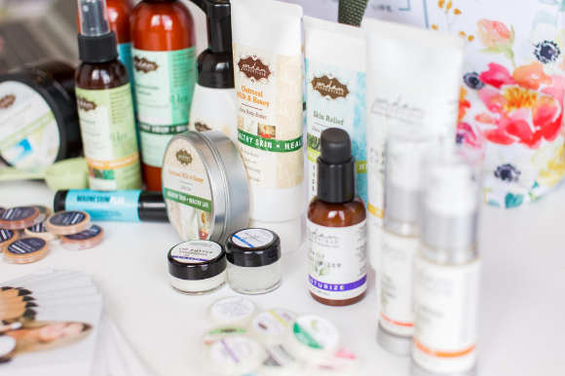
Post: Creating a Wish List  We will not be lengthy tonight, but we will be covering a number of products and one of the easiest ways to remember what you’re interested in along the way is to create a wishlist! You can jot down this list OR as we post and chat this evening, comment INTERESTED on products or bundles that you want to order or know more about.  There are two ways to order. Go to (enter party link) to shop OR contact me with your order or questions and I’ll place the order for you.  Remember, by commenting INTERESTED on any post, you’ll create a wish list for easy checkout at the end of our event! If you’ve read this post and are ready to get started, comment READY below! | 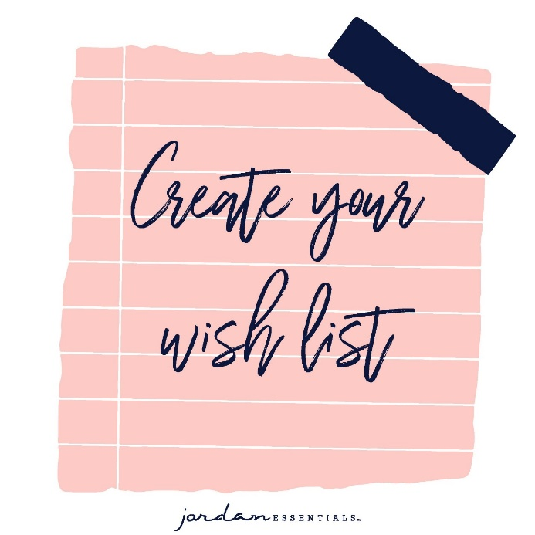
Pamper Yourself with JE Products  To make pampering easy, JE has created a variety of bundles! These specially priced bundles of products support soothing, relaxing and healthy spa experiences. Think of them as treatments to do at home!  Listen as Nancy shares two bundles that feature everything you need for cleansing, exfoliating and moisturizing the healthy way.  Upload Hand & Body Video or share Video Link: https://vimeo.com/327304191/687e0989fa | VIDEO will preview here.
(This is a great one to share a live as well. All three items of the Basic Collection are included in your $49 Social Sharing Kit)  Our Basic Collection is a great way to get started! This trio is everything you need to exfoliate, moisturize and protect your skin. The perfect set to start or to gift to a friend too! | 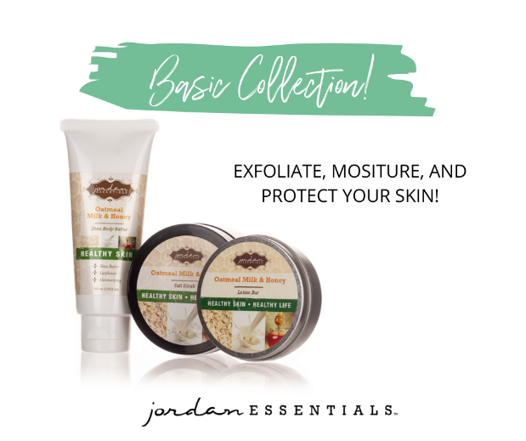
DEMO option for a LIVE  The Lotion Bar  This is a great demo to share how to use the lotion bar. | 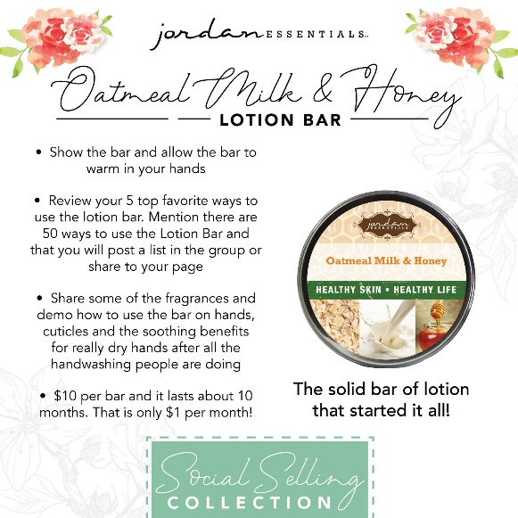
Post: Lotion Bar  The Lotion Bar, our flagship and the product that started it all! I don’t leave home without it! I have one in my purse, my car, at the office. Simple but so effective in sealing in the moisture after applying shea butter or for use on the go. There are SO many ways to use your lotion bar. At only $10 a bar, it also makes a great gift!  Which of these applications would YOU use the lotion bar for? | 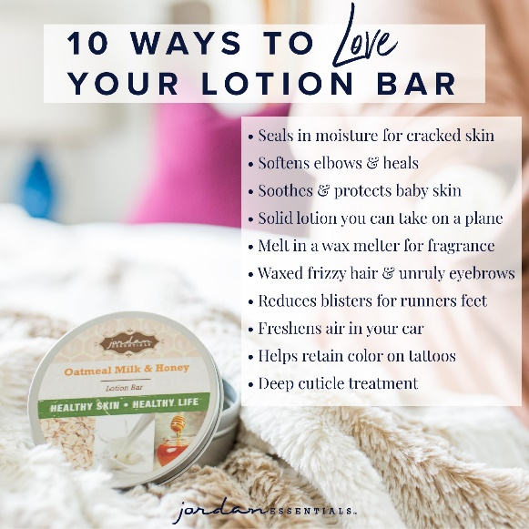
Post: Fragrance Choices  We offer all of our products in the Basic and Everyday Collection in all of our amazing Signature Fragrances.  My favorite is __________. What one would you choose: | 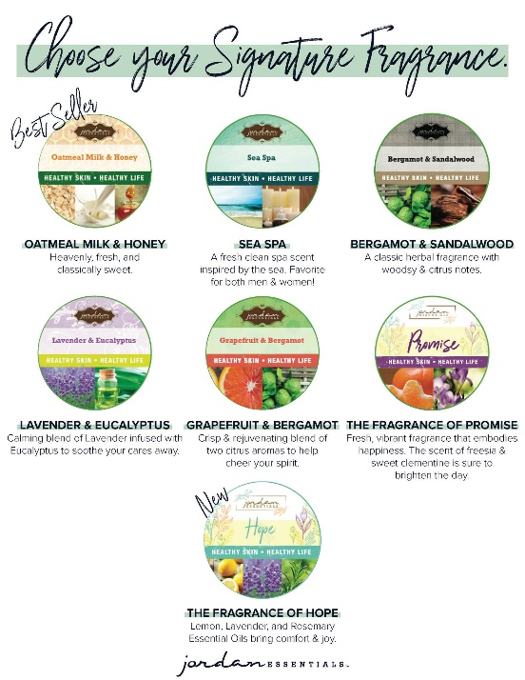
Marvelous Magnesium  Our Magnesium Lotion is one of our top-selling products each month. Did you know 55% of America’s are deficient in magnesium? How many of you or someone you love suffers from occasional leg cramps, muscle spasms like eye twitches, or achy, sore muscles? Our topical magnesium lotion comes both with and without peppermint essential oil and is made with healthy ingredients like aloe, sunflower oil and jojoba oil along with magnesium. These ingredients have been shown to help relieve those minor aches and pains, and support the body’s need for magnesium. | 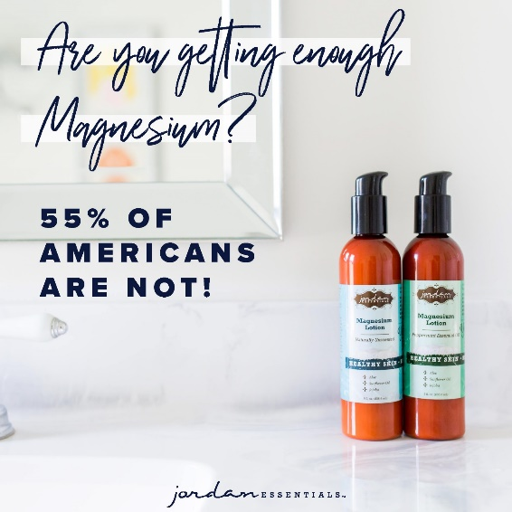
Start with the Best!  Core 4 includes your choice of unscented or peppermint magnesium lotion, a magnesium stick, lotion bar, plus Skin Relief to soothe and care for even the driest skin. Not only is this bundle a significant savings, but it makes you an instant qualifier for this month’s guest special! (More on that later!) Remember to comment “Interested” to add this set to your wishlist! | 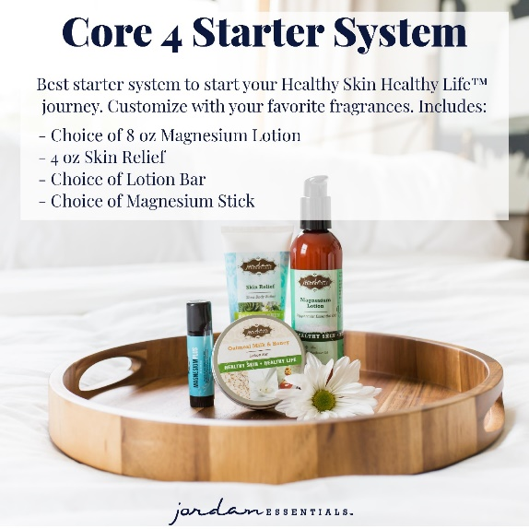
Relief on the Go  One of the items in our Core 4 is our Magnesium Stick. These convenient on-the-go sticks are perfect for your purse or gym bag! Simply rub on your wrists, temples, back of your neck… wherever you want soothing relief! If ordering the Core 4, choose from the Magnesium Plus Muscle Relief, Magnesium Plus Peace, Soothing , Allergy or our Helio Magnesium Stick. You can also purchase sticks separately for $14 each or purchase any 3 for $36 (a $6 savings)! | 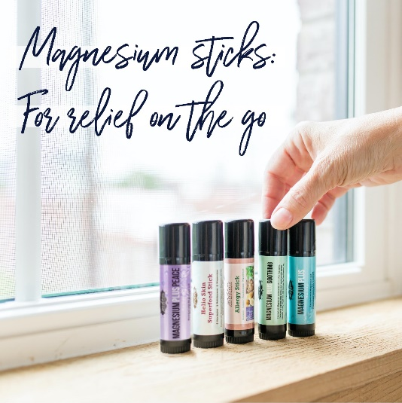
Got Tech Neck
Working from home or from an office desk, tech neck is real! For those stick necks, grab the Blue Stick!
Magnesium in our soothing lotion bar base is enhanced with Peppermint, Sweet Basil, Lavender, and Frankincense to ease minor muscle aches and pains.

Marker Challenge  Do you dare? Grit, grime and everyday toxins collect on our skin. Our Activated Charcoal Soap and Purifying Chrocol Mask gently remove these from the skin leaving it fresh, and feeling fine!  Our charcoal soap is so powerful, yet gentle, it removes permanent marker! Activated Charcoal Soap clarifies and detoxifies your skin with activated charcoal. Gentle enough for daily use and strong enough to remove permanent marker! Take the marker challenge!  (Do the marker challenge live) | 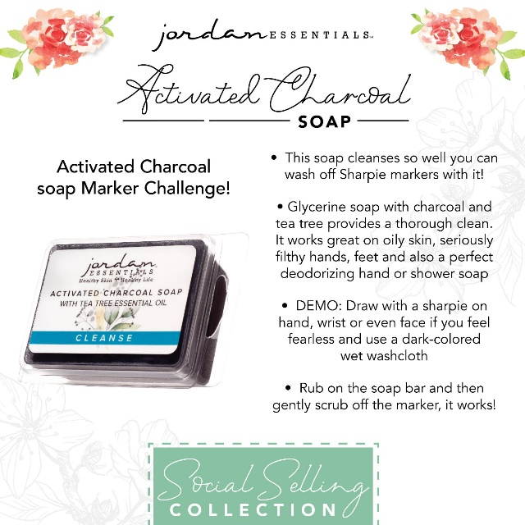
Resistance Essential Oil Spray  Great demo to go live. :-) | 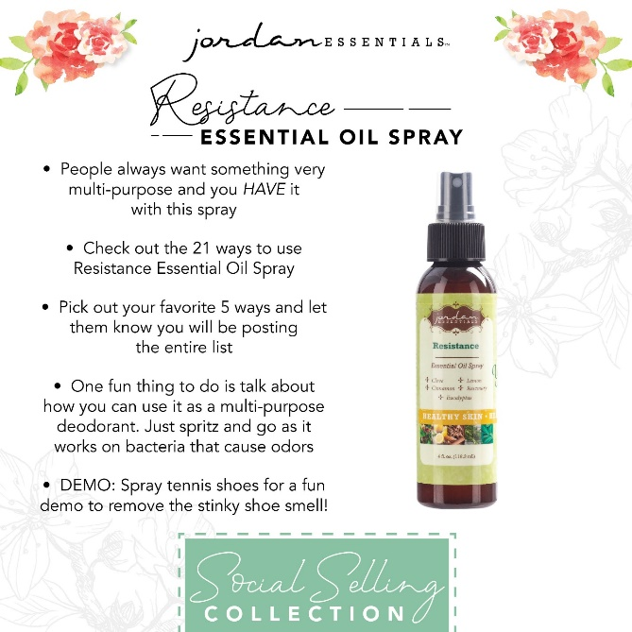  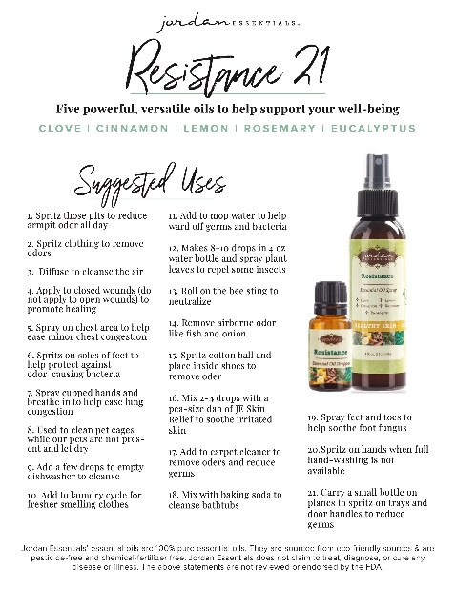
A Box of Happy  If you love those items and think they will make you happy…share the happy with a friend with our limited-time only – Happy Box!  The Happy Box feature our fan favorite Magnesium Plus “Blue Stick”, the top selling Oatmeal Milk & Honey Glycerin Soap, and YOUR choice of either our Promise or Hope Lotion Bar. All three in a gift box for only $25 with FREE Shipping! | 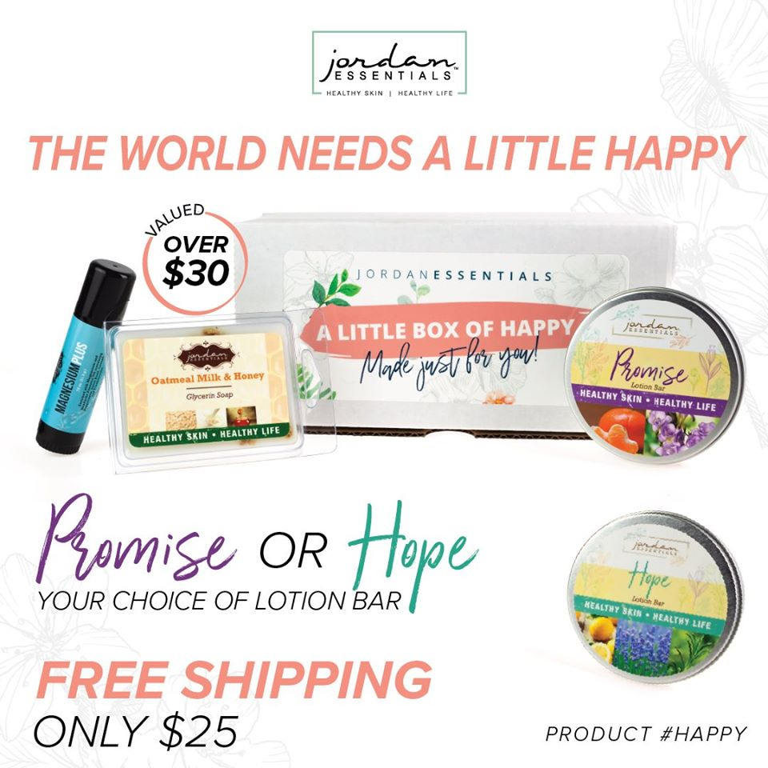
Post: Joyful Jordan Box  We also have our box of Awesomeness - The Joyful Jordan Box. This box is a monthly box of favorites and exclusives that value over $35 each month for just $25.  ADD INFO on the current month’s JJ Box. | INSERT current month’s image here. Available from Current Specials folder in the Digital Library.
Online Catalog  By now you have some items on your wish list. And there are so many products that we didn’t get to feature tonight, but you can check out the complete catalog at  Bit.ly/JEFallWinter | Preview will show when link is posted.
3 Ways  Did you know there are 3 ways to get Jordan Essentials products in your home?  The first way is by placing an order on ____’s party! We have an incredible Customer Special this month. With any $50 purchase, you can add our _________ for just $5. This is a savings of _____!  Add info on the current month’s special. | INSERT current month’s image here. Available from Current Specials folder in the Digital Library.
Host  The 2nd way to get JE products in your home is to become a host. We pamper our qualifying hosts with free products, ½ price items, a monthly special and more! I would love to share healthy, nontoxic products with your friends and family too and help you earn your favorite products for FREE.  In addition to the rewards mentioned above, our hosts receive a ½ price item for EVERY party booked from theirs! When two or more friends book, _______ will be eligible to receive Book 2 VIP $50 Host Shopping Spree! And you’ll be eligible for this when you get 2 bookings from YOUR party!  We can do an online party like this one...or an in-person Spa Bar or even a Party On the Go. Let me know which would work for you. Comment which party type you are interested in below and I can answer any questions. When you select your date before _____ closes her party, she will receive credit for your booking. | INSERT current month’s image here. Available from Current Specials folder in the Digital Library. 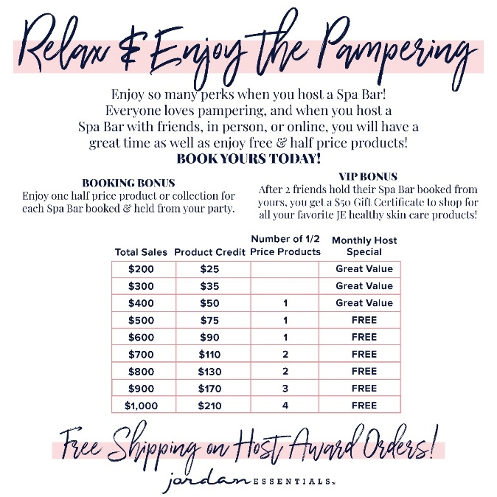
Join with Me! Be a Jordie too!  Of course, if you were thinking, “I can do what she does!”, you are right! YOU can earn money by sharing healthy products with others too! You can start a Jordan Essentials business for $49. This is the BEST way to get JE products in your home!  Our business kit features over $185in full-size products and all the materials you will need to get off to a successful start in the business. You can work this business online, part-time or big-time, the choice is yours! If you would like to learn more about starting your business, message me or type “Tell Me More” in the comments and I’ll send you some more information to look over and we can chat! | INSERT current month’s image here. Available from Current Specials folder in the Digital Library.
Be a VIP
We have so many products I didn’t get to share with all of you today, but great news! I have a VIP Facebook Group where I share valuable tips and information that focuses on Healthy Skin and a Healthy Life. Members also get access to promotions and notifications of special events!
Go to _____________________(Insert VIP Group Link)and request to join for one final chance to win tonight’s drawing!

Order Reminders  I’m getting ready to gather all of the entries for our prize drawing! Want to make sure you didn’t miss a video or post? Click on PHOTOS or VIDEOS in this group to quickly jump to what you’re looking for!  Just a few reminders while I’m figuring out who our winner is tonight. If you would like to place your order directly, here is the party link:  If you would like me to contact you for your order, comment below and I will connect with you shortly.  We will be closing our party on…. (INSERT DATE AND TIME)  Winner post  Drum roll please…. I have collected up the virtual tickets and the winner is….. | 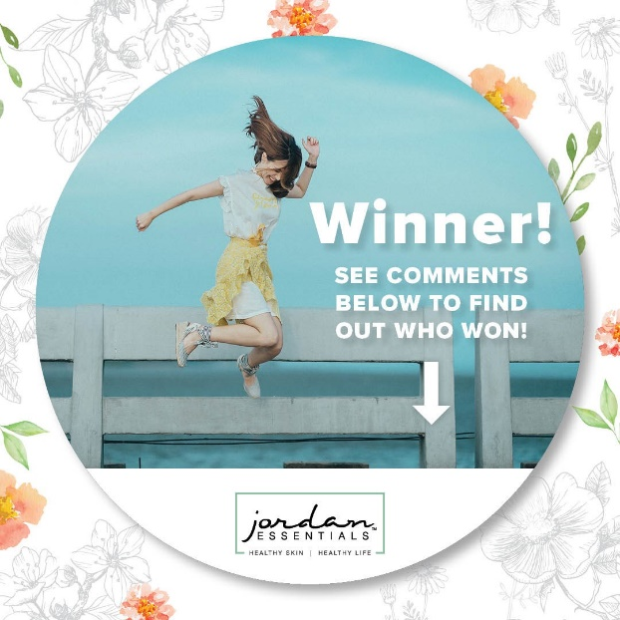
Thank You to Host & Guest  A big thank you to our host, ________, for getting everyone together for our fun online Spa Bar! You were an awesome host! And to every guest who participated, it was a pleasure having you. I hope you will join our mission of sharing Healthy Skin - Health Life.  Remember, you will want to place your order at _______ (insert party link) by ________ (close date) OR message me and I will review your wishlist with you, answer your questions and get your order placed for you! Goodnight everyone! | 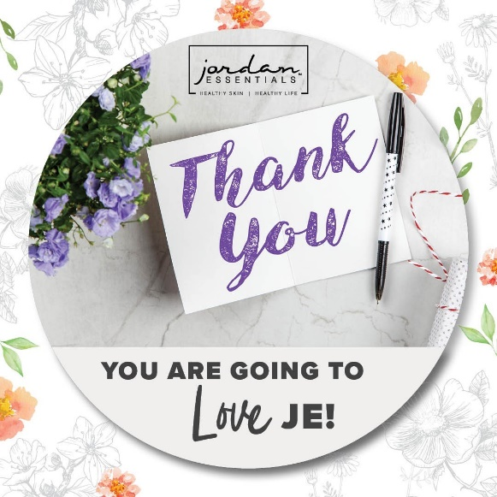
After Party Post (The Next Morning)  Thank you all so much for attending live or viewing our online party! I had a great time sharing Jordan Essentials with all of you. Please take a minute to comment below with the letter that most describes you!  I look forward to continuing to serve you. Keep my contact information in your phone and stay connected with me in my VIP group at __________________.  Enjoy your new products and thanks again to _______, our awesome host!! | 